Advancing CRVS Digital Transformation in Africa: African eCRVS Shared Asset (ACSA) initiative In-Person Workshop Report

February 3 to 7, 2025
Kigali, Rwanda
Grand Legacy Hotel

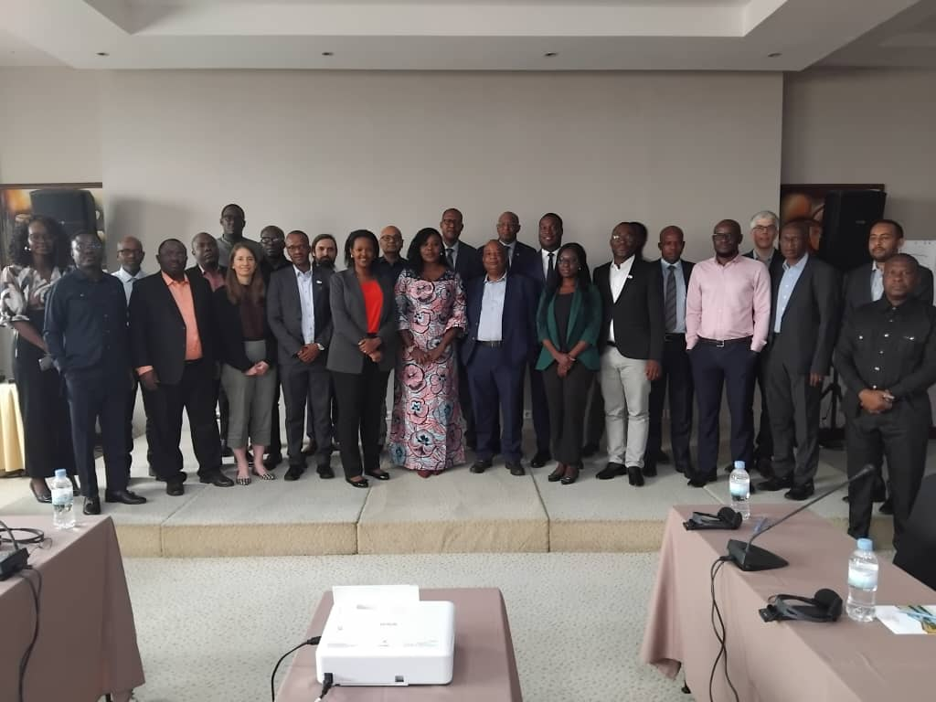

FEBRUARY 2025

Table of Contents
Introduction 2
Workshop Objectives 2
Workshop Overview 3
Participants 3
Structure and Format 3
Workshop proceeding 3
Opening 3
Presentations 4
Vision and Strategic Purpose 4
Governance and Institutional Framework 4
Core Objectives and Strategic Pillars 4
Key Achievements and Strategic Milestones 5
Key Takeaways 7
Day 2 7
Day 3-5 9
Conclusion 11

Introduction
In recognition of the critical roles that robust Civil Registration and Vital Statistics (CRVS) systems play in promoting good governance, public service delivery, and sustainable development, the African eCRVS Shared Asset (ACSA) initiative was established to drive digital transformation and regional integration across Africa. From 3rd to 7th February 2025, a high-level workshop was convened in Kigali, Rwanda. It brought together the three structures of the ACSA (1) Advisory Board members, (2) national technical experts, and (3) development partner representatives from the UNECA, UNICEF, and Vital Strategies.
The workshop was designed to build on earlier virtual engagements to foster in-depth dialogue, consensus-building, and collaborative planning. Central to the discussions were the development of design principles and data standards for the digitalisation of CRVS systems and the establishment of comprehensive modalities for assessing the suitability of CRVS digital solutions. These were intended to support efforts to enhance CRVS systems in a manner that is both technologically robust and contextually appropriate for African countries.
Structured around plenary sessions, technical workstreams, and collaborative exchanges, the workshop underscored the importance of CRVS digitalisation and interoperable systems as well as government buy in and support. This report provides a detailed account of the key discussions, resolutions, and next steps agreed upon during the workshop. It also serves as a reference document for member states, ACSA partners, and technical experts who are committed to advancing CRVS digital transformation and governance across the continent.

Workshop Objectives
The workshop objective was to:
- Enable direct interaction among Advisory Board members, technical experts, and partner representatives to strengthen working relationships
- Form the two technical working groups
- Kickstart the development of a regional interoperability standard for CRVS systems and CRVS digital solutions

Workshop Overview

Participants
The ACSA Kigali Workshop brought together different stakeholders committed to strengthening CRVS systems in Africa. Participants included members of the ACSA Advisory Board, national technical experts, and representatives from partners organizations - UNECA, UNICEF, and Vital Strategies. A representative from GIZ joined the workshop online.

Structure and Format
The workshop was structured to facilitate meaningful engagement through a combination of plenary sessions and technical workstreams. The plenary sessions provided a platform for high-level discussions on CRVS priorities, digital transformation strategies, and interoperability frameworks. They also allowed for collaborative dialogues and the exchange of country-specific experiences. The technical workstreams allowed technical working groups to engage in tailored discussions on the development of design principles and standards for the digitalisation of CRVS systems and the establishment of comprehensive modalities for assessing the suitability of CRVS digital solutions.

Workshop proceeding

Opening
The workshop started with an opening session that set the stage for discussions on strengthening CRVS systems through the ACSA initiative. The session included welcoming remarks from the Vice Chair, Ms Josephine Mukesha. The Chair of the ACSA Advisory Board, Ms Henrietta Lamptey, provided an overview of the initiative’s mission. Her presentation explained ACSA as a collaboration among African countries to develop a shared digital CRVS asset that integrates the best open-source, proprietary, and homegrown solutions, fostering interoperable, cost-effective, and sustainable CRVS operations. The objectives of ACSA were enumerated as:
- Establishing normative standards for CRVS digitalization by developing design principles and data standards.
- Providing technical oversight and guidance to ensure adherence to best practices.
- Facilitating capacity building and knowledge sharing through strategic partnerships.
- Advocating for standardized CRVS digitalization approaches across regional and global platforms.

Presentations
The Chair of the ACSA Advisory Board, delivered a presentation on the African eCRVS Shared Asset (ACSA), outlining its vision, governance structure, and strategic objectives. The presentation emphasized ACSA’s role in advancing digital transformation in CRVS systems across Africa through a collaborative and interoperable framework.

Vision and Strategic Purpose
ACSA is a continental initiative designed to enhance CRVS digitalization through shared resources, technical standardization, and strategic partnerships. The initiative aims to develop a unified and interoperable approach to CRVS systems across Africa, ensuring that national efforts align with regional and global best practices.

Governance and Institutional Framework
ACSA operates under the oversight of an Advisory Board, comprising CRVS experts from 11 African countries. The Board was officially inaugurated in May 2024 in Cape Town and has since been instrumental in guiding the initiative’s strategic direction. The Advisory Board is supported by a Secretariat responsible for coordinating ACSA’s activities, managing technical working groups, and facilitating stakeholder engagement.

Core Objectives and Strategic Pillars
The presentation outlined the four core objectives of ACSA, which serve as the foundation for its operational framework:
Normative and Technical Standardisation: Developing continental normative standards that establish design principles, data standards, and interoperability protocols for digitalizing CRVS systems.
Technical Oversight and Guidance: Ensuring digital CRVS solutions align with international best practices while adaptable to national contexts.
Capacity Building and Knowledge Exchange: Strengthening the technical expertise of CRVS authorities through collaborative learning, peer reviews, and technical workshops.
Advocacy and Policy Engagement: Positioning CRVS digital transformation as a policy priority at the continental and global levels, with engagement from UNECA, UNICEF, Vital Strategies, ID4Africa, and other development partners.

Key Achievements and Strategic Milestones
The chair highlighted the significant progress made since ACSA’s inception, including:
- The successful establishment of the ACSA Advisory Board and its governance framework.
- The operationalisation of the ACSA Secretariat to facilitate day-to-day coordination.
- The development of a Terms of Reference (ToR) of technical working committees to guide the design and implementation of digital CRVS solutions.
- Strategic collaborations with UNECA, UNICEF, Vital Strategies, and ID4Africa to mobilise technical expertise and funding support.
The presentation concluded with a call for stronger alignment between national CRVS digitalization efforts and ACSA’s regional strategy, emphasizing the need for sustained government ownership and cross-border data interoperability. She indicated the objectives and expected outcomes of the workshop.
Following Henrietta's presentation, Madam Josephine Mukesha made a presentation on the ToR of the technical working committees (TWCs). She indicated that ACSA would require two distinct TWCs who will be working to help achieve its mission. The TWC 1 will focus on Design Principles and Data Standards. It will aim to establish robust, actionable data standards and design principles for digitalizing Civil Registration and Vital Statistics (CRVS) systems. On the other hand, TWC 2 focuses on CRVS Digital Solutions Assessment and seeks to establish comprehensive modalities for assessing the suitability of CRVS digital solutions, address technical and non-technical dimensions while focusing on the unique challenges of Africa. Participants were allowed to join TWC where they were most comfortable with based on their expertise.
TWC 1 - Design Principles and Data Standards, the members were:
- Kennedy Chisumpa- Zambia- Chair
- Dr. Stephan Nwolley – Ghana
- Stephen Bugingo – Rwanda
- Aliou O SALL – Senegal
- Agbanlinsou Rodéric - Benin
- Nicholas Chimuriwo- Zimbabwe
- Alex Morgan Chege- Kenya
- Aristides Marques - Angola
- Gloria Mathenge - UNICEF
- Carlie Congdon - Vital Strategies
- Aisha Hassan- GIZ
- Madam Henrietta Lamptey
- William Muhwava
TWC 2 - CRVS Digital Solutions Assessment, the members included:
- Paul Dume Mwangemi- Kenya- Chair
- Nicholas Owusu Appiah – Ghana
- Frank Kitema – Rwanda
- Ali Tirera – Senegal
- Bakaal Mekonen- UNECA
- Henry Tawona Machiri- Zimbabwe
- Kloussa Romaric- Benin
- João Paulo Montes- Angola
- Chipo Muleya- Zambia
- Patrick Delcriox- Vital Strategies
- Josephine Mukesha - Rwanda
- Bhaskar Mishra, UNICEF
It was indicated that the TWCs were to use the workshop to start their work and continue virtually but are expected to complete their work by May 15th, 2025.
Patrick Delcriox and Martin Bratschi presented on the Value of a Standard for Interoperability and Beyond and ACSA: digitalization resource package including design principles and data standards. The sessions focused on the role of technical and regulatory standards in ensuring CRVS integration with national identity, health, and statistical systems. The presentation emphasized that digitalisation is not an end in itself, but a tool to enhance service delivery, improve governance, and strengthen civil registration as a core public function. CRVS digitalisation should be directed towards interoperability, seamless exchange of data across institutions. Participants admitted that interoperable CRVS systems are fundamental to achieving key sustainable development objectives such as achieving legal identity for all and providing accurate population data for governance and development planning. It was noted that risks associated with the absence of domain-specific standards, including data inconsistencies and inefficiencies in cross-agency collaboration, scalability and sustainability challenges, are due to lack of standardized protocols, vendor locking, as well as regulatory compliance issues that may impede system adoption and cross-border data sharing. The presentation further highlighted that ACSA’s digitalisation resource package should be structured around the following four pillars
- Principles - Guidelines for civil registration.
- Standards- Human-readable operational and functional requirements for CRVS implementation.
- Reusable Resources- Machine-readable, software-neutral frameworks ensuring interoperability.
- Specific Software Solutions- ACSA compliant software tools aligned with these standards.
Carle Congdon’s presentation focused on existing resources and guidance materials that could help the TWCs in their work. The presentation provided a comprehensive overview of key international frameworks, toolkits, and reports that offer technical guidance, best practices, and lessons learned in CRVS digitalisation and interoperability.

Key Takeaways
The session concluded with the following;
- There was a need to develop a harmonized interoperability framework that ensures cross-border compatibility of CRVS systems.
- Strengthen national regulatory frameworks to align with global best practices.
- Mobilise technical and financial partnerships to support member states in advancing the ACSA initiative.

Day 2
The day started with Dr. William Muhwava's presentation on country profiles of CRVS digitalisation. The presentation gave an overview of each member country's status in terms of CRVS digitalisation. This session opened a forum for member countries to present in detail the extent of digitalisation in the various countries, showing that countries are at different levels in terms of digitalisation of CRVS.

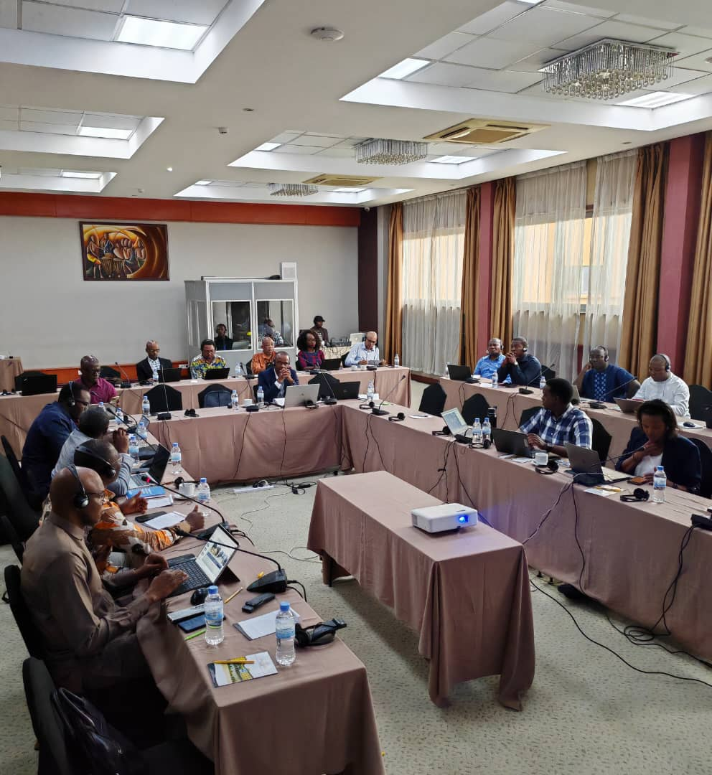

Day 3-5

Based on this discussion, members were put into workstreams according to the TWCs they belonged to. TWC1 was tasked with developing design principles and data standards for the digitalization of CRVS systems in Africa, while TWC2 was tasked with developing modalities for assessing the suitability of CRVS digital solutions and contributing to design principles and data standards. By the end of Day Five, TWCs presented drafts of documents they had produced. On Day 5, Bhaskar Mishra from UNICEF presented the following milestones for developing, finalizing, and releasing ACSA deliverables, which were discussed and agreed upon.
Milestone | Description | Deadline | Responsible Party
Refinement of Deliverables | TWC2 will share/add their inputs on design principles and data standards with/add them into the TWC1 template.  TWC1 will share/add their inputs on functional and non-functional requirements with/add them into the TWC2 template. | 10th March | TWC1, TWC2
Consolidation of Design Principles and Data Standards | TWC1 will refine the design principles and data standards and share the first consolidated draft with the ACSA Board. | 14th March | TWC1
Review of Boxes 3 and 4 | TWC2 (Nicholas Owusu Appiah, Frank Kitema, Chipo Muleya, Patrick Delcroix, and Baakal Mokonnen), with support from select TWC1 experts (Dr. Stephan Nwolley, Nicholas Chimuriwo, and Alex Morgan Chege) will review and unpack Boxes 3 and 4, defining the requirements and sharing them with TWC2. | 14th March | TWC2, TWC1 Experts
Draft Submission | TWC1 will share the first consolidated draft of functional and non-functional requirements with the ACSA Board.  First draft of deliverables for Boxes 3 and 4 will be shared with the ACSA Board. | 18th March  18 March | TWC2
First Remote Meeting | The outputs of both TWCs will be presented and discussed, allowing remote input from World Bank, UNICEF, and GIZ members. | 25th March | TWC1, TWC2, World Bank, UNICEF, GIZ
Meeting Schedule | The TWCs will meet bi-weekly, with the ACSA Board meeting monthly. | Bi-weekly (after 28th March) | TWC1, TWC2, ACSA Board
APAI-CRVS Expert Group meeting | Presentation of the ACSA outputs at the EGM for review and input (only board members to attend) | 7-11 April | ACSA Board
ID4Africa AGM Activities | On Day 0 of the ID4 Africa AGM, the ACSA Board and TWCs will hold a one-day meeting. The technical working committees can have a working week in Addis. | 22 – 26 May | ACSA Board, TWCs
GitHub Hosting for Feedback | The ACSA Board will host outputs on GitHub to gather feedback from the CRVS community and solution providers. | 15th June | ACSA Board
Pre-Final Outputs and UNGA Side Event | Pre-final outputs, incorporating relevant feedback, will be ready for a side event at the UN General Assembly where the chair, vice-chair, and member-secretary can present the progress on ACSA (subject to resolving the challenges posed by financial cuts resulting from the USA's foreign aid reductions). | Early September | ACSA Board, Partners
Pilot Testing | Identify 2-3 countries to pilot the outputs. | Simultaneously with pre-final outputs | ACSA Board
Final Outputs and Release | Final outputs, incorporating feedback from pilot tests, will be ready for presentation during the ministerial conference in October for consideration for endorsement, marking the readiness of the outputs for country-level implementation. | October (Ministerial Conference) | ACSA Board

Conclusion
The workshop marked a significant step forward in advancing CRVS digital transformation and interoperability in Africa. It laid the foundation for:
- A harmonized regional approach to CRVS digitalization.
- Stronger governance structures, including the formation of an ACSA Secretariat.
- Continued collaboration with international partners to mobilize resources and expertise.
While significant progress was made, continued engagement is critical. The next phase of work will focus on finalizing the technical outputs, securing government buy-in, and ensuring the sustainability of ACSA’s strategic objectives.

