Training for Trainers
EASTC TANZANIA
Dar Es Salaam 11-14 March 2025
Dar Es Salaam 13-16 May 2025

Content
- Criteria
- Report
- Attendees
- Programme Timetable

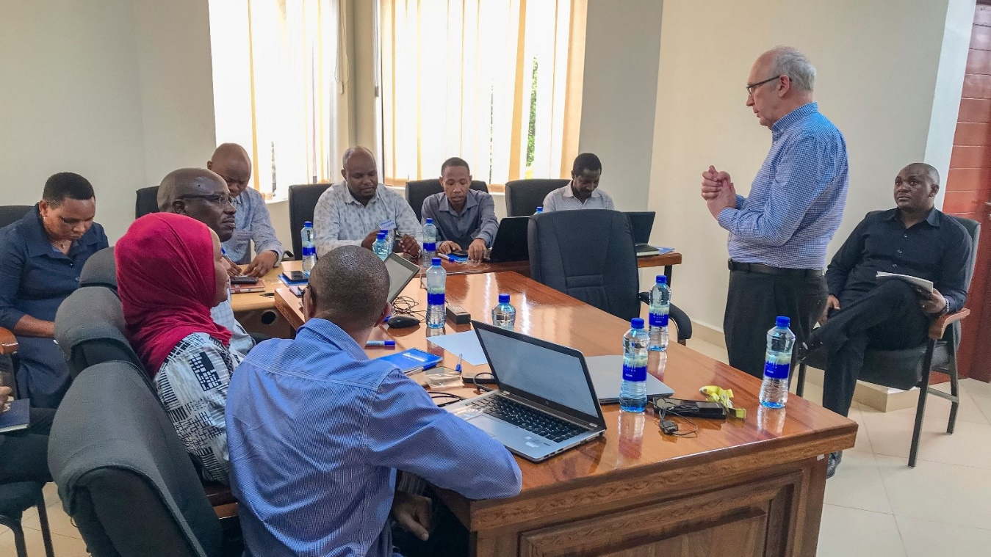

Criteria

Statistical Leadership Train the Trainer Project – EASTC

At the ninth meeting of the Statistical Commission for Africa, held in Addis Ababa in October 2024, there was encouragement to provide more training of trainers in statistical leadership, so that the programme could be offered more widely. In particular, Tanzania National Bureau of Statistics (NBS) and the East African Statistical Training Centre (EASTC) put themselves forward to collaborate with ONS/UNECA on the statistical leadership programme. ONS has subsequently been scoping the option of working with EASTC and NBS to develop a train the trainer programme.

There are two elements to this project:
- Introducing elements of statistical leadership into existing and future courses offered by EASTC
- Training staff from EASTC and NBS to deliver the statistical leadership (SLP) and women into leadership (WiL) courses to NSOs

- Support for EASTC existing and future statistical leadership courses

EASTC is the regional Statistical Training Centre for Anglophone Africa and currently serves 19 member countries (Tanzania, Botswana, Eritrea, Eswatini, Ethiopia, Kenya, Lesotho, Malawi, Mauritius, Namibia, Seychelles, Somalia, South Africa, South Sudan, Sudan, The Gambia, Uganda, Zambia and Zimbabwe). There are a series of existing undergraduate (Bachelor of Business Statistics and Economics and Bachelor of Agricultural Statistics and Economics) and post-graduate (Masters in Official Statistics) academic statistical programmes that can be enhanced by adding a comprehensive leadership skills element. ONS would supply expertise to support the redesign of existing statistical programmes to become practical statistical leadership programmes. ONS would also coach and support EASTC training staff to develop the knowledge and skills to deliver these new modules in an interactive and practical manner. EASTC staff will develop confidence in using a more interactive and facilitative style rather than lecturing when delivering the training.

This will involve selecting a group of trainers and developing their skills and understanding of the materials. This will principally be a face-to-face exercise with a number of short (3 day) train-the-trainer programmes as well as online coaching and training sessions.

Report
I have been in discussion with Eastern Africa Statistical Training Centre (EASTC) for a few months. We have been exploring how we can work together and if it would be possible to hand over the leadership training programmes when ONS ceases to be involved.
I have been in contact with Dr. Joyce Minja and it was decided to hold a Training for Trainer event in March with attendees from EASTC and interested parties form Tanzania National Bureau of Statistics.
The course was delivered over 2 days with a further 2 days individual coaching between Dr. Joyce Minja and me and meetings with other EASTC staff regarding potential transfer of the programme to EASTC in 2026.
For the initial training course there were 17 attendees (15 from EASTC and 2 from Tanzania NBS). The course was delivered by me in EASTC offices, Dar Es Salaam.
Training for trainers
The course was designed to be very interactive with participants having the opportunity to deliver some training themselves and receive feedback.
The programme was evaluated informally between me and Joyce Minja.
There were 2 aspects of the feedback:
- The evaluation of the programme feedback was that people enjoyed it. They felt they learnt a great deal about how to give better presentations. They thought the ‘tips’ I gave were very useful. Some people really liked the MBTI aspects – a few didn’t.
They all felt this could be very useful in the future – not just to help with any training they had to deliver on ‘softer’ skills, but also tips they can use in their statistical training.
- Joyce and I identified 5 candidates we believed may be able to deliver leadership training with more coaching.
We agreed that I would return in a few months to deliver a more intensive training programme focusing on these people in the context of the leadership programme.

Coaching
This follow up programme was delivered from 13th May to 16th May 2025 in EASTC training centre in Dar Es Salaam.
The follow up programme was delivered to 5 selected participants. The training entailed some additional theory, a run through of some of the sessions from the Leadership training course and some 1:1 coaching.
During the programme each attendee delivered a session to a small group of people from EASTC – students, administrative staff, etc.. The participants received feedback on their session immediately after they delivered it.

Joyce and I evaluated the training as a whole and felt it met the goals we had set. We also identified 3 trainers we felt would be able to deliver Statistical Leadership Training in 2026 – with some coaching and a training plan.

Timetables

training for trainers 1
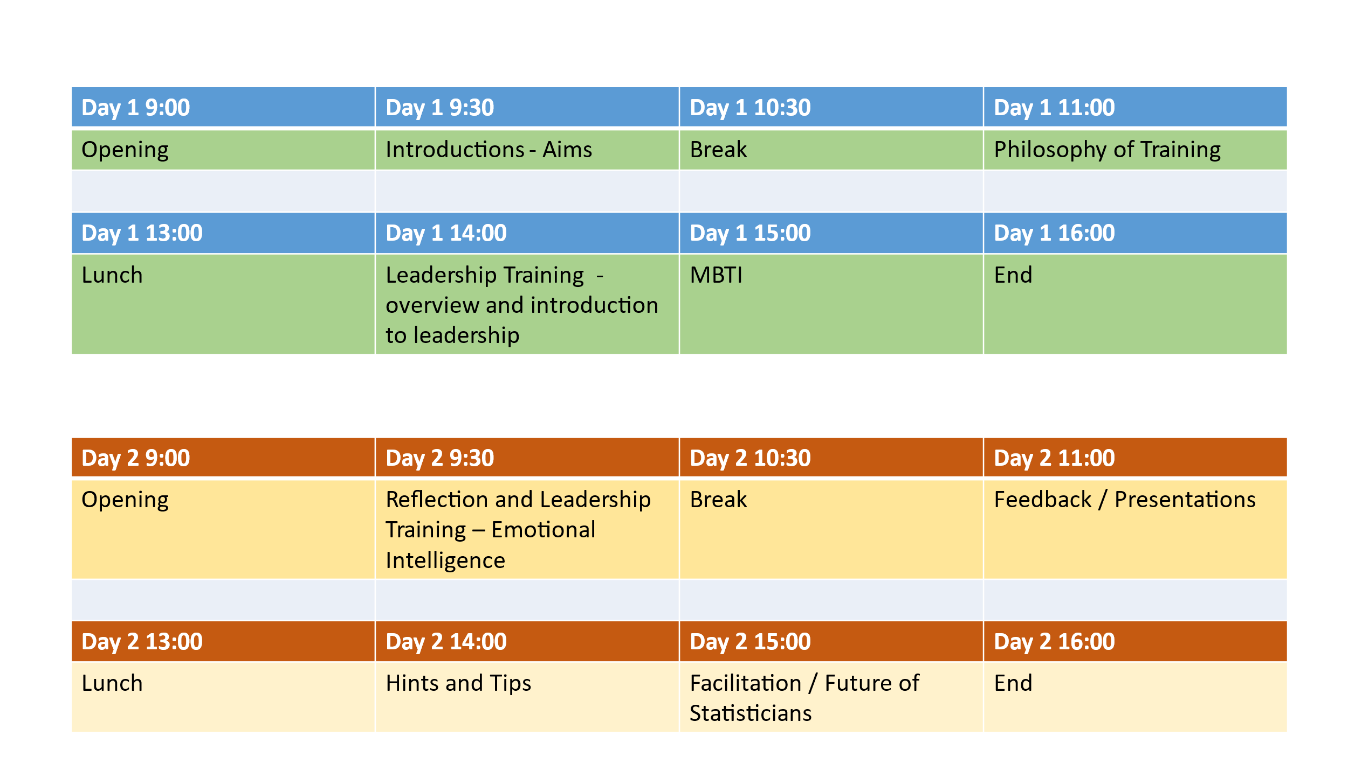

Coaching 1

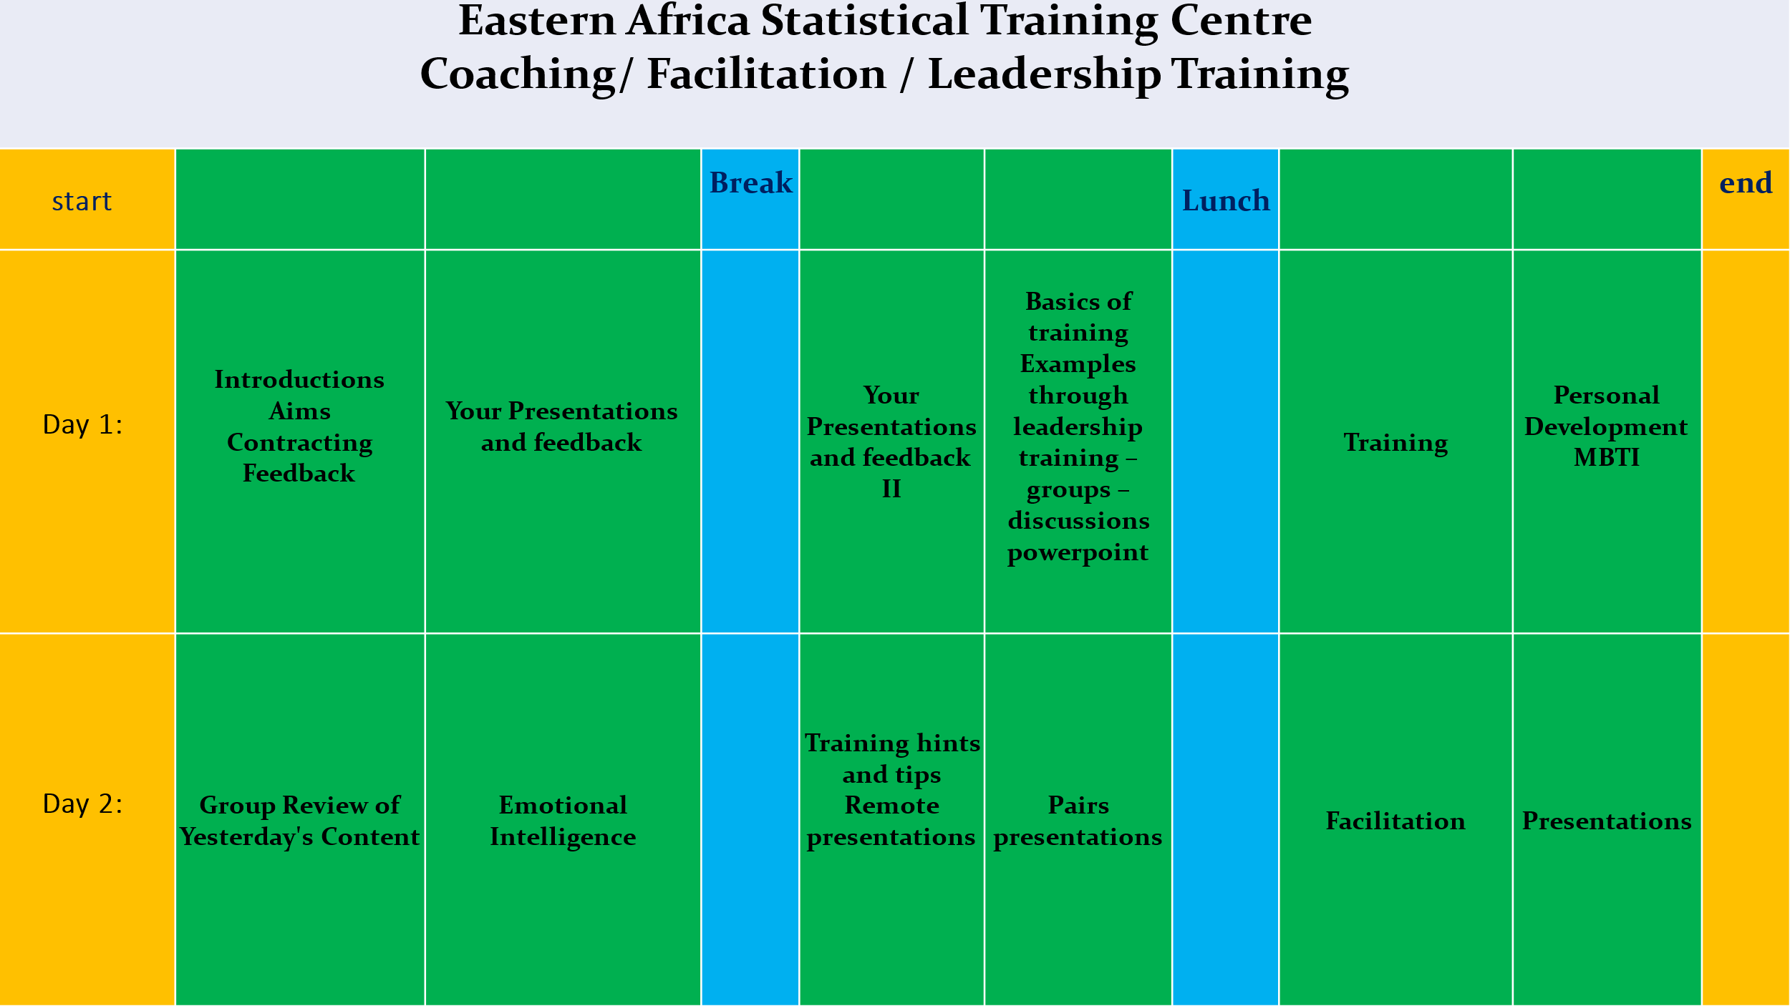
Attendees

Training for trainers 1
EASTC List of Statistical Leadership TOT participants
Name | Email
Joyce J. Minja | joyce.minja@eastc.ac.tz
Sospeter Muchunguzi | sospeter.muchunguzi@eastc.ac.tz
Judicate Selenya | judicate.selenya@eastc.ac.tz
Eusebius Mwisongo | eusebius.mwisongo@eastc.ac.tz
Samuel Marandu | samuel.marandu@eastc.ac.tz
Rehema Mizimbiri | rehema.mzimbiri@eastc.ac.tz
Benjamine Miku | benjamine.miku@eastc.ac.tz
Emanuel Sulle | emanuel.joseph@eastc.ac.tz
Nyambilila Minga | nyambilila.minga@eastc.ac.tz
Donata Kemirembe | donata.kemirembe@eastc.ac.tz
Godfrey Saga | godfrey.saga@eastc.ac.tz
Bernada Sianga | bernada.sianga@eastc.ac.tz
Leguma Bakari | leguma.bakari@eastc.ac.tz
Edwin Magoti | edwin.magoti@eastc.ac.tz
Elisante Heriel | elisante.hayuma@eastc.ac.tz
Phausta Ntigiti | phausta.ntigiti@nbs.go.tz
Pastor Ulimali | pastor.ulimali@nbs.go.tz

Coaching 1

Name | Email
Joyce J. Minja | joyce.minja@eastc.ac.tz
Sospeter Muchunguzi | sospeter.muchunguzi@eastc.ac.tz
Judicate Selenya | judicate.selenya@eastc.ac.tz
Eusebius Mwisongo | eusebius.mwisongo@eastc.ac.tz
Donata Kemirembe | donata.kemirembe@eastc.ac.tz

