Training for Trainers

EASTC TANZANIA

Dar Es Salaam 25 August – 3 September 2025
Content
- Criteria
- Report Update August / September
- Draft work plan

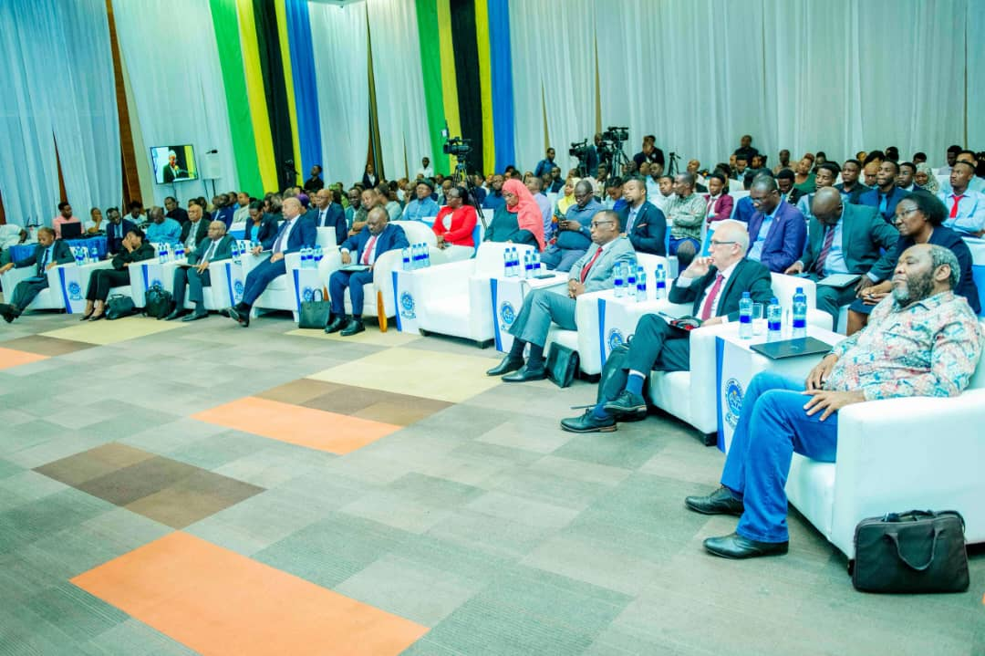

Criteria

Statistical Leadership Train the Trainer Project – EASTC

At the ninth meeting of the Statistical Commission for Africa, held in Addis Ababa in October 2024, there was encouragement to provide more training of trainers in statistical leadership, so that the programme could be offered more widely. In particular, Tanzania National Bureau of Statistics (NBS) and the East African Statistical Training Centre (EASTC) put themselves forward to collaborate with ONS/UNECA on the statistical leadership programme. ONS has subsequently been scoping the option of working with EASTC and NBS to develop a train the trainer programme.

There are two elements to this project:
- Introducing elements of statistical leadership into existing and future courses offered by EASTC
- Training staff from EASTC and NBS to deliver the statistical leadership (SLP) and women into leadership (WiL) courses to NSOs

- Support for EASTC existing and future statistical leadership courses

EASTC is the regional Statistical Training Centre for Anglophone Africa and currently serves 19 member countries (Tanzania, Botswana, Eritrea, Eswatini, Ethiopia, Kenya, Lesotho, Malawi, Mauritius, Namibia, Seychelles, Somalia, South Africa, South Sudan, Sudan, The Gambia, Uganda, Zambia and Zimbabwe). There are a series of existing undergraduate (Bachelor of Business Statistics and Economics and Bachelor of Agricultural Statistics and Economics) and post-graduate (Masters in Official Statistics) academic statistical programmes that can be enhanced by adding a comprehensive leadership skills element. ONS would supply expertise to support the redesign of existing statistical programmes to become practical statistical leadership programmes. ONS would also coach and support EASTC training staff to develop the knowledge and skills to deliver these new modules in an interactive and practical manner. EASTC staff will develop confidence in using a more interactive and facilitative style rather than lecturing when delivering the training.

This will involve selecting a group of trainers and developing their skills and understanding of the materials. This will principally be a face-to-face exercise with a number of short (3 day) train-the-trainer programmes as well as online coaching and training sessions.

Report
For most of the time I was in Tanzania I was working with EASTC at their offices.
I met a number of different people to discuss the handing over processes from our training programmes before April next year:
They are looking to update a number of their courses to include leadership training so I helped with the design and will follow up with them in November.

Update EASTC Official Statistics Curriculum
I met with a number of EASTC senior leaders over the first 2 days. They are looking to update a number of their courses to include leadership training so I helped with the design and will follow up with them in November.

Transfer of eLearning and Communication
I met with the communications and IT teams at EASTC to discuss how we would manage the transfer of the programme. We will look to arrange meetings with Clare Lowndes and Bex Jakeway (ONS) with their teams to construct a timetable for moving this forward.
Bex is also keen to agree a timetable to communication and branding with EASTC that will allow a smooth handover.

Coaching
I worked with Joyce Minja and Donata Kemirembe on the women into leadership training programme.
I spent a day with them discussing the content and giving feedback then we delivered 2 days of the programme to a selected group of EASTC employees.
The programme went well and Joyce and Donata had a good feel for the programme and what we are trying top achieve. We will look to deliver a full programme for EASTC employees / students in November.

60th anniversary events
I helped with EASTC 60th anniversary events –
- I was keynote speaker at end EASTC ran for the media explaining how statistics could / should be used when reporting. This was very well attended and had excellent feedback.
- I presented a paper at the anniversary event with a number of guests. This was a great occasion and good opportunity to network and discuss the plans for the leadership training in the future.

Workplan for handover

