ECA support to Developing capacities in the use of Statistical Data and Metadata Exchange (SDMX) Tools, Open Data Platform 2.0 and Open SDGs platform

In Country Retreat on the Open SDG Data Portal Workshop, Nakuru - Kenya, 28 – 30 July 2025

Workshop Report

July 31, 2025

Contents
1. Background 2
2. Activities of the mission 2
Retreat on the Open SDG Data Portal Workshop, Nakuru – Kenya, 28 – 30 June 2025 2
Technical and Institutional Focus 2
National Context and Progress 3
Dissemination and Standardization 3
Implementation of the Open SDG Platform 3
Coordination and Data Validation 3
Alignment with National and Regional Agendas 4
Platform Functionality and User Engagement 4
3. Conclusions and way forward 4
Key recommendations emphasized: 4
4. Annexes 5
5.1. Agenda of the mission 5
5.2. Opening and Welcome Remarks delivered at the in-country Retreat on the Open SDG Data Portal Workshop. 6
5.3. Evaluation of the Training Workshop on SDMX, Open Data Platform 2.0, and Open SDGs Tools: Nairobi – Kenya 7
5.4. List of participants at the In Country Retreat on the Open SDG Data Portal Workshop, Kadoma - Zimbabwe, 2 – 6 June 2025 8
5.5. Pictorial of the Mission: In Country Retreat on the Open SDG Data Portal Workshop, Kadoma - Zimbabwe, 2 – 6 June 2025 0
5.6. Presentations delivered during the training workshop. 1

Background

The United Nations Economic Commission for Africa (ECA) in partnership with the Kenya National Bureau of Statistics (KNBS) undertook a three-day mission in Nakuru – Kenya to develop a comprehensive user guide for the SDG platform. Following the development of Kenya’s SDG Platform and presentation to the SDG secretariat, there is a recognized need for a comprehensive user guide to maximize its potential use. A well-structured guide to improve users’ understanding of the platform, facilitate effective navigation of its tools and resources, and encourage adoption by a wide range of stakeholders, including government institutions, civil society organizations, development partners, and researchers. The purpose of the guide is to introduce the platform, outline its key features and functionalities, and offer step-by-step instructions on essential actions such as registration, data access and interpretation, reporting, progress visualization, and stakeholder engagement. It includes frequently asked questions (FAQs), troubleshooting guidance, and support contact information to ensure smooth and efficient use of the platform.
The mission team comprised:
- Angela Kiconco, and
- Yared Bekele
This report summarizes the mission activities and articulates recommendations.

Activities of the mission

Retreat on the Open SDG Data Portal Workshop, Nakuru – Kenya, 28 – 30 June 2025
The specific objectives of the workshop were to:
- Develop a comprehensive user guide for the SDG Platform.
- Support diverse users in navigating the platform effectively.
- Enable users to access SDG-related data with ease.
- Facilitate monitoring of progress toward the SDGs.
- Encourage contributions to the achievement of the 2030 Agenda.
The workshop was officially opened by representatives from the United Nations Economic Commission for Africa (ECA)- Angela Kiconco, Statistician and the Kenya National Bureau of Statistics (KNBS) - Benjamin Avusevwa, Director for Statistical Coordination and Methods. In their opening remarks, they emphasized the importance of enhancing data quality and accessibility for monitoring the SDGs and Agenda 2063, while leveraging the Open SDG platform to promote transparency and accountability.
Specifically, the KNBS representative emphasized the critical need to correct the disconnect between the Global and National reporting in SDG for instance, the increase in the number of SDG indicators data in Kenya is not reflected in the Global SDG database. He indicated that KNBS’ budget is funded under the development budget which is prune to unforeseen cuts compared to the recurrent He also emphasized the need for making the interactive Open SDG platform easily usable hence the retreat – adding that creating awareness of the platform is as important as its use. He called on ECA to continually support KNBS’ capacity building efforts especially now that more Data Scientists have been on-boarded.
The workshop focused on technical and institutional aspects of SDG data reporting and dissemination through the Open SDG Platform. Participants highlighted the importance of reliable and disaggregated data to track progress toward the 17 SDGs and 169 related targets. The discussions emphasized that while some progress has been made at both the continental and national levels, challenges remain, including data gaps, inconsistent reporting, and the need for harmonized methodologies. Policymakers were urged to pay close attention to areas of regression, particularly in goals related to affordable energy, sustainable cities, environmental protection, and governance.

Technical and Institutional Focus
The discussions centred on the technical and institutional aspects of SDG data reporting and dissemination through the Open SDG Platform. Participants highlighted the importance of reliable and disaggregated data for tracking progress toward the 17 SDGs and 169 related targets. While progress has been made both continentally and nationally, key challenges remain, including data gaps, inconsistent reporting, and the need for harmonized methodologies. Policymakers were urged to address areas of regression, particularly in goals linked to affordable energy, sustainable cities, environmental protection, and governance.

National Context and Progress
The Kenya National Bureau of Statistics (KNBS) presented on the country’s progress in implementing the SDG platform. Kenya has made improvements in data availability and openness, moving upward in global rankings of statistical capacity. However, participants acknowledged persistent challenges such as insufficient integration of administrative data, reliance on outdated formats like Excel, and delays in ensuring timely updates. The platform was recognized as a valuable tool to increase accessibility, transparency, and stakeholder engagement, but greater investment in standardization, automation, and institutional coordination is required to maximize its benefits.

Dissemination and Standardization
A key theme was the role of dissemination strategies in ensuring that data reaches users in meaningful and usable formats. KNBS shared its efforts to strengthen dissemination through workshops, websites, social media, and official reports. At the same time, the importance of aligning dissemination with clear policies, standardized templates, and metadata guidelines was emphasized. Participants noted that siloed approaches among government departments often hinder harmonization, underscoring the need for stronger coordination across ministries and agencies.

Implementation of the Open SDG Platform
The session also included a technical demonstration of the Open SDG platform and its functionalities. Participants learned about the structure of repositories, data submission processes, and the role of metadata in ensuring quality reporting. The Open SDG platform was presented as a collaborative, open-source solution supported by UNECA, AfDB, and other partners. Its adoption offers Kenya and other countries a standardized approach to reporting SDG progress while promoting transparency and interoperability with global systems.

Coordination and Data Validation
The afternoon session focused on coordination mechanisms for SDG reporting and the importance of validated, country-owned data. Participants discussed the need for better engagement between the Kenya National Bureau of Statistics (KNBS), ministries, departments, and agencies (MDAs) to ensure clear identification of data providers and avoid duplication. It was emphasized that data must be validated at the national level before submission to global platforms, reinforcing the principle that countries should maintain ownership and accountability for their official statistics. Challenges highlighted included delays in obtaining administrative data, difficulties in harmonizing sectoral information, and limited agreements on accessing micro-level datasets.

Alignment with National and Regional Agendas
Participants also stressed the need to align SDG indicators with Kenya’s Vision 2030, Africa’s Agenda 2063, and the Second Ten-Year Implementation Plan (2024–2033). Harmonization across these frameworks would strengthen policy integration, monitoring, and investment prioritization. The use of tools such as UNECA’s Integrated Planning and Reporting Tool (IPRT) was highlighted to streamline reporting across multiple agendas.

Platform Functionality and User Engagement
The platform demonstration showcased features such as indicator dashboards, metadata pages, reporting status, publications, and FAQs. Suggestions for improvement included updating branding, adding direct links to publications, expanding reporting categories, and better integrating administrative data sources. Multilingual support, including Swahili and Portuguese, was also discussed to improve accessibility.
Participants underscored the importance of user engagement strategies to meet the needs of policymakers, researchers, media, and the public. Recommendations included user satisfaction surveys, web analytics, and structured feedback mechanisms. The role of dissemination policies and standardized templates was highlighted to ensure consistent publication of survey and administrative data.

Conclusions and way forward
In conclusion, participants agreed on the need to finalize guidelines supporting SDG data and metadata reporting in Kenya. Priority areas include strengthening dissemination policies, enhancing metadata systems, building institutional capacities, and better integrating administrative and survey data.

Key recommendations emphasized:
- Strengthening coordination among KNBS and MDAs for reliable data sharing.
- Aligning SDG reporting with national and continental frameworks.
- Enhancing the Open SDG platform with improved features, multilingual support, and expanded data sources.
- Establishing user engagement strategies and ensuring continuous updates.
- Promoting a culture of openness, accountability, and capacity building in national institutions.

Annexes

Agenda of the mission
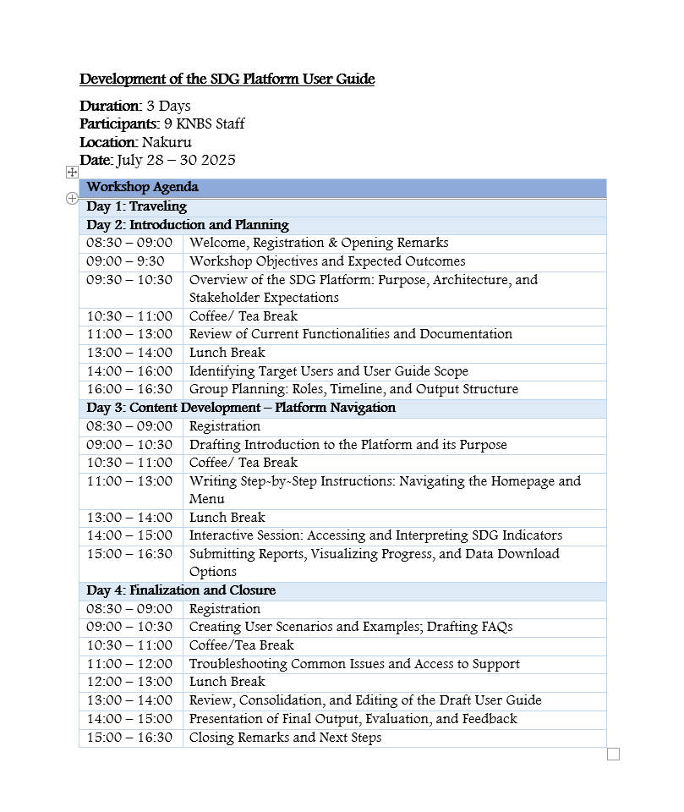
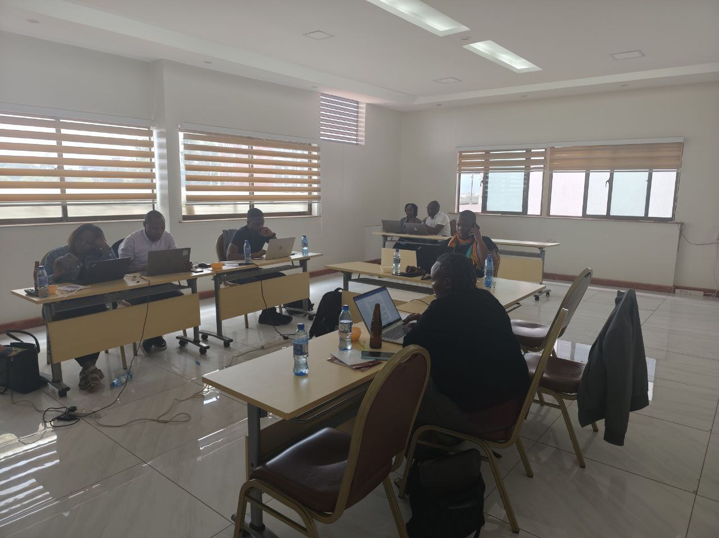

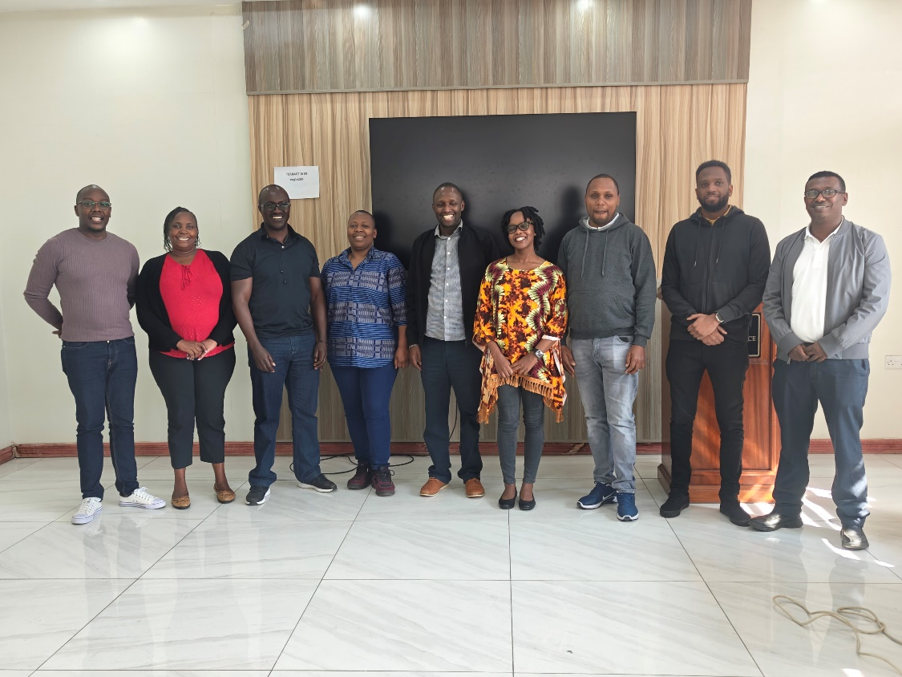

Evaluation of the Kenya In-Country Workshop: Nakuru – Kenya
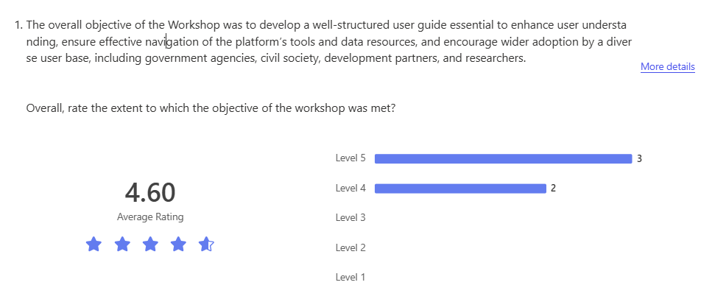
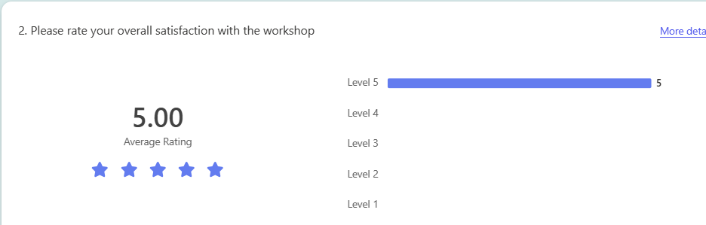

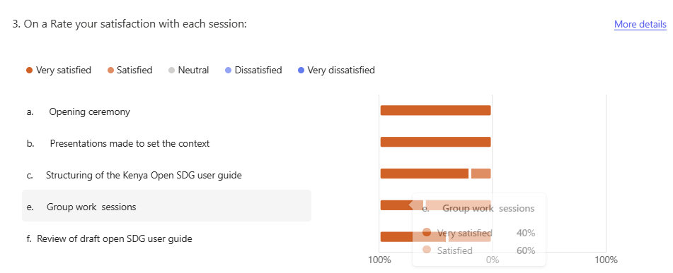
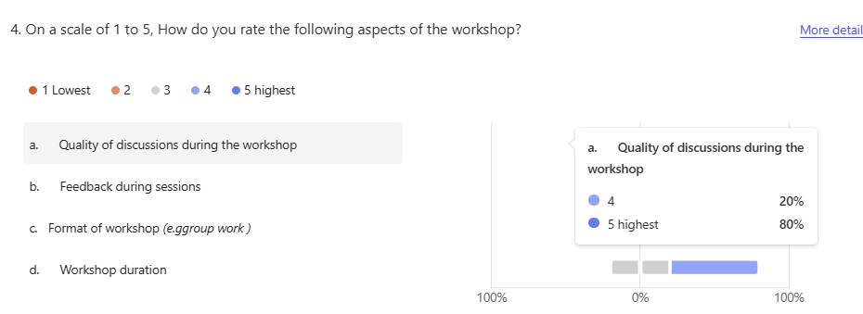
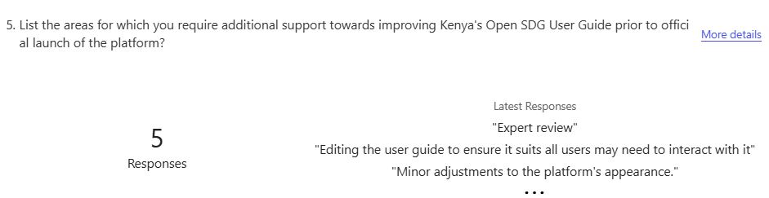
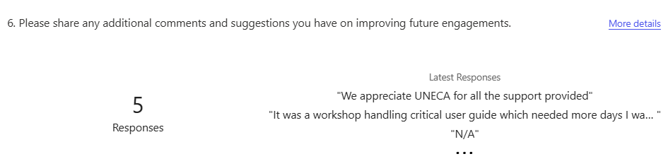

List of participants at the In Country Retreat, Nakuru – Kenya

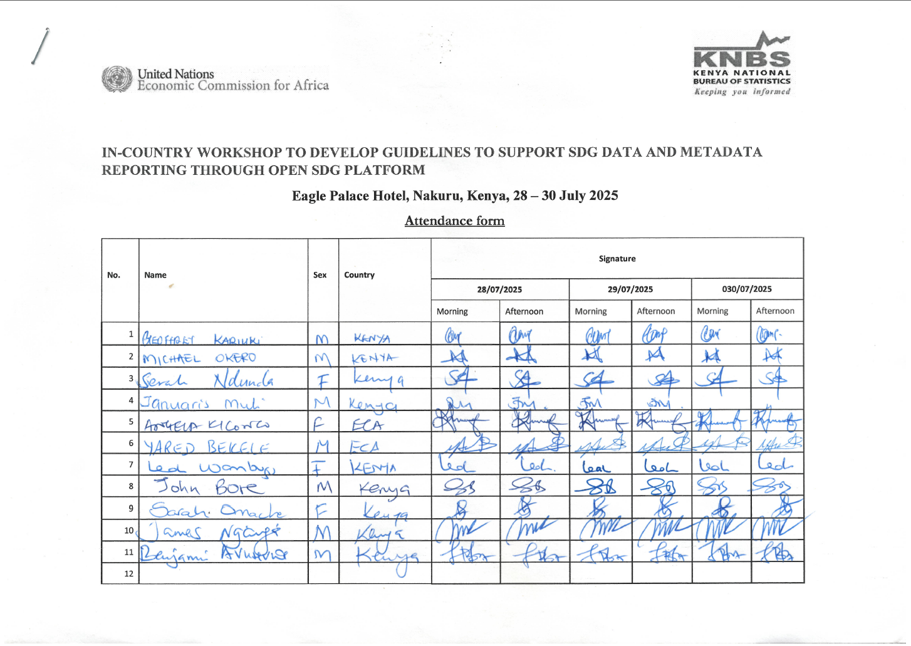

Pictorial of the Mission: In Country Workshop to develop a user guide for the Kenya Open SDG Data Platform, Nakuru - Kenya, 28 – 30 July 2025
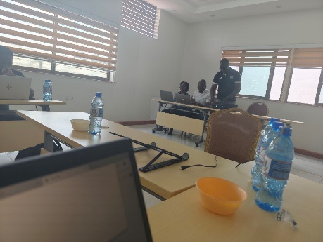 | 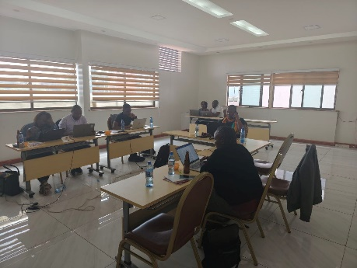 | 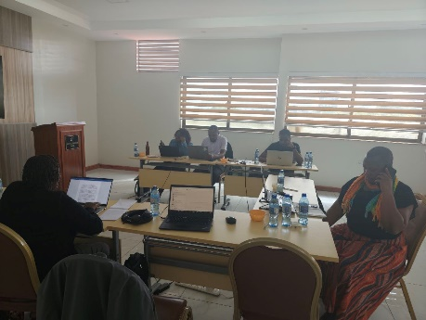
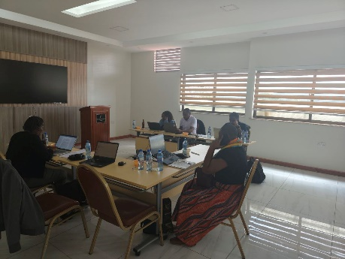 | 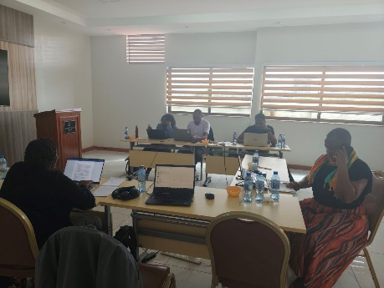 | 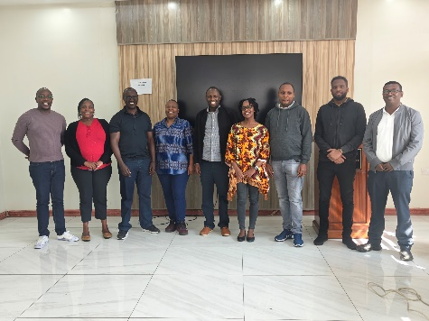

Presentations delivered during the training workshop.
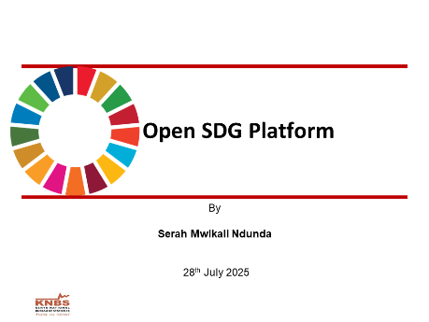 | 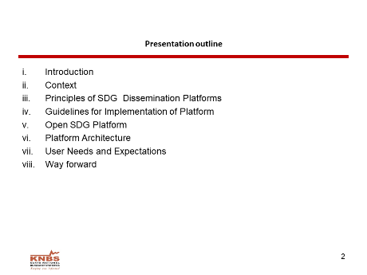 | 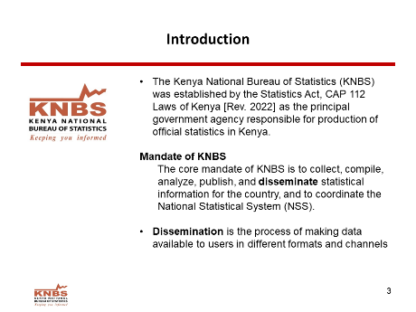
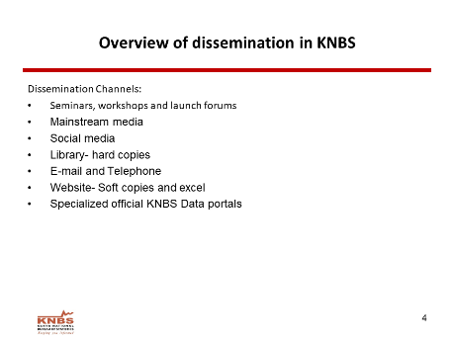 | 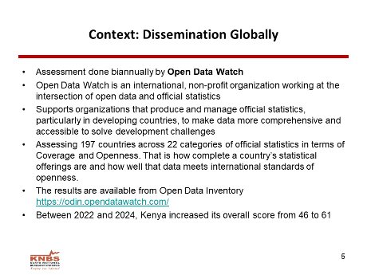 | 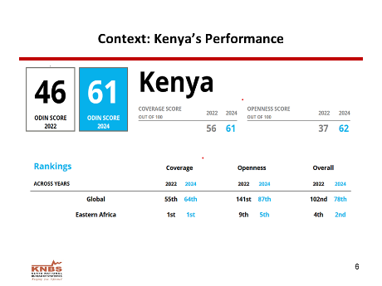
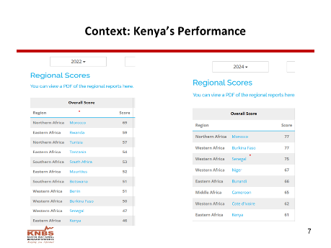 | 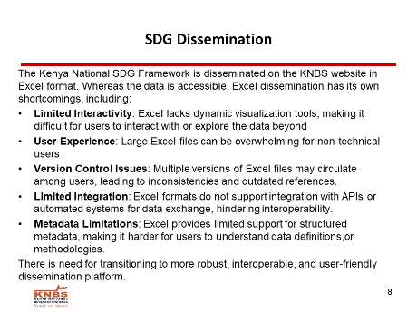 | 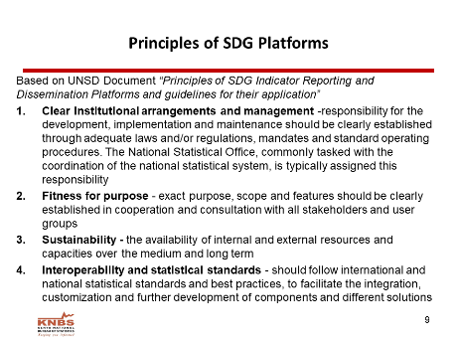
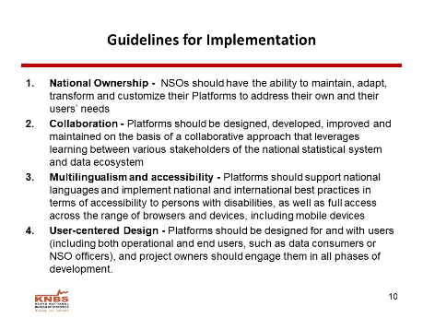 | 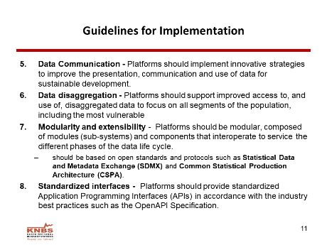 | 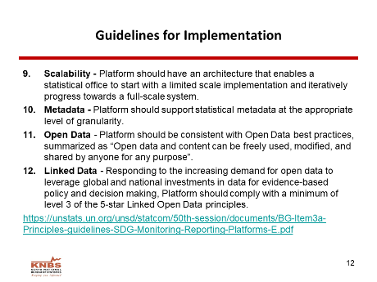
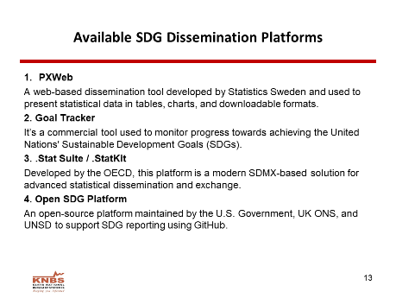 | 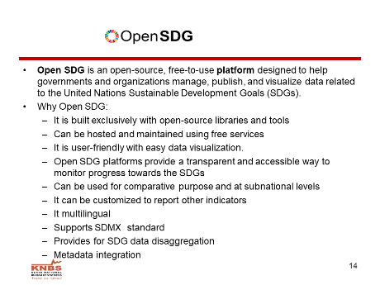 | 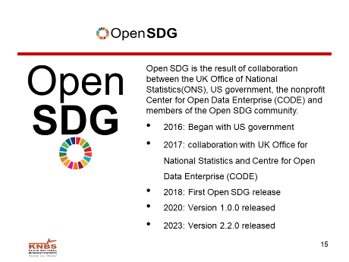
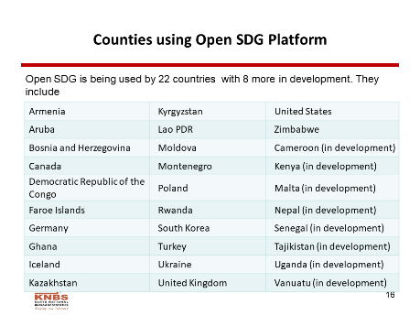 | 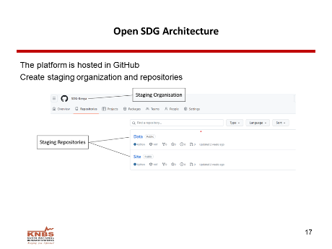 | 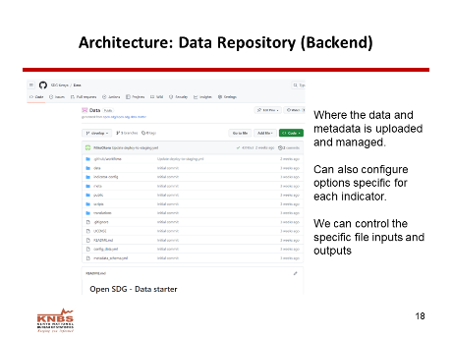
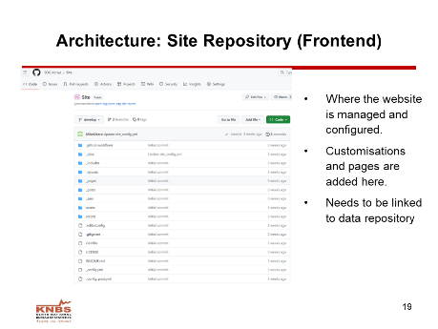 | 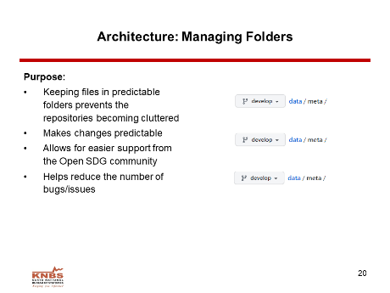 | 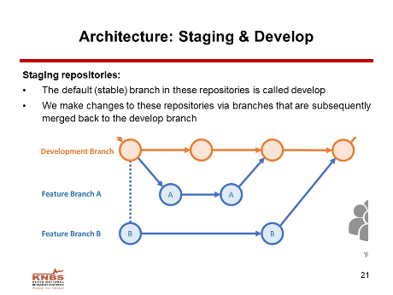
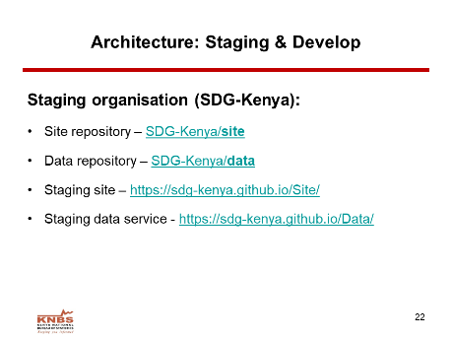 | 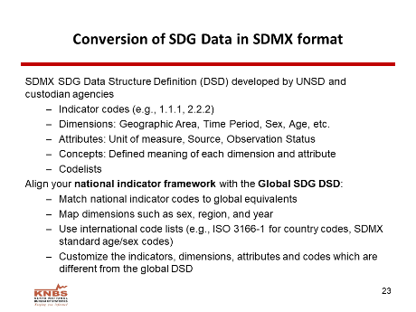 | 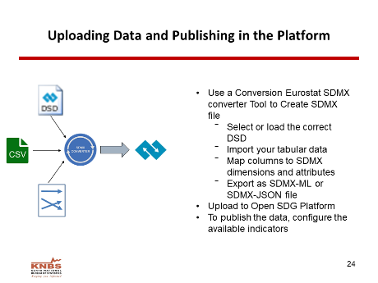
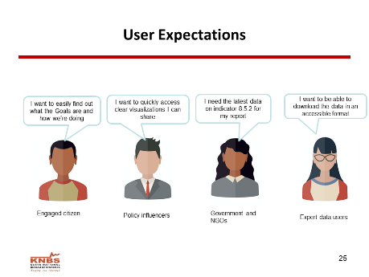 | 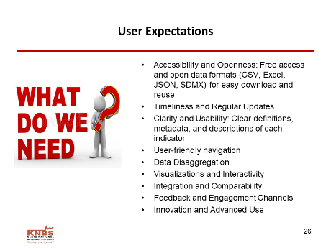 | 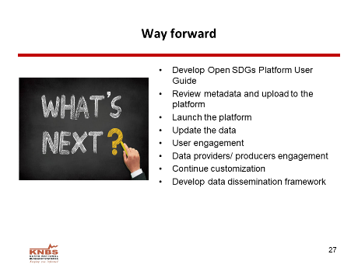

 | 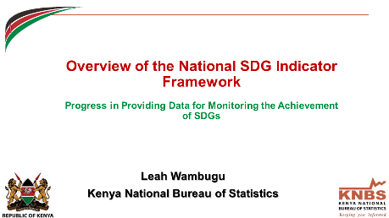 | 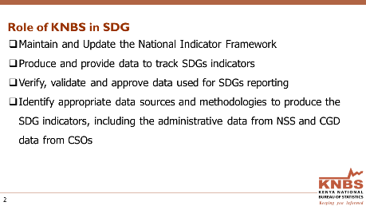
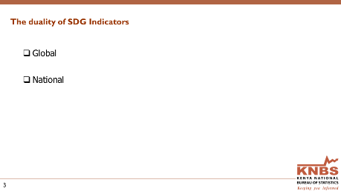 | 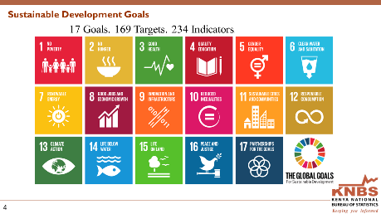 | 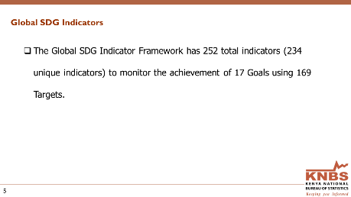
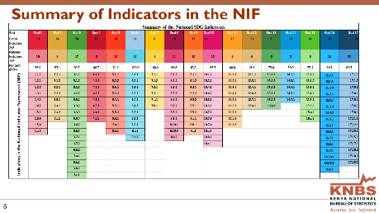 | 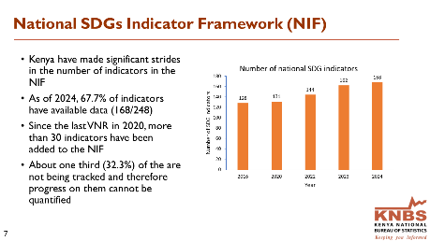 | 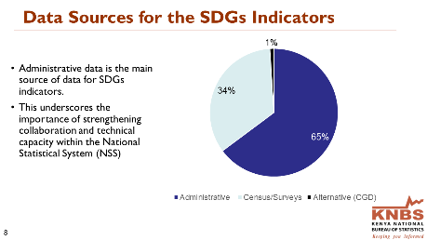
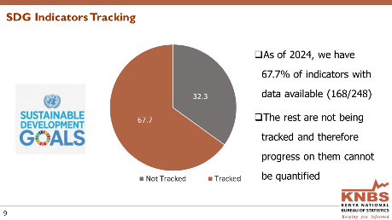 | 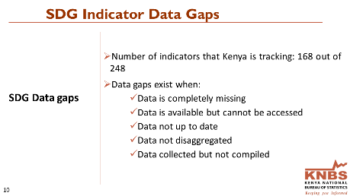 | 