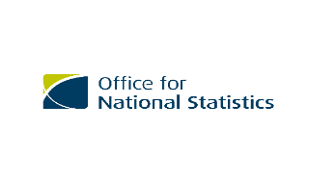




United Nations Regional EGM on the 2030 World Programme on Population and Housing Censuses in Africa: International Standards and Innovative Approaches
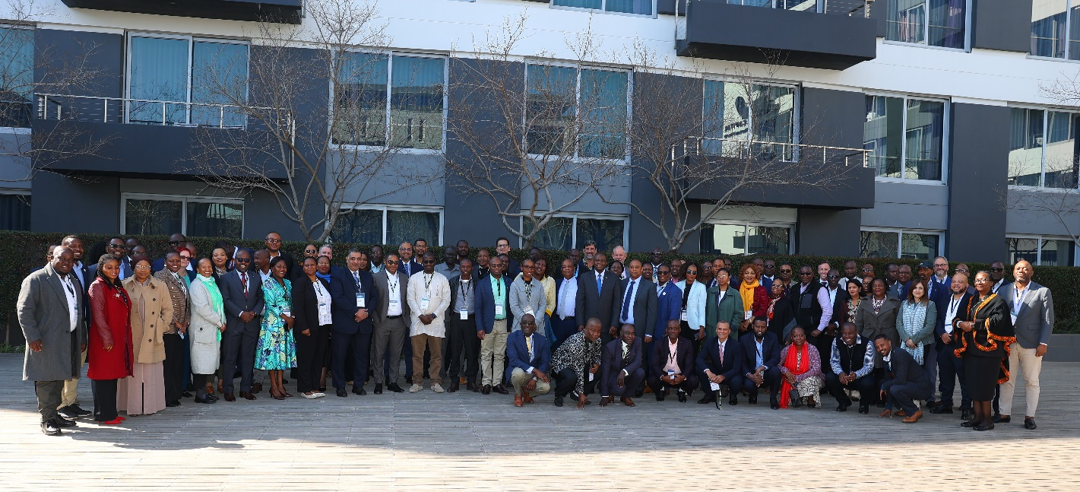

4th- 8th August 2025, Pretoria-South Africa

Contents
Abbreviations and Acronyms 3
1. Background 4
2. Meeting objectives 4
3. Overall Participant profile 5
4. Opening session 5
5. Meeting Proceedings 8
6. Meeting outcomes 11
7. Recommendations 12
8. Closing Session 15
9. Results from Evaluation Survey 18
a) Participant Profile 18
b) Impact of the EGM 18
c) Quality of the Content and Materials for the EGM 20
d) Quality of individual presentations 22
e) Value of the EGM 23
f) Planning and Logistics 25
g) Lessons Learnt 27
10. Program of work 29
11. Photo gallery 33

Abbreviations and Acronyms

ACCC Africa Census Coordination Committee
AfDB African Development Bank
AI Artificial Intelligence
APAI-CRVS Africa Programme on Accelerated Improvement for Civil Registration and Vital Statistics
BYOD Bring Your Own Device
CATI Computer Assisted Telephone Interviews
CAPI Computer Assisted Personal Interviews
CAWI Computer Assisted Web Interviews
COVID-19 Coronavirus disease 2019
CRVS Civil Registration and Vital Statistics
EA Enumeration Area
EGM Expert Group Meeting
GIS Geo Information System
NSO National statistical office
ONS-UK Office of National Statistics of the United Kingdom
PAPI Paper Assisted Personal Interviews
PHC Population and Housing Census
P&R Principles and Recommendation
SDGs Sustainable Development Goals
UN United Nations
UNECA United Nations Economic Commission for Africa
UNSC United Nations Statistical Commission
UNSD United Nations Statistics Division
UNFPA United Nations Population Fund

Background
Population and housing censuses are primary sources of data on a nation’s population and socio-economic characteristics. The 9th Africa Statistical Commission, held in Addis Ababa- Ethiopia in October 2024 urged and committed all African countries to undertake a population and housing census during the 2030 Round. The commission also recommended that the Africa Census Programme for the 2030 Round covering the period 2025 to 2034 should be developed. Hence, the formation of the Africa Census Coordination Committee was endorsed.
At the 56th session of the United Nations Statistical Commission (UNSC) the 2030 World Population and Housing Census Programme was endorsed, which comprises several activities aimed at ensuring that countries conduct at least one population and housing census or otherwise produce population and socioeconomic statistics at the small area level during the period from 2025 to 2034 and calls for fully fledged support for the Programme.
To prepare for the 2030 round, the United Nations Statistics Division (UNSD) has revised its primary international census standards: the Principles and Recommendations for Population and Housing Censuses (Revision 4). This revision updates the previous version (Revision 3) to reflect current best practices in census planning, organization, conduct, and utilization. It addresses key areas such as administrative data use, geospatial integration, contingency planning, and quality assurance. The revised Principles and Recommendations (P&R rev4), endorsed by the 56th UNSC, emphasize the importance of censuses for achieving development goals and promote modern practices, including georeferencing and administrative data use. They also stress quality standards and timely data dissemination. The P&R rev4 provides global guidance for planning and conducting national Population and Housing Censuses during the 2030 Census Round, considering different regional contexts and the diversity of statistical capacity across nations.
The African Centre for Statistics of the United Nations Economic Commission for Africa (UNECA), in partnership with Statistics South Africa (StatsSA), UNFPA, the Office of National Statistics of the United Kingdom (ONS-UK) and United Nations Statistics Division (UNSD) organized a regional Expert Group Meeting (EGM) for all Anglophone and some Lusophone government agencies responsible for undertaking Population and Housing Censuses (PHCs) in Africa. This was a hybrid meeting that took place from 4th to 8th August 2025 in Pretoria, South Africa.
The year 2025 marks the start of the 2030 Census Round and the EGM was used to launch this round as well as present the latest version of the UN Principles and Recommendations for Population and Housing Censuses, as well as to provide an opportunity for discussion on innovative technologies and methodologies that may be used in the 2030 round.

Meeting objectives
The EGM aimed to prepare census managers for the successful planning and implementation of their censuses the revised international guidelines for the 2030 round of population and housing censuses. The EGM also served as a platform to exchange national experiences and practices in census activities, including challenges and innovations in census undertakings.
The core objectives of the EGM were to:
- Foster a common understanding of the revised international standards and global trends:
- To provide an overview of the relevant international guidelines, standards and methodologies available to support African countries in the 2030 census round.
- To achieve a common understanding of updated international recommendations for censuses and discuss how these apply in the African context.
- To highlight recent developments and trends in global census taking and opportunities for adoption in the 2030 round.
- To present the reference materials, technical resources and tools that have been developed to support census activities in Africa.
- Enhance technical implementation skills:
- To improve participants' technical skills in applying the revised guidelines.
- To provide training on new aspects of the P&R including geospatial data integration, administrative record usage, new core topics, contingency planning, quality assurance frameworks, and communication/dissemination strategies.
- Facilitate knowledge sharing and collaboration:
- To share best practices and lessons learned from recent national and international censuses.
- To identify anticipated challenges and develop collaborative strategies for the 2030 round.
- To discuss the necessary enhancements required to implement P&R Rev 4 in the 2030 round and develop plans for the inclusion of the new topics.
- Review and validate the identified areas of expertise that could potentially be called upon in future to provide technical assistance to African countries as part of the digital census development process through south-south cooperation.
- Discuss innovations and opportunities:
- To examine opportunities for how census implementing agencies can prepare for a future administrative data-based census in the 2030 round.
- To deliberate on innovations and adaptations to census methodology that have the potential to save time, financial resources and/or improve quality.

Overall Participant profile
The meeting was attended in person by 109 participants. Delegates from 26 African countries attended, as well as representatives from UNECA, ONS-UK, UNFPA, East African Community (EAC) secretariat, African Development Bank (AfDB), IGAD and World Pop.
The meeting was made hybrid and there was also a good on-line attendance, making an additional 105 people to participate online for sessions of their choice.
Twenty-six African countries were represented from the National statistics office or census implementing agency and the UNFPA country offices. The countries included Angola, Botswana, Egypt, Eswatini, The Gambia, Ghana, Kenya, Lesotho, Liberia, Libya, Malawi, Mauritius, Mozambique, Nigeria, Namibia, Sierra Leone, Somalia, South Africa, South Sudan, Tanzania, Zambia, Zimbabwe, Senegal, Burundi, Djibouti, and Sudan.

Opening session
Remarks by Mr. Garnett Compton, ONS-UK
Mr. Compton emphasized the importance of transparency and strategic decision-making in conducting a successful census during these challenging times. He underscored the need to openly acknowledge the trade-offs involved and encouraged embracing innovation and efficiency to seize emerging opportunities. Honesty about the compromises required is essential to achieving meaningful outcomes. He further highlighted the value of mutual learning, noting the wealth of experience present in the room. For Mr. Compton personally, this year marked his 29th year of involvement in census operations—a testament to his deep expertise in the field. Looking ahead, he shared that the United Kingdom is currently preparing for its next census in 2031 and expressed keen interest in learning from the insights and experiences shared during this meeting.
Remarks by Mr. Seiffe Tadesse, UNSD
Mr. Seiffe noted that the EGM is an official launch of the 2030 World Population and Housing Census Programme in Africa, initiating a five-day engagement to prepare for the upcoming census round. He reaffirmed that the programme emphasizes the adoption of international standards and innovative methodologies to enhance census outcomes across the continent. He emphasized that censuses remain a cornerstone of national statistical systems, providing granular demographic and socio-economic data critical for policymaking, resource allocation, and tracking progress toward the 2030 Sustainable Development Goals (SDG).
Reflecting on the 2020 census round, he acknowledged the challenges posed by the COVID-19 pandemic, which catalyzed technological advancements such as CAPI and CAWI, and increased use of administrative and geospatial data. These developments underscored the importance of contingency planning and methodological adaptability.
He highlighted that in preparation for 2030, the UNSD, with input from Egypt, Kenya, South Africa, and Tanzania, revised the global census standards now published as the Principles and Recommendations for Population and Housing Censuses, Revision 4. The Statistical Commission endorsed this revision in March 2025 and adopted a resolution establishing the 2030 Census Programme (2025–2034), later affirmed by ECOSOC in June 2025. He urged Member States to conduct at least one census or produce equivalent small-area statistics during this period. He concluded by reaffirming the commitment of UNSD, in partnership with UNECA and UNFPA, to supporting Member States through technical assistance, knowledge-sharing platforms, and ongoing programme monitoring.
Remarks by Ms. Young Hong, Deputy Regional Director, UNFPA ESARO
Ms. Hong emphasized that census operations have improved through stronger partnerships, despite the challenges faced during the 2020 round. She highlighted the need to build resilient systems and institutional capacity to manage future shocks. Financing remains a critical issue, and countries must develop strategies to overcome funding gaps. She noted persistent challenges, including limited trust in governance systems and low utilization of census data, despite improved timeliness and dissemination platforms. There is a need for a renewed institutional narrative that positions census data within the broader data ecosystem.
Ms. Hong questioned the limited use of Artificial Intelligence (AI) and other technologies in census data analysis and dissemination, citing Nepal as an example where AI has been successfully applied in report writing. She stressed the importance of inclusivity and effective communication to ensure no one is left behind. Speaking as a non-expert in census planning, Ms. Hong acknowledged the progress made in the region and chose to focus on unresolved challenges. She urged participants to reflect on lessons learned from the COVID-19 era, particularly in logistics, financing, and technical capacity. Key questions remain: Have the observed gaps been addressed? Are resources being allocated to close the funding gap? Is census data being used effectively and supported by evidence?
She concluded by encouraging the integration of census data with systems such as Civil Registration and Vital Statistics (CRVS), the adoption of AI technologies, and the strengthening of partnerships. She emphasized the need to justify the value of census operations and noted that while answers may not be readily available, collective dialogue during the EGM can help identify viable solutions.
Remarks by Mr. William Muhwava, UNECA
Mr. Muhwava expressed appreciation to delegates and partners for their participation and support in ensuring the success of the EGM. He reiterated the theme of the meeting “International Standards and Innovative Approaches” as a guiding framework to assist countries in aligning their census operations with global best practices. He noted that this EGM is part of a broader series, subject to funding availability, with future sessions planned for specialists in GIS, data processing, and other technical domains. The overarching goal is to equip census managers with the tools and knowledge necessary to plan and execute successful censuses.
Mr. Muhwava emphasized the importance of leveraging Africa’s collective expertise to promote best practices and integrate census operations with routine administrative systems, such as CRVS. He highlighted the need to reduce reliance on direct enumeration for data such as births, given advancements in CRVS systems in several countries. He raised concerns regarding large countries specifically DRC, Nigeria, and Ethiopia that have missed multiple census rounds. He indicated that a dedicated committee will be established to support advocacy efforts in these countries. He noted that the EGM specifically targeted Anglophone countries, with future thematic sessions planned to encourage broader and more diverse participation. He also noted that ECA continues to serve as a vital link between African Member States and global statistical initiatives, enhancing capacity through digitization, innovation, and strategic partnerships with organizations such as UNFPA and ONS-UK. He also reinforced that the meeting is a collective commitment to ensuring that all African countries conduct a census during the 2030 round and effectively implement the revised international guidelines. He also highlighted that the 2030 round will serve as a strategic platform to prepare African countries for transitioning towards administrative-based registers.
Remarks by Mr. Risenga Butler Maluleke, Statistician General, Statistics South Africa
Mr. Maluleke emphasized the evolving role of artificial intelligence (AI) in census operations, noting that while AI offers significant potential, it still requires human oversight and configuration to effectively harness data for tasks such as census report writing. He reassured participants that challenges should not be discouraging, as they have always been part of census undertakings. He reflected on South Africa’s experience during the 2020 census round, which was conducted at the height of the COVID-19 pandemic and resulted in the largest undercount globally. This was subsequently corrected through the Post Enumeration Survey. The experience underscored the importance of robust contingency planning and the strengthening of partnerships to overcome operational challenges. He also raised the following key points to be considered during the round:
- Countries must consider their legacy and impact in the 2030 census round, particularly in terms of innovation and inclusivity.
- Member States should develop strategies to address data gaps through administrative data systems, especially in contexts of limited funding.
- There is growing public fatigue with traditional enumeration methods; alternative approaches must be explored.
- Statisticians and demographers should recognize that AI is a tool guided by human expertise, and concerns about job displacement are unfounded.
- Universal registration in administrative systems is essential to facilitate future register-based censuses.
- Countries must adopt tools and methodologies that ensure complete enumeration, including in areas where physical access is limited.
- Strengthening partnerships remains a cornerstone of successful census implementation.
- Gender equality must be actively promoted throughout census planning and execution.
Mr. Maluleke concluded by urging Member States to embrace innovation, reinforce collaboration, and ensure inclusiveness in their preparations for the 2030 round of population and housing censuses.

Meeting Proceedings
The EGM was participatory and interactive with delegates working sometimes in smaller groups to discuss challenges and potential solutions in depth. The meeting was held in English. The EGM was guided by the United Nations Principles and Recommendations for Population and Housing Censuses, Revision 4 (P&R rev4), whilst considering the recommendations in an African context, celebrating the successes and learning from the mistakes of the 2020 Census round. In addition, the participants were given an overview of the technical resources available as reference materials to support census activities. The detail programme of work is attached to this report including a photo gallery. The Presentations can be accessed here.
Following the session presentations, the following questions were raised and responded to.
2030 World Programme on Population and Housing Censuses
- How do we determine what method to use for enumeration of the three (CAPI, CATI, CAWI) and advise on when to use which one? Elaborate on how CATI relates with GIS?
- What advice should be given to countries regarding when to use de jure and de facto censuses? When to use both de jure and de facto?
- What is the status of readiness for the Register based census
African Programme on 2030 Round of Population and Housing Censuses and supporting Mechanisms
- During the 2030 round of PHCs will middle income countries get technical and financial support for their censuses?
- What strategies will be in place to achieve over 50 African countries to undertake a census?
- How will capacity built for census undertaking be retained in the 2030 round of censuses? What mechanism are there to ensure institutional memory and frameworks at NSOs is preserved?
- How will the programme deal with a country that insists on doing something that is contrary to the international standards e.g the use of biometrics
Methodologies of population estimation in unenumerated areas
- After how many months should the PES be conducted from the end of enumeration? If quality assurance is conducted, is there need for PES?
- During population estimation in unenumerated areas, do you compute tolerance errors and when do you use it?
- Will NSOs receive technical support for data analysis in addition to the current training which is focused on planning and implementing the census data collection.
- Explain how the long questionnaires administrated to a 10% sample of the Enumeration Areas (EAs) can be used to generalize to the whole country?
Census Planning, Organization and Management
- How should countries conduct documentation of the previous Census while at the same time plan for the next census. Can the ACCC develop the documentation guideline to assist countries in drafting their administrative reports?
- Should there be a resource mobilisation strategy at the national level or regional level?
- How can a reliable estimate of the number of EAs be obtained before the mapping exercise to inform the census budgeting since it is mainly hinged on number of EAs.
- What mechanisms did South Africa use to avoid double payments for census personnel?
Integrating geospatial information into census operations
- Did South Africa conduct real geospatial analysis? What measures were taken? Was open-source GIS software used?
- Are there recommended open-source GIS Apps?
- Why should countries use high resolution satellite imagery?
- Do we really need to do household listing enumeration before census enumeration? During the relisting of households, what information needs to be collected?
- What motivated Botswana to use Mb.tiles during the census mapping?
Quality Assurance in census operations
- Are there advantages and disadvantages of undertaking a PES over other options given that there are limited resources?
- What advice is available to countries to come up with a good quality assurance framework?
- Are gated communities’ part of the risks during a census?
Mobile and migrant populations in census
- How did Libya manage to use drones in enumeration? How practical is the use of drones due to legal issues? What are the strategies to ensure all migrants are counted?
- What challenges does Libya face in counting migrants?
Use of administrative data in support of census operations
- How does a country ensure the use of administrative data for validating census data to identify signs of life?
- What are the methodologies recommended to validate register data before its use in population registers?
Recommended population and housing census topics
- What advice for countries regarding the use of the long and short questionnaires?
- How can countries moderate the length of the questionnaire?
- Can questions for one country be made available for other countries? Do we have a questionnaire repository from the countries now that we are automating all the processes?
Collecting census data with CAPI with CAWI and multimode census data collection
- What is the extent of the risk of obtaining incorrect data in CAWI?
- Are there documented challenges and complications arising from the use of multi-mode?
- Bring your own device, where do you draw the line on compatibility of devices? How does that happen? What if I don’t bring my gadget on the day? How do you ensure data security?
- In testing, data capture systems, what are the key issues that needs to be tested? Do countries have a checklist for the issues to be tested highlighting what exactly countries must pilot?
- Are countries ready to calculate the effect of using multi-mode data collection? What is the acceptable safety margin?
- What are the recommendations for capturing the location when using the CAWI? Since the use of CAWI is expected to reduce cost, what should be the coverage?
- Egypt will implement a combined census using field enumeration and digital registry records. Key identifiers like national ID and unified housing numbers will ensure data consistency. How is the unified housing number developed and how is it useful? Is Egypt using a custom application for rejecting or accepting data. How/ what software are the map polygons for the EAs drawn? How is the business register used in PHC?
- How can countries be guided and supported to code the responses from CATI into CAPI?
Available digital Census Monitoring tools
- Is there a standard criterion on who should access the census monitoring dashboard given the sensitive nature of census data?
- Is there a standard for trouble shooting a census monitoring dashboard to avoid delays? i.e a list of the main issues that need to be addressed to ensure break down of dashboard clashes do not derail the enumeration exercise.
- Is there documentation on some of the critical decision that were made based on the data presented by the dashboards during the 2020 round?
Census Data Dissemination
- When does confidentiality expire? What is the cutting off point between data confidentiality and data desegregation when disseminating to the lowest administrative units or EAs?
- Is there standard guidance on the extent of data confidentiality in dissemination of census micro data?
- What is the standard guidance on when to make the full dataset available to external users?
Using PHC data to monitor SDGs indicators
- What is the Cost per capita to undertake the census?
Guidelines on the use of administrative data for census purposes in Africa. Guidelines for Independent Census Monitoring in Africa
- Who funds the independent census monitors when they come to countries? Is the budget for independent monitoring part of the main census budget or it is separate? Who should plan and develop its budget?
- What is the procedure of releasing the final report from independent monitoring? Who should be the recipient of the report?
- How do we ensure reliability of administrative data in case of emergencies?

Meeting outcomes
The EGM reaffirmed the critical role of population and housing censuses in providing data essential for tracking progress on the Sustainable Development Goals (SDGs), Africa’s Vision 2063 Africa’s and national development strategies. Censuses serve as a foundational element of national statistical systems, enabling evidence-based planning and policy formulation. Participants noted that the 2020 census round successfully enumerated more individuals than the 2010 round, despite significant challenges. It was anticipated that this upward trend would continue into the 2030 round, if countries adopt advanced methodologies and integrate new technologies alongside traditional approaches.
To ensure successful planning and implementation, the UNFPA representative encouraged countries to reflect on the following strategic questions:
  - Has institutional capacity been built among census partners to withstand large-scale disruptions, such as those experienced during the COVID-19 pandemic?
  - Have financial gaps—exacerbated by shifting donor priorities—been adequately addressed?
  - Has each country identified, in a timely manner, the financial, technical, and political requirements necessary for a smooth census operation? What opportunities can be leveraged during implementation?
  - How do census, administrative, and survey data coexist within the broader data ecosystem? There is a need to ensure interoperability across these sources.
  - To what extent will emerging technologies, including AI, be utilized in data collection, analysis, and reporting?
  - How can inclusivity be deepened to reach populations in remote or hard-to-access areas, particularly those affected by mobility constraints or climate change? What innovative approaches can be employed?
  - What partnerships must be established or strengthened to support effective census operations?
In launching the 2030 round of population and housing censuses for the Anglophone countries in Africa, partners:
- Encouraged member states to embrace more innovation opportunities and approaches to increase efficiency while reducing costs. Honestly think about the trade-offs to achieve a successful census and noting the importance of learning from each other’s experience.
- Re-echoed that Population and housing censuses are more than just a count of people; they are a fundamental pillar of our national statistical systems. Member states were urged to adhere to the revised principles and recommendations as well as all available international standards and guidelines to enhance capacity.
- Committed to supporting Member States in implementing 2030 census round programme. As requested by the Statistical Commission, UNSD, in collaboration with its partners like UNECA and UNFPA, will continue to provide technical assistance, develop knowledge-sharing platforms, and monitor the implementation of the census programme.
- Encouraged member states to consider putting in place specific plans for a successful 2030 round of censuses, each country must: build systems & institutional capacity to handle external shocks, develop a sustainable financing plan, build trust in the governance system, and increase census data usage. All African countries are encouraged to conduct a census during the 2030 round to achieve a target of reaching at least 50 countries.
- Encouraged member states to recognise the need to strengthen capacity and partnerships to produce and integrate census data with administrative systems such as the CRVS. While incorporating new technologies and the use of artificial intelligence (AI) in selected processes.
- Encouraged all Africa member states to undertake a census during the 2030 round (2025-2034), including the DRC (which consistently missed the last three rounds) and Ethiopia and Nigeria (which missed two of the last three rounds). To address this, six Statistician Generals together with the EAC have committed to gaining the support of the leadership in these countries to approve and conduct a population and housing census.
- Encouraged member states to develop and advance administrative data sources for future use in population and housing censuses as a promising way to address the high costs and logistical challenges of field-based censuses. This includes establishing legal frameworks that grant NSOs the authority to access data from other government agencies and assessing existing administrative data sources to evaluate their coverage, accuracy, and relevance for census purposes. There is a need to assess readiness for register-based censuses and invest in administrative data systems.
- Encouraged member states to develop innovative communication and publicity tools to ensure all people are enumerated including the hard-to-reach population groups and to ensure inclusivity, including gender equality and intergenerational representation, in census activities. Census communication, publicity, and advocacy efforts must be aligned with the realities of a rapidly changing world.
- UNFPA committed to developing a strategy for the 2030 round PHCs by the end of 2025 with strategic focus on embracing innovation, upholding “Leaving No One Behind”, maximizing data utilization and policy impact, and strengthening data ecosystems. Countries were encouraged to provide suggestions.

Recommendations
The Expert Group Meeting participants in a bid to have a successful 2030 population and housing census round.
- Recommended that countries should embed geospatial information, remote sensing, AI and big-data analytics across census operations to transform output into geospatially enabled, dynamic information systems, directly supporting evidence-based policymaking. This is to be achieved by systematically implementing the guidance in P&R Rev.4 Part III that is grounded in the Global Statistical Geospatial Framework (GSGF) and leveraging modern technologies like satellite imagery.
- Recommended that countries should exercise caution when using open-source geospatial tools for census operations. Sighting the key issue as the limited technical support from developers and implementing partners. While these tools are cost-effective, a lack of dedicated support means the census team must have in-house expertise to troubleshoot and customize them. Before committing to open-source solutions, it is essential to conduct a thorough risk assessment and ensure the census team has the necessary technical capacity.
- Recommended that countries should enhance the geospatial analysis of census data beyond producing basic map products like atlases in the 2030 round. By integrating census data with geospatial information and tools, countries can gain deeper insights, including on spatial distributions, disparities, and inclusivity, to support evidence-based national and sub-national planning and policymaking. While some countries currently use geospatial analysis to measure access to facilities and services, the full potential of census data extends to a broader range of critical issues.
- Urged countries to embrace the benefits of census independent monitoring for all phases of the census undertaking at the earliest stage of planning and commit adequate resources. Additionally, adopt guidelines on independent census monitoring for use in Africa with the aim of promoting adherence to international standards and contemporary census practices, while also serving as a regional mechanism to standardize census operations across the continent.
- Cautioned countries on a Bring Your Own Device (BYOD) approach for census operations. While some countries in the region have experience with BYOD and its cost-effectiveness is recognized—as it obviates the need to procure a large number of devices—such an approach presents significant data protection challenges. There are now technologies that apply "data container" applications that create a secure, isolated environment on the enumerator’s device, separating census data from personal and other user data. A BYOD approach should not be attempted without such mitigation measures to assure the security and confidentiality of sensitive census data.
- It was recommended that census plans include explicit provisions for the tablet deprovisioning and storage space of electronic data collection devices.
- Member states requested the Africa Census Coordination Committee (ACCC) to:
  - update and share the Africa programme on migration statistics
  - draft a checklist for testing digital data collection systems in census operations
  - develop a comprehensive generic quality assurance framework across all census processes that is adaptable and scalable for census managers to customize and develop one for their censuses
  - create a reference document on the proper disposal of tablets used in census operations, drawing on experiences from the 2020 census round
  - develop a generic risk register for census operations, with a view to providing NSOs in the continent a dynamic tool for identifying, assessing, and mitigating potential risks.
  - develop a joint one stop portal for all census technical resources including questionnaires.
- Encouraged all countries to ask for the date of birth (in addition to age) during enumeration in recognition of the importance of this variable for linking census data with other sources. Additionally, it was proposed to set up a committee to review census topics specific to Africa.
  - In turn, member states were advised to reach out to the focal persons in ECA, UNSD, UNFPA and ONS-UK for support related to reviewing the census questions.
  - Recommended that member states use one standard household questionnaire given the complexity of administering both short and long questionnaires.
- Recommended countries to strengthen their data use culture to ensure selected topics translate into policy use while embracing production of policy briefs and inclusion of data strategic impacts/implications of the census findings in our statistics reports.
- Requested UNECA and UNFPA to finalize the compilation of census per capita costs of enumeration for all countries to inform resource mobilization efforts in the 2030 round.
- Requested that better training on the use of field monitoring dashboards is given to countries – not just in terms of the technical operation, but in understanding what the dashboard is telling you, and how you should respond in particular scenarios e.g., low response rate. Noting the need to review the use of indicators and streamline/simplify the dashboard to only include those indicators that the NSO will be able to actively address during field enumeration. Recommended that monitoring tools should leverage evolving technologies like AI and ML to track enumeration progress and respond instantly to anomalies
- Requested UNFPA in collaboration with other census partners to negotiate with donors to have one basket funding and management of census resources. Noting the need for financial and logistical support for innovative census solutions, countries should secure financial support to procure relevant technological infrastructure.
- Requested intergovernmental organizations, UNFPA and UNECA to support coordination and provide technical assistance to member states. In addition, provide support through south-south cooperation to encourage sharing of knowledge and resources especially on mixed-mode data collection and digital innovations. As well as promoting cross-border mechanisms to share equipment and reduce duplication of costly investments. Strategic platforms should be leveraged to advocate for the Africa Census Programme and secure necessary resources.
- Recognized the need to investigate why current population registers fail to comprehensively capture international migration. Member states were thus encouraged to strengthen links between population registers and other administrative data systems, coupled with resource development to support assessments of coverage and quality.
- Recognizing that the growing implementation of national identification systems offers a significant opportunity to advance population registers, countries and development partners are urged to collaborate and maximize the available technical support, including through the Africa Programme on Accelerated Improvement for Civil Registration and Vital Statistics (APAI-CRVS) initiative.
- Acknowledging the need to overcome the low usage of administrative data sources for statistical purposes, member states will be advised on when to complete the SATRAC self-assessment tool.
- Noting there is a pressing need to empower countries to adopt international standards and innovative approaches to reduce costs and enhance data quality. Countries should explore innovative ways to reposition census operations within the broader data ecosystem. Member states proposed some innovative approaches and cost-saving suggestions as follows:
  - Cartographic mapping –utilization of other data sources to reduce the amount of fieldwork to be done during mapping while prioritizing on areas of greatest change and adopt Geo AI. Adopt cost-effective and less resource-intensive hybrid approaches to EA mapping such as using building footprints from open-source satellite imagery and the pre-census EA tool validated by a sample of field-based census listing; Use of EA demarcation tools so that majority of the mapping work is done in-office with field visits limited to verification purposes only where necessary.
  - Data collection approach – Adoption of multi-modal data collection approach of integrating CATI and CAWI with the current CAPI method and PAPI in hard-to-reach areas to increase accessibility to challenging areas and enhance data quality and reliability. Countries that are considering the use of CAWI in their next census were advised to use it in a blended multi-mode approach rather than as a standalone.
  - Monitoring dashboards – reduction of external dependency in development and maintenance of real time monitoring dashboards with advanced features and leverage on national capacity.
  - E-recruitment and training – integration of online recruitment platforms with the census management systems. Adaptation and increased utilization of videos and other e-learning tools during training to reduce the amount of face-to-face training. Automation of recruitment processes.
  - Data analysis and report writing - usage of AI tools and Machine Learning in census data editing and coding to improve data quality, analysis, visualization and report writing.
  - When a census is not possible – Adoption of alternative methods such as AI facilitated validation methods, GIS digital footprints and satellite imagery for population estimation in the hard-to-reach areas. Proposals include integration of geospatial data with socio-demographic census and survey data to model population estimates for each EA; use of a ‘hybrid census’ approach – a combination of imagery with statistical modelling for population estimates in inaccessible areas; conduct regular surveys and improve access to administrative data for population model estimation.
- Member States highlighted the following areas of technical support that will be needed during the 2030 round:
  - Capacity building on transforming the census real time monitoring dashboards for use in surveys after the census is completed.
  - Availability of technical specialists in use of biometrics for census enumeration.
  - Technical training in digital systems and data collection methods (CAPI, CATI and CAWI) as well as the use of administrative registers. Including mechanisms for sustaining population registers
  - Capacity building and strengthening in CSPro programming skills for customization and quality assurance; Artificial Intelligence and Machine Learning; MBTiles conversion of maps and geospatial technologies, data integration, and IT systems critical for modern census operations.

Closing Session
The meeting concluded with final remarks from representatives of the United Nations Statistics Division (UNSD), United Nations Population Fund (UNFPA), and the United Nations Economic Commission for Africa (UNECA), reaffirming their collective commitment to supporting the successful implementation of the 2030 round of Population and Housing Censuses across Africa.
UNSD Commitments and Updates:
- UNSD will continue to revise and update methodological guidelines to reflect emerging best practices.
- The methodological handbook and GIS resources are currently being updated and will be made available to all countries.
- Member States are encouraged to adopt Computer-Assisted Web Interviewing (CAWI) and enhance data registration systems to improve efficiency and coverage.
UNFPA Commitments and Recommendations:
- UNFPA emphasized the importance of documenting census successes to facilitate knowledge transfer and institutional learning.
- Thematic training programmes will be rolled out in collaboration with UNECA and the UK Office for National Statistics (ONS).
- Countries were advised to incorporate contingency planning into census strategies, preparing for worst-case scenarios such as pandemics.
- UNFPA will promote peer learning and south-south cooperation to strengthen census implementation across the region.
UNECA Commitments and Observations:
- UNECA expressed appreciation to Member States for nominating appropriate participants and acknowledged South Africa for its logistical support.
- UNECA reaffirmed its commitment to promoting south-south cooperation among African countries.
- A pledge was made to support fully digital censuses during the 2030 round, with a strong emphasis on innovation and adherence to the Principles and Recommendations for Population and Housing Censuses, Revision 4 (P&R Rev 4).
- The African Centre for Statistics (ACCC) will provide technical support to Member States upon request.
- Countries were encouraged to establish baseline assessments to help partners coordinate support effectively.
- A collective commitment was made to ensure that at least 50 African countries, including Nigeria, conduct a census during the 2025–2034 period.
Closing Remarks by Statistics South Africa
Representing the Statistician General, the Deputy Statistician General posed critical questions regarding the future of census operations: How can countries reduce the costs associated with conducting censuses? What strategies can be employed to develop and implement user-centric census models? He emphasized the importance of ensuring that population and housing censuses remain a relevant and integral data source within the evolving data ecosystem, particularly in the context of the global data revolution. He advocated building future-proof census systems that incorporate register-based methodologies and prioritize respondent-centric approaches.
StatsSA encouraged Member States to leverage strategic platforms such as the G20 to advocate for the African Census Programme and mobilize technical and financial support. Collaboration with pan-African institutions and the private sector was highlighted as essential to transforming census operations and ensuring effective coordination and utilization of census data. He emphasized that census operations cannot be managed by a single agency alone and called for strengthened collaboration across institutions. The Deputy Statistician General concluded by expressing gratitude to all individuals and organizations involved in the logistical and technical preparation of the workshop.
A vote of thanks was delivered on behalf of the participants by the UNFPA Zimbabwe Representative.

Results from Evaluation Survey
An evaluation survey was carried out on the final day of the EGM. Responses were gathered from 84 people. The results in this section reflect responses from these 84 participants only.

Participant Profile
75% (63) of the responses were from census implementation agencies such as national statistics offices. The remaining 25% (21) of responses were from development partners such as UNPFA, UNSD, EAC and ONS.
Eight of the responses were from people who attended the EGM virtually and the remaining 76 responses were from people who were able to attend the EGM in person.
The age profile of the respondents is shown in Figure 1 below. Most of the respondents (62) were 50 years or older, but since the intended audience for the EGM was census managers, which is a senior role, this is to be expected.
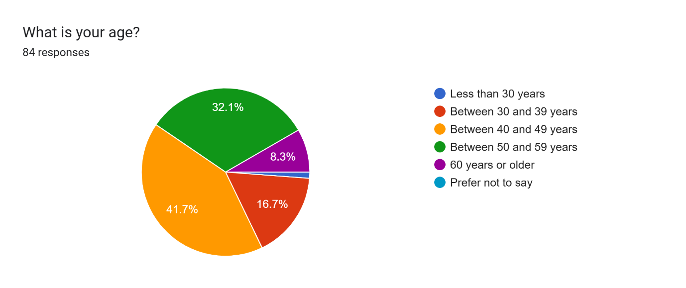
Figure 1: Age profile of EGM participants

Only 29.8% (25) of the response were from women and the remaining 70.2% (59) responses were from men. It is likely that the specification of the roles of participants i.e., senior leaders at NSOs, also contributed to this disparity since most senior leaders at NSOs are male. However, it should be noted that this is an improvement on the 2024 EGM where only 20% of the participants were female.

Impact of the EGM

All of the respondents reported that they found the EGM useful with 81 respondents (96.4%) saying that they found attending the EGM very useful.
Figure 2 shows which type of activity at the EGM participants found most useful. Respondents were able to choose as many activities as were applicable. This shows that the sessions on innovative approaches (which included a presentation, group exercise and discussion) were found to be the most useful (86.9% of respondents), closely following by the presentations of the principles and recommendations (85.7%). The country presentations and group discussions were also found to be useful by 79.8% and 66.7% of the respondents respectively. Four respondents also mentioned other activities that they found to be useful, and all stated this to be networking with other participants.

Figure 2: Most useful activities

Nearly all (96.2%) of respondents said that the aims of the EGM were clear to them in advance. The remaining 3.8% of respondents said the aims were somewhat clear in advance.
Regarding learning from the EGM, all respondents stated that they acquired substantial knowledge at the EGM regarding at least one of the following topics, with many selecting more than one response for this question as shown in Figure 3.
- Planning and management of censuses
- Census methodologies and technologies
- Recommended census topics
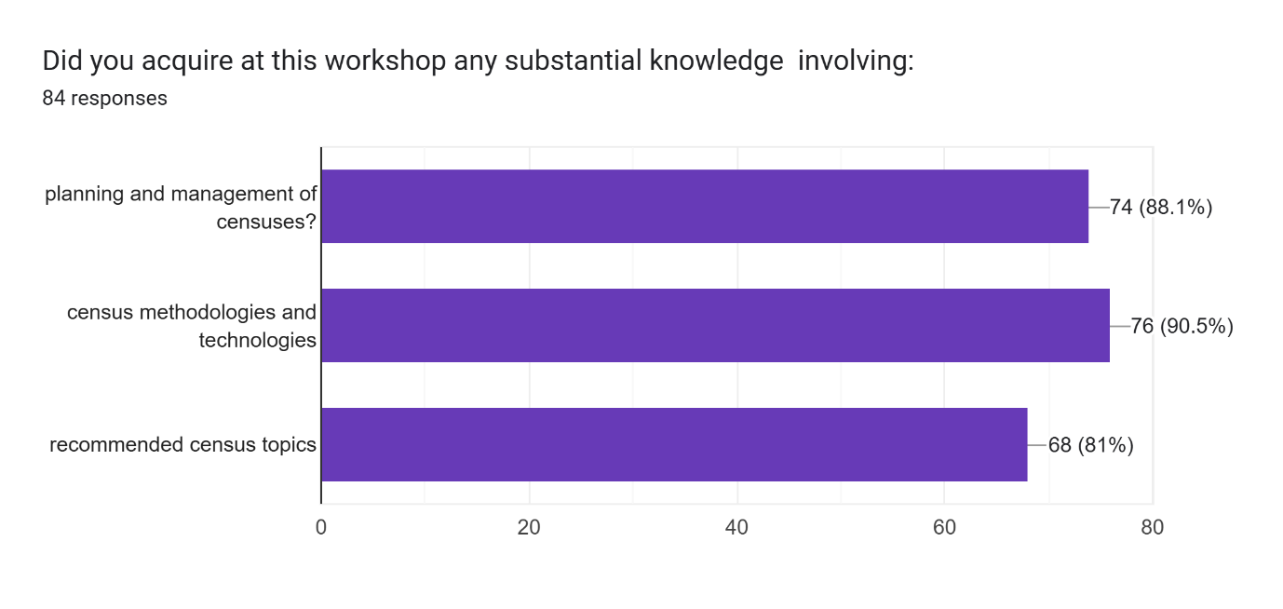
Figure 3: Topics on which substantial knowledge was gained during the EGM
Participants were asked to write in (free text) their key learning from the EGM and there was a wide range of responses with a strong emphasis on innovation and the integration of technology in census planning and implementation. Many highlighted the importance of transitioning to register-based censuses and adopting hybrid models that incorporate administrative data, as well as emerging tools such as e-Census, AI, machine learning, CAWI, CATI, and geospatial technologies.
The revised UN Principles and Recommendations (Rev. 4) were widely appreciated for their guidance on methodology and planning. Participants stressed the need for early and comprehensive planning, including testing, logistics, and quality assurance, and called for longer EGMs to allow deeper engagement. There was a clear recognition of the value of administrative data in improving efficiency and reducing costs, alongside the need to strengthen national data systems.
Knowledge sharing and collaboration—particularly peer learning, south-south cooperation, and support from development partners—were seen as vital for successful census implementation. The EGM also broadened participants’ understanding of the complexity of census operations, highlighting the importance of behind-the-scenes workflows and the role of independent monitoring in ensuring credibility. Overall, the EGM empowered participants with practical insights and strategic direction for preparing and conducting the 2030 round of population and housing censuses.

Quality of the Content and Materials for the EGM
Most respondents found the quality of the materials used for the EGM good or excellent, although five people reported that they were only adequate and one reported that they were poor. See Figure 4.

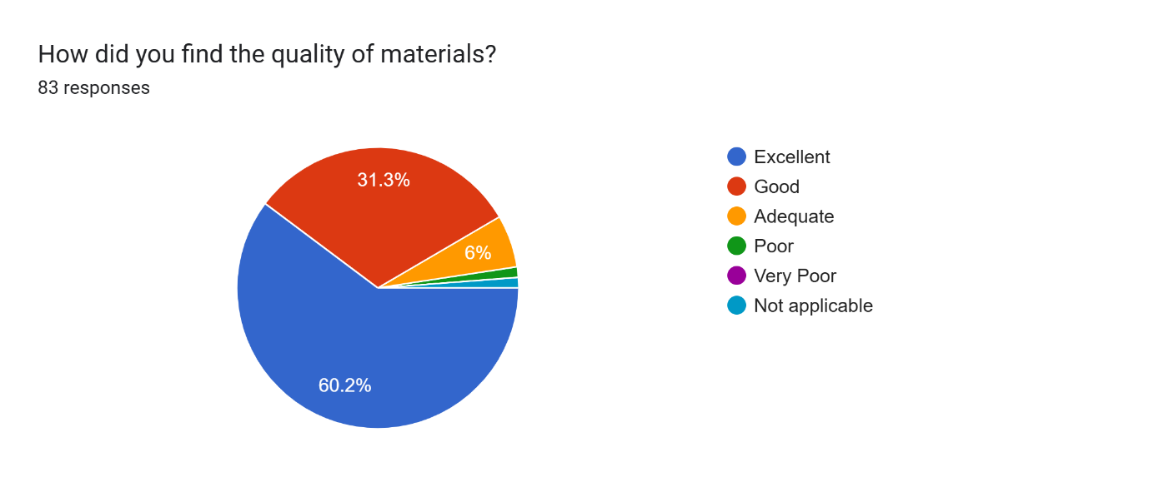
Figure 4: Quality of the EGM materials
Most respondents reported that the quality of the presentations was good or excellent, although 4 respondents said they were adequate only as shown in Figure 5.
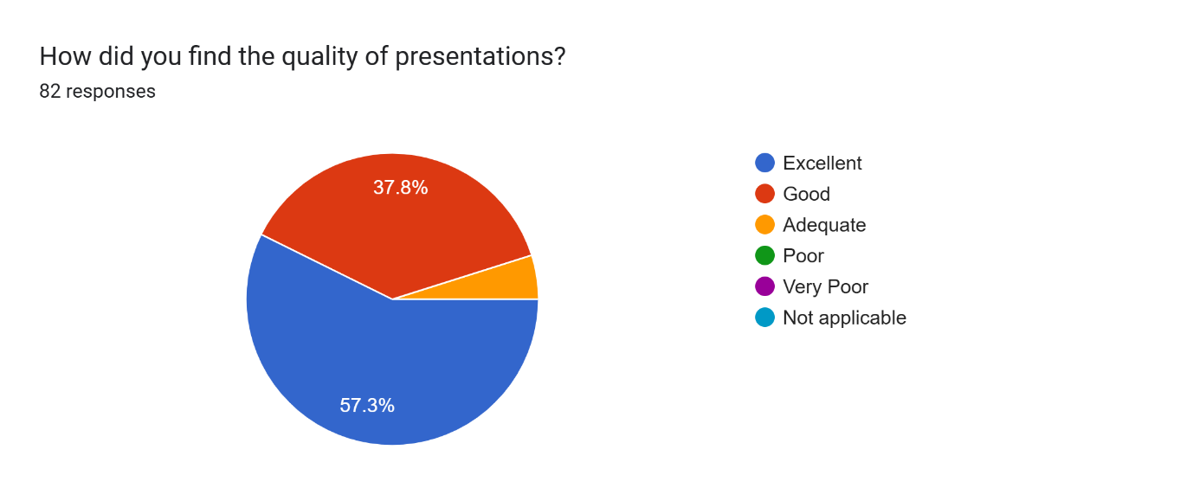
Figure 5: Quality of presentations at the EGM
The agenda for the EGM was very packed and inevitably timings did start to slip with group activities and discussions and some country presentations having to be sacrificed. This is reflected in the feedback on whether there was sufficient time for discussion and participation. Whilst 38 respondents reported that there was excellent or good time for discussion, 37 people reported that this was only adequate, and the remainder reported that the amount of time for discussion was poor or very poor. See Figure 6.

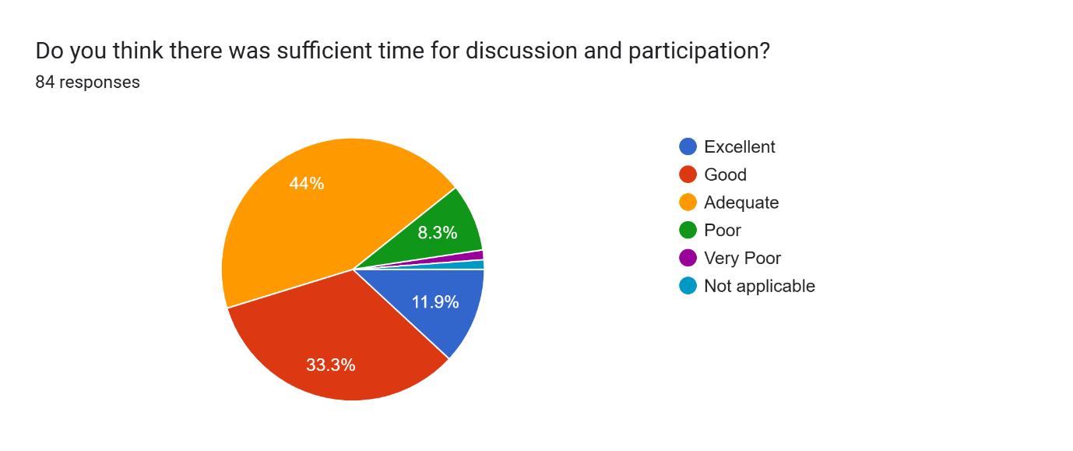
Figure 6: Was there sufficient time for discussion and participation
Most people found the balance between the topics excellent (29 respondents) or good (36 respondents) but 17 people found the balance only adequate and the 1 respondent thought it was poor. See Figure 7.
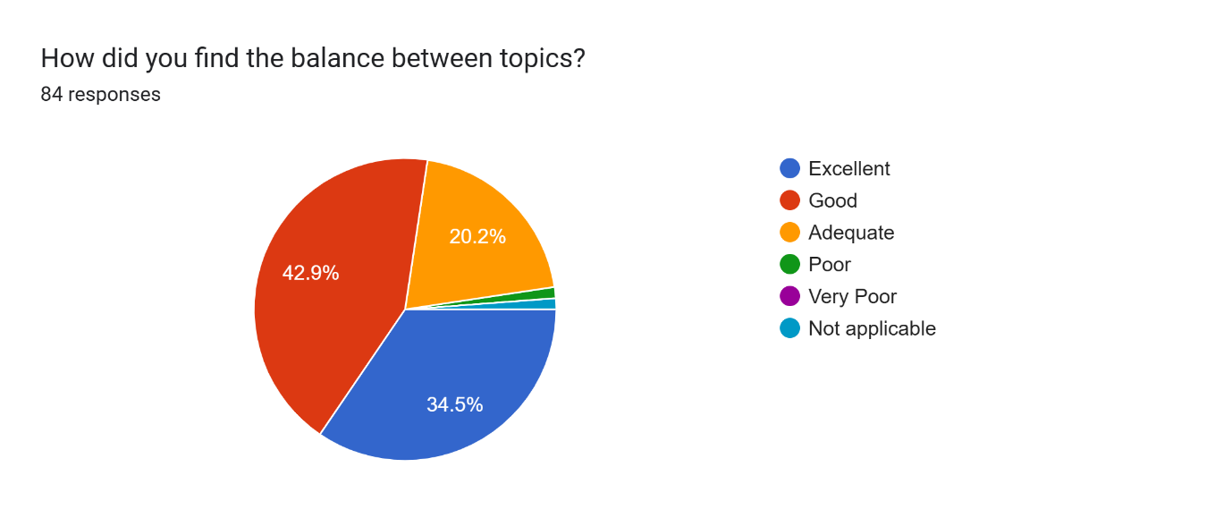
Figure 7: Balance between topics at the EGM

Quality of individual presentations
Respondents were asked to rate each individual presentation. As shown in Figure 8, all presentations are rated as good or excellent by the majority of the respondents. Where there is a slightly larger number of adequate, poor or very poor responses, this may indicate that the session was not of relevance for that respondent. For example, since most NSOs in Africa will not attempt to use CAWI for their census, this presentation may not have been of interest.

Figure 8: Quality of individual presentations

Value of the EGM
Participants were asked to rate the clarity of the conclusions reached after each session. Whilst the majority reported that the clarity of the conclusions was excellent (37 people) or good (34 people), some people thought this was only adequate (11 people), and one person reported that the clarity of the conclusions was very poor. See Figure 9.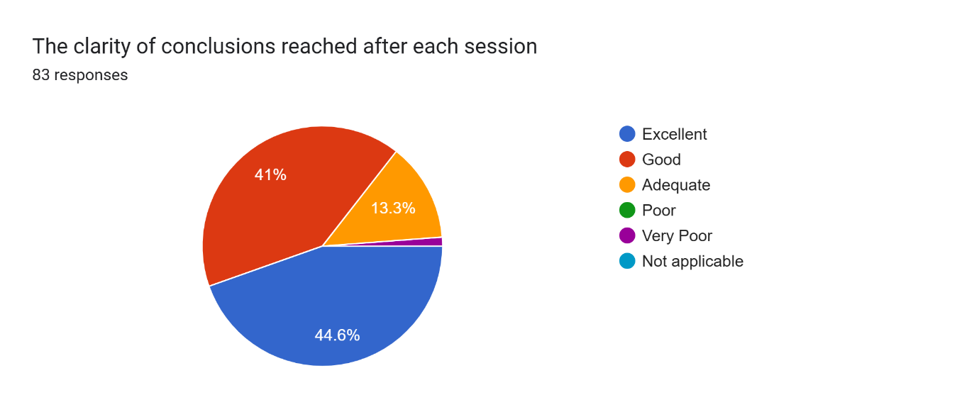
Figure 9: Clarity of conclusions after each session
Asked about the extent to which the EGM objectives were achieved (see Objectives) most participants thought that the way the objectives had been met was excellent (34 people) or good (42 people). However, six people thought this was only adequate, and one person reported that this was very poor. See Figure 10: How well were the EGM objectives met?
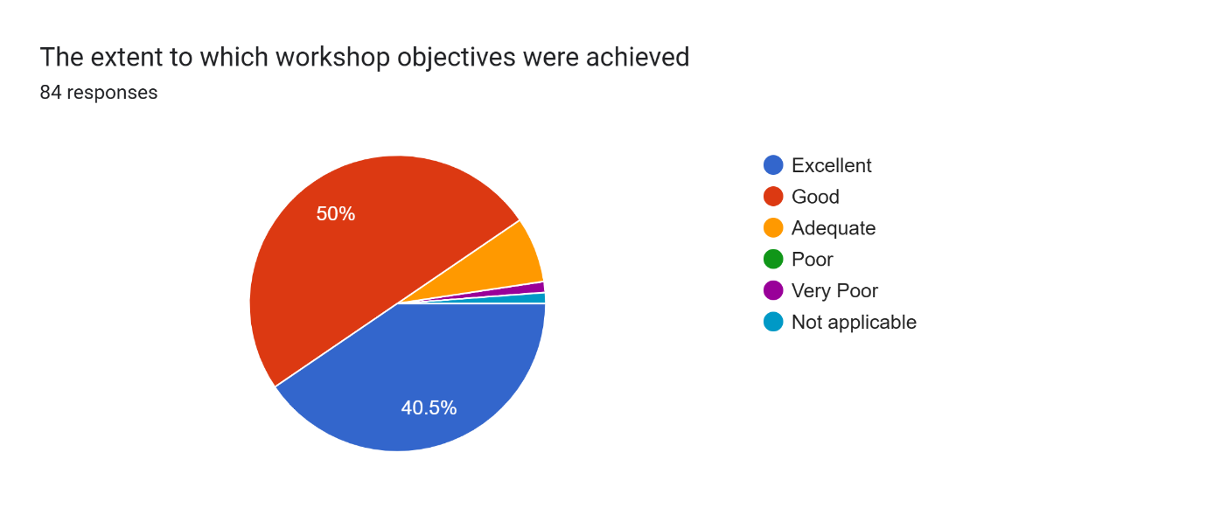
Figure 10: How well were the EGM objectives met?

Asked about the overall value of the EGM, the majority of people thought this was excellent (47 people) or good (30 people) whilst the remaining respondents (7 people) thought that the value of the EGM was adequate. See Figure 11.
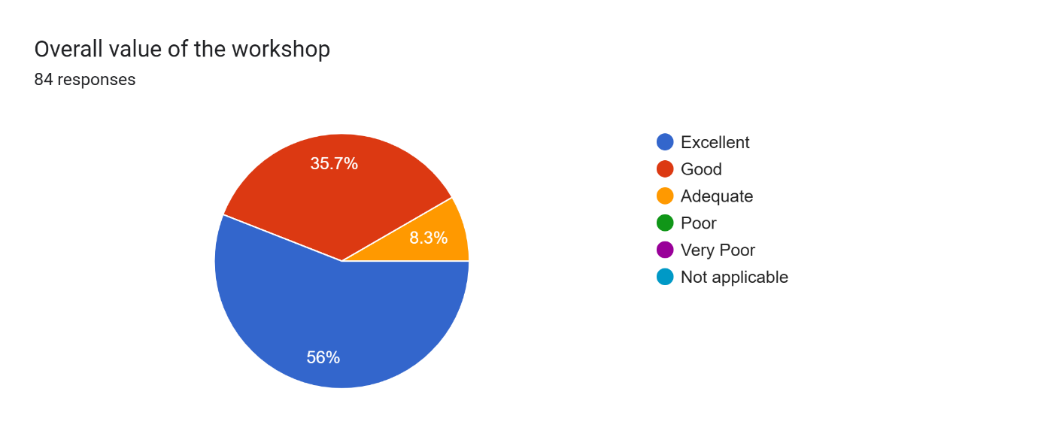
Figure 11: Overall value of the EGM

Planning and Logistics
Whilst the majority of respondents reported that the timeliness of distribution of the invitation/agenda and other materials was excellent (30 people) or good (39 people), others thought that the timeliness was only adequate (9 people), poor ( 3 people) or even very poor (1 person). See Figure 12.
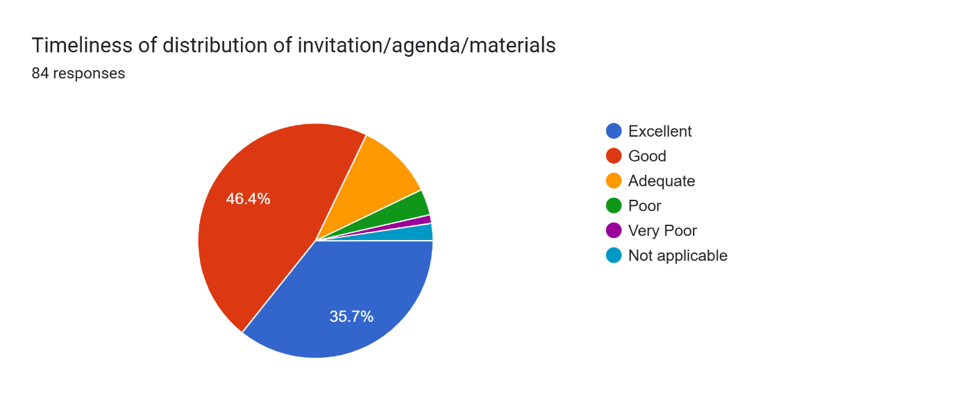
Figure 12: Timeliness of distribution of material
Similarly, although most people were satisfied with the timeliness of travel and DSA arrangements, for nine people this was only adequate, and for 6 people it was poor. Late agreements about who was sponsoring delegates may have caused some last-minute travel arrangements and in fact, some participants were unable to attend in person (Mozambique for example) because their sponsoring partner was not able to get the necessary logistical support in place in time. See Figure 13.
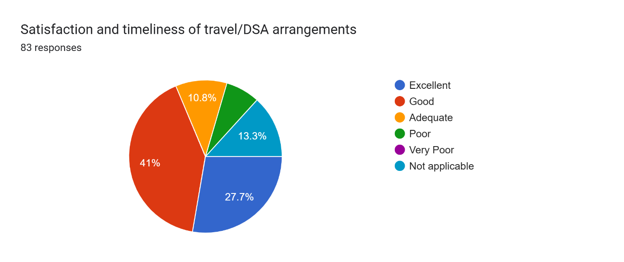
Figure 13: Satisfaction with travel/DSA arrangements

Regarding the duration of the EGM, whilst most people thought this was good (47 people) or excellent (17 people), a sizable number of people thought it was only adequate (16 people) or poor (4 people). This is likely due to the packed nature of the agenda which meant that some items did have to be very rushed, or omitted. Of course, it should be noted that extending the length of the EGM would increase the cost and in an era of reduced financial support this was not possible. See Figure 14.
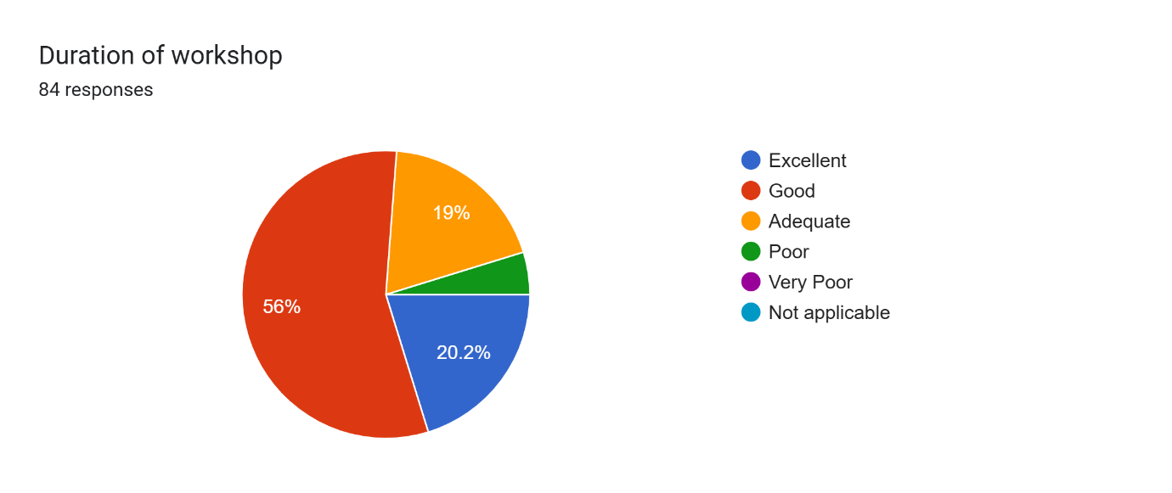
Figure 14: Duration of the EGM
The quality of the EGM facilities were thought good (40 people) or excellent (21 people) by most people. But 16 people thought these were only adequate, or poor (4 people) or even very poor (1 person). This was likely due to the size of the room which was a bit too small meaning that all participants were squashed in together. This was unfortunate, but a result of this being the only conference room available to book in Pretoria for the time of the EGM. Setting the date and securing the venue earlier for future events would mean that there is more choice on the selection of a suitable venue.
Overall, all respondents reported that the planning and organisation of the EGM was at least adequate (9 people) with the majority of people reporting that it as good (38 people) or excellent (36 people). See Figure 15.
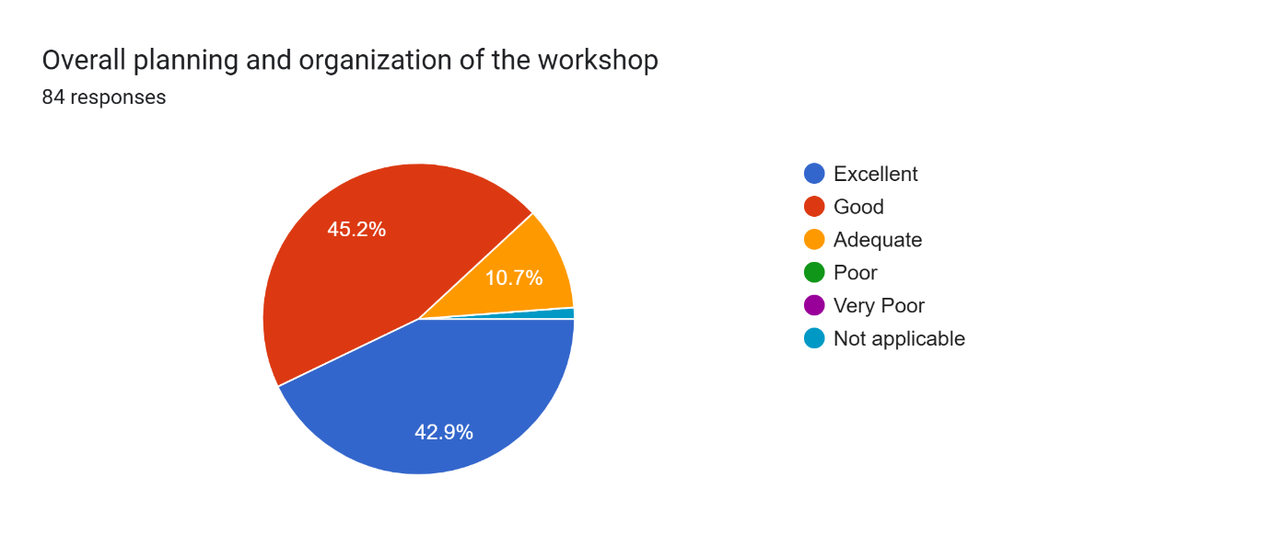
Figure 15: Overall planning and organisation of the EGM
Participants were also asked to give suggestions for things that could have been done better. A summary of the responses is given below.
Participants expressed appreciation for the EGM but noted several areas for improvement to enhance future sessions. A recurring theme was the need for a larger and more comfortable venue, as the meeting room was overcrowded and not conducive to group work or health safety. Many felt the agenda was overly packed, leaving insufficient time for in-depth discussions, country presentations, and group exercises. Suggestions included extending the EGM duration, splitting it into two sessions, or organizing parallel clinics to allow more focused engagement. There were calls for better time management, earlier distribution of materials, and improved coordination of logistics such as ticketing and refreshments. Participants emphasized the importance of including professionals from key areas like GIS, IT, and data processing, and involving countries in EGM facilitation as part of capacity building. Several highlighted the need for follow-up mechanisms to track the implementation of recommendations and support countries facing challenges, particularly in adopting new technologies. Additional recommendations included promoting south-south cooperation, ensuring equitable participation and moderation, and incorporating practical site visits and training for younger statisticians. Overall, the feedback underscores the value of the EGM while advocating for a more inclusive, well-organized, and interactive format in future editions.

Lessons Learnt
To try and avoid the situation from last year where ONS overpaid for the conference package because the estimate for how many people would attend was too high, this time the final numbers were underestimated. Registrations were still being accepted right up to the week before the conference, and this meant that the final numbers were not available until last minute. More people attended than were orginally budgeted for, meaning that the final bill for the conference package was higher than expected. Since ONS were paying for the conference package via FCDO Pretoria and Stats SA were also involved in the negotiations with the hotel, this became a very complicated situation. Neither the hotel, not FCDO Pretoria were very responsive making it difficult to assess what the final bill was, what had been paid and what was still due. This has now been resolved, but ONS are unlikely to use this method of paying for a conference package in the future.
The conference room was only just big enough to accommodate the large number of participants. Fixing the date and the venue earlier for subsequent events would mean that this is more choice of venue – this time the venue was chosen because it was the only suitable venue in Pretoria available for the given week.
The agenda was very packed in order to try and include all topics of interest as well as group discussions and activities rather than just presentations. When time slipped, some of the group activities and discussions had to be cut. This was particularly unfortunate for some countries who had prepared presentations and were then given an inadequate time to present. This depended on who was chairing the session. A more realistic agenda should be set next time – although there is a balance to be struck between including all topic and fitting into the available time. Some of the presentations could have been cut down to key points and signposting to relevant places in the P&R or other documentation.
Halaal and vegetarian food was provided this time – a lesson learnt from the previous year. However, it was hard to establish exactly how many Halal meals would be required. We therefore over-ordered – but were able to reduce the amounts for the latter part of the week, which reduced the conference package bill by almost £1,000. For future events, delegates should be asked in advance whether or not they have any specific requirements regarding food or access.

Program of work
Day One: Monday, 4 August 2025
Opening, innovations, Part 1 of UN P&R rev 4
Time |  | Activities |  |  | Moderator
08h30-09h00 |  | Registration |  |  | UNECA
09h00-09h40 |  | Opening Remarks  - ONS-UK  - UNSD  - UNFPA  - UNECA  - Statistics South Africa |  |  | STATSA
09h40-10h10 |  | 2030 World Programme on Population and Housing Censuses: International Standards and Innovative Approaches  Speaker: Seiffe Tadesse - UNSD |  |  | UNFPA
10h10-10h25 |  | African Programme on 2030 Round of Population and Housing Censuses  Presenter: Fredrick Okwayo - UNFPA
10h25-10h40 |  | Supporting Mechanisms to the Africa Programme on 2030 Round of Population and Housing Censuses  Presenter: William Muhwava - ECA
10h35-11h00 |  | Discussion, Q & A Session by Moderator
11h00-11h30 |  | HEALTH BREAK & GROUP PHOTO
11h30-11h50 |  | Innovations -Thinking outside the box  Presenter: Garnett Compton, ONS-UK |  |  | UNFPA
11h50 -12h20 |  | Countries going early in the round- key innovative aspects  Presenters from: Malawi, Lesotho, Sierra Leone, Nigeria
12h20 -12h40 |  | Group Exercise 1
12h40 -13h00 |  | Plenary session
13h00-14h00 |  | LUNCH BREAK
14h00-14h30 |  | Essential features, definitions and methodologies of population and housing censuses  Presenter: Seiffe Tadesse UNSD |  |  | UNFPA
14h30-15h00 |  | Methodologies for population estimation in unenumerated areas Presenter: Tapiwa Jhamba, UNFPA / Ian Coady, World Pop
15h00-15h30 |  | Discussion, Q & A Session by Moderator
15h30-15h50 |  | HEALTH BREAK
15h50-16h20 |  | Group Exercise 2
16h20-17h00 |  | Plenary feedback session
Day Two: Tuesday, 5 August 2025
Census planning and operations
Time | Activities |  |  |  | Moderator
09h00-09h30 | Planning, Organisation and management of census operations  Presenter: Collins Opiyo - UNFPA |  |  |  | UNECA
09h30-10h00 | Emergency preparedness, risk management and contingency planning  Presenter: Seiffe Tadesse - UNSD
10h00- 10h25 | Group Exercise 3
10h25-10h40 | Plenary feedback session
10h40-11h00 | HEALTH BREAK
11h00-11h30 | Integrating geospatial information into census operations  Presenters: Frankline Echerue, UNFPA & Ayenika Godheart Mbiydzenyuy - ECA |  |  |  | UNSD
11h30-12h10 | Country Case Use  Presenters from: South Africa, Kenya, Botswana
12h10-12h40 | Group Exercise 4
12h40-13h00 | Feedback and plenary discussion.
13h00-14h00 | LUNCH BREAK
14h00-14h20 | Quality assurance in census operations  Presenter: Seiffe Tadesse - UNSD |  |  |  | UNFPA
14h20-14h40 | Application of census data quality evaluation  Presenters from: The Gambia, South Africa
14h40-15h10 | Group Exercise 5
15h10-15h40 | Feedback and plenary discussion
15h40-16h00 | HEALTH BREAK
16h00-16h20 | Covering Mobile and Migrant Populations in Censuses  Presenter: UNSD |  |  |  | UNHCR
16h20-16h50 | Country presentations on covering mobile and migrant populations  Presenters from: Somalia, Sudan, Libya
16h50-17h10 | Feedback and plenary discussion
Day Three: Wednesday, 6 August 2025
Data collection
Time |  |  |  | Activities | Moderator
09h00-09h30 |  |  |  | Use of administrative data in support of census operations  Presenter: Seiffe Tadesse - UNSD | UNFPA
09h30-9h50 |  |  |  | CRVS data systems for census support and effective population estimation  Presenter: William Muhwava - ECA
09h50-10h10 |  |  |  | Group Exercise 6
10h10-10h30 |  |  |  | Discussion, Q & A Session by Moderator
10h30-11h00 |  |  |  | HEALTH BREAK
11h00-11h50 |  |  |  | Core and Non-Core Topics  Presenter: Seiffe Tadesse - UNSD
11h50-12h10 |  |  |  | Selection of Topics for Inclusion in the PHC  Presenters from: Eswatini, Namibia, Mauritius
12h10-12h30 |  |  |  | Group Exercise 7
12h30-13h00 |  |  |  | Feedback and plenary discussion
13h00-14h00 |  |  |  | LUNCH BREAK
14h00-14h20 |  |  |  | Collecting census data with handheld electronic devices (CAPI)  Presenter: Steve Lwendo and Kakinyi UNFPA | UNFPA
14h20-14h50 |  |  |  | Collecting census data with Internet (CAWI) and Multimode census data collection  Presenter: Seiffe Tadesse - UNSD
14h50-15h10 |  |  |  | Plans for data collection  Presenters from: Egypt, Zimbabwe
15h10-15h30 |  |  |  | Discussion, Q & A Session by Moderator
15h30-16h00 |  |  |  | HEALTH BREAK
16h00-16h30 |  |  |  | Group Exercise 8 | UNFPA
16h30-17h00 |  |  |  | Discussion and feedback Session
Day Four: Thursday, 7 August 2025
Monitoring, publicity and finance
Time |  |  |  | Activities | Moderator
09h00-09h30 |  |  |  | Census Monitoring operations  Presenter: Pamela Kakande Nabukhonzo - UNECA | UNSD
09h30-10h10 |  |  |  | Available digital census monitoring tools  Presenters from: Zambia, Tanzania, South Africa
10h10-10h30 |  |  |  | Experiences in Independent Field Monitoring  Presenters from: Ghana
10h30-11h00 |  |  |  | HEALTH BREAK
11h00-11h30 |  |  |  | Group Exercise 9 | UNECA
11h30-11h50 |  |  |  | Feedback and plenary discussion.
11h50-12h10 |  |  |  | User consultation, communication and publicity  Presenter: Fredrick Okwayo - UNFPA
12h10-12h30 |  |  |  | Census data dissemination  Presenter: Tapiwa Jhamba - UNFPA
12h30-13h00 |  |  |  | Discussion, Q & A Session by Moderator
13h00-14h00 |  |  |  | LUNCH BREAK
14h00-14h20 |  |  |  | Census data utilization for sustainable development goals  Presenter: Molla Hunegnaw Asmare - UNECA | UNFPA
14h20-14h50 |  |  |  | Group Exercise 10
14h50-15h10 |  |  |  | Discussion, Q & A Session by Moderator
15h10-15h30 |  |  |  | Financial management and resource mobilization  Presenter: Tapiwa Jhamba - UNFPA
15h30-15h50 |  |  |  | Discussion, Q & A Session by Moderator
15h30-16h00 |  |  |  | HEALTH BREAK
16h00-16h20 |  |  |  | Highlights of UNFPA support to the 2030 census round  Presenter: Fredrick Okwayo - UNFPA | UNECA
16h20-16h40 |  |  |  | IT infrastructure and support  Presenter: Pamela Kakande Nabukhonzo - UNECA
16h50-17h00 |  |  |  | Discussion, Q & A Session by Moderator
Day Five: Friday, 8 August 2025
Conclusions and Recommendations
Time |  |  | Activities |  |  | Moderator
09h00-09h30 |  |  | Guidelines on the use of administrative data for census purposes in Africa  Presenter: William Muhwava - UNECA |  |  | EAC
09h30-10h00 |  |  | Guidelines for Independent Census Monitoring in Africa  Presenter: Pamela Kakande Nabukhonzo - UNECA
10h00-10h30 |  |  | Discussion, Q & A Session by Moderator
10h30-11h00 |  |  | HEALTH BREAK
11h00-11h30 |  |  | E-Census handbook based on lessons from the 2020 round in Africa  Presenter: Rachel Shipsey - ONS-UK |  |  | EAC
11h30-12h00 |  |  | Discussion, Q & A Session by Moderator
12h00-12h30 |  |  | Key takeaways and recommendations from the EGM for the 10th Africa Statistical Commission  Presenter: William Muhwava - UNECA |  |  | STATSA
12h30-12h35 |  |  | EGM evaluation
12h35-13h20 |  |  | Conclusions and closing remarks  • UNSD  • UNFPA  • UNECA  • Statistics South Africa
13h20-14h00 |  |  | LUNCH BREAK

Photo gallery
This section highlights some of the moments of the EGM.
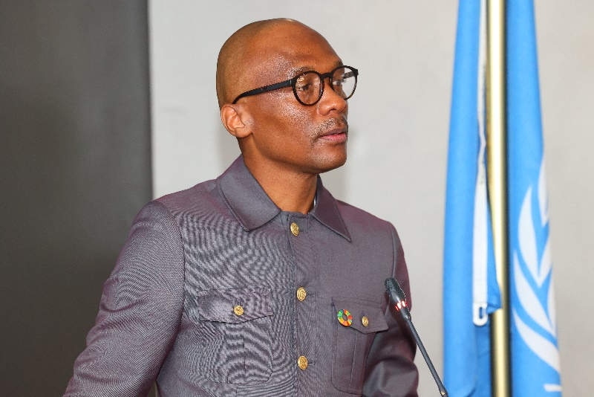  Welcome remarks by Deputy Secretary General, StatSA | 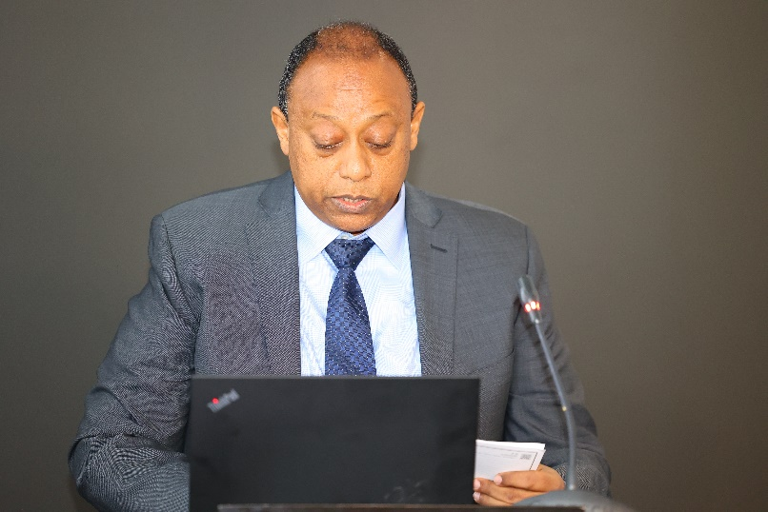  Opening remarks from UNSD
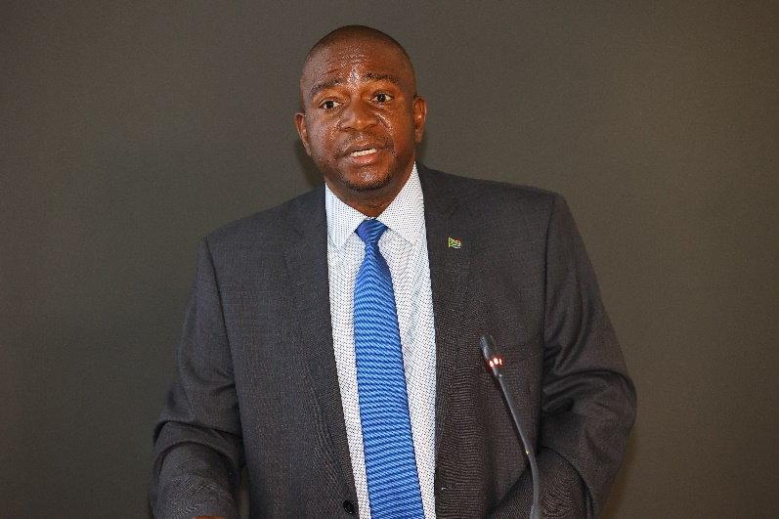  Official Opening of the EGM by Secretary General, StatSA | 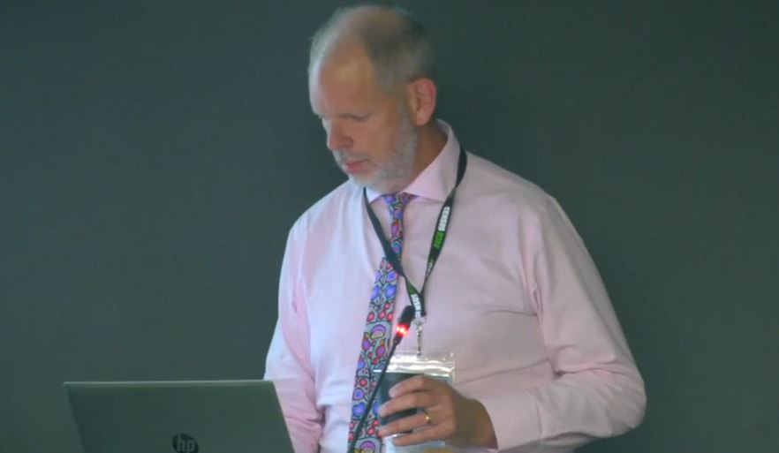  Presentation by ONS-UK
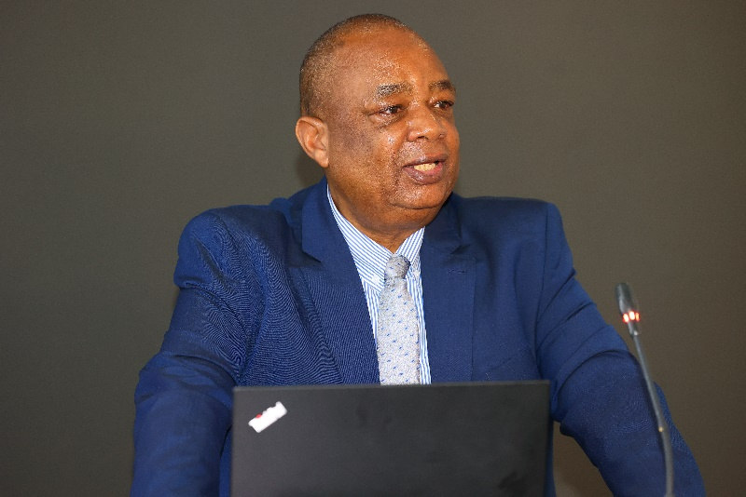  Opening remarks from UNECA | 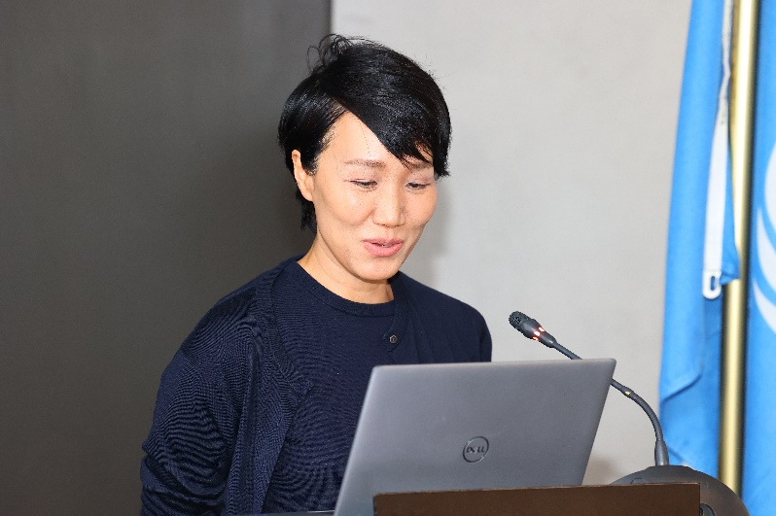  Opening remarks from UNFPA

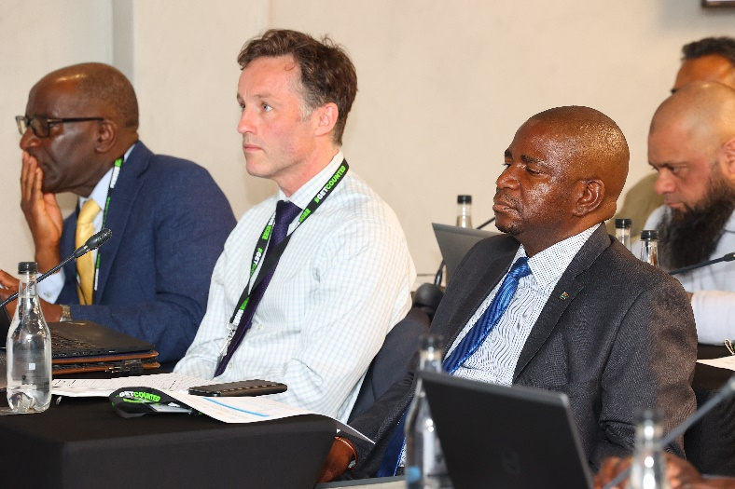  Opening session of the EGM | 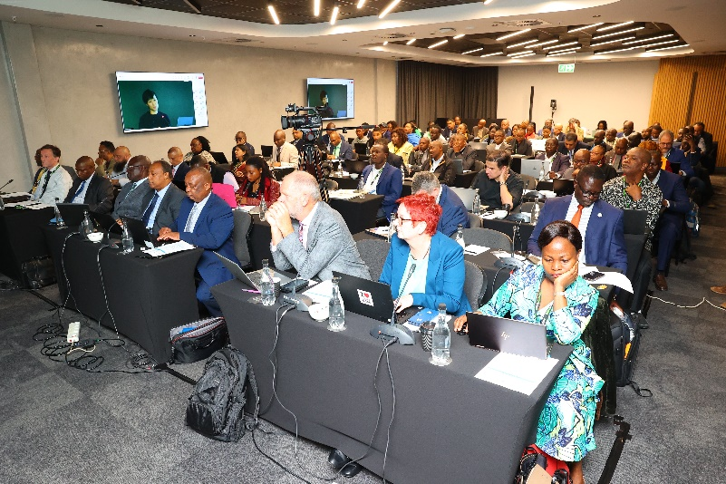  Opening session of the EGM
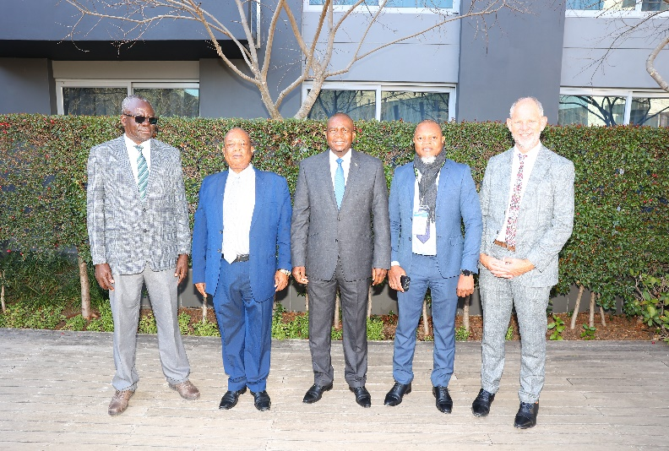  A light moment | 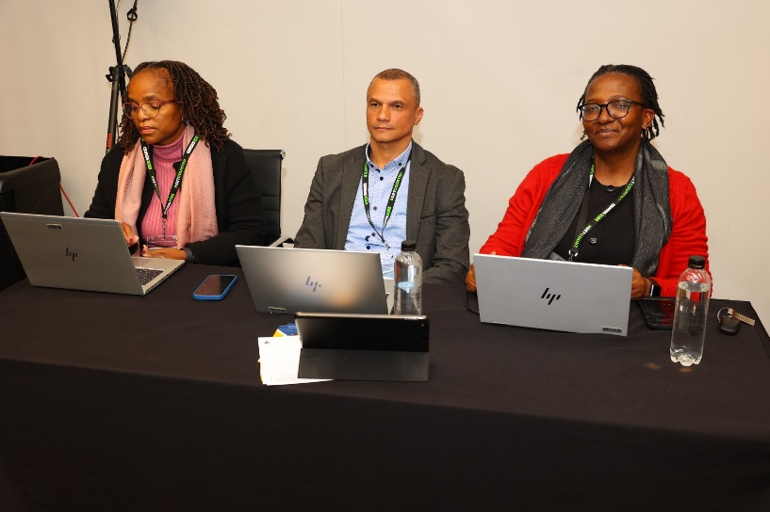  Session in progress
  Presentation on the P&R by UNSD | 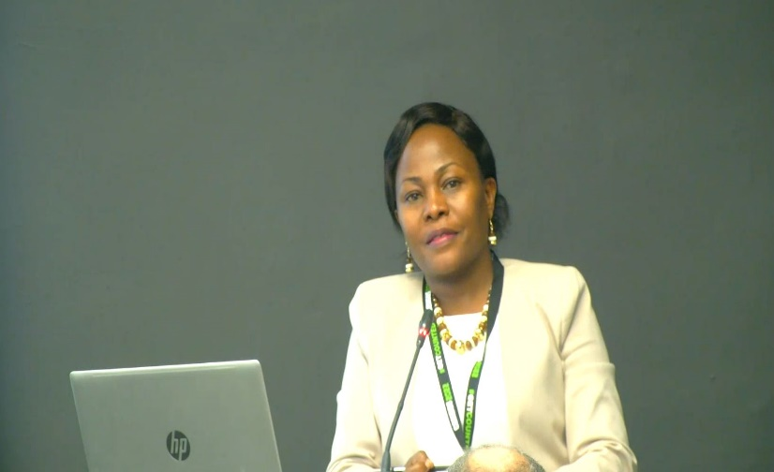  Presentation on the P&R by UNECA

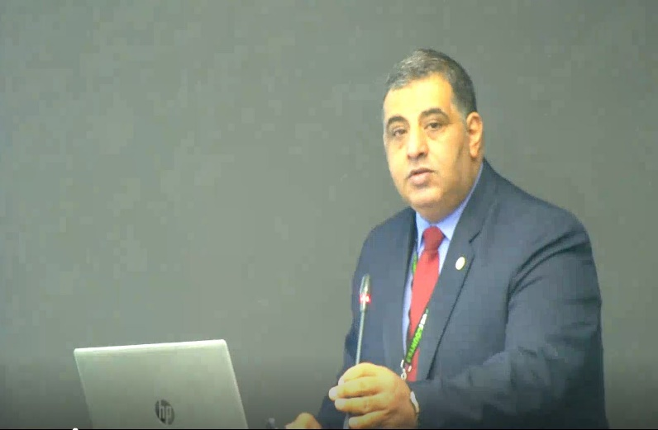  Country experience sharing from Egypt | 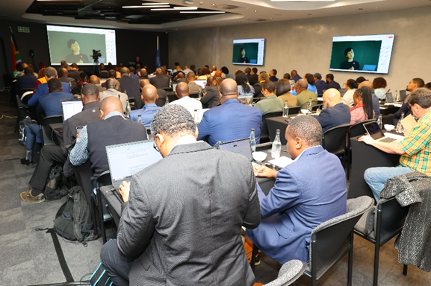 EGM session in progress
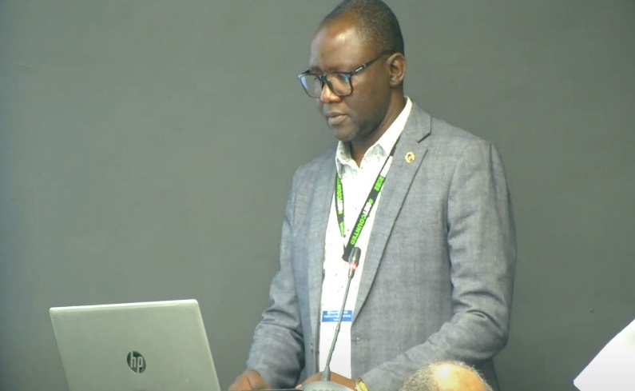  Country experience sharing from Kenya | 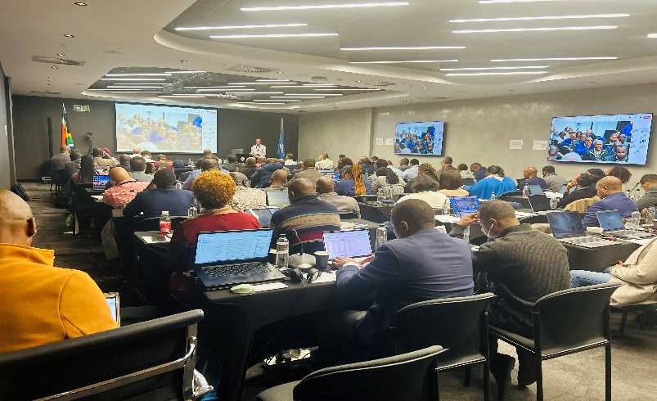  EGM session in progress
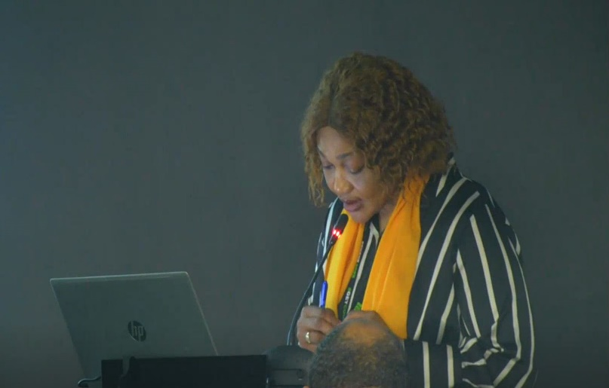  Session moderation by UNFPA | 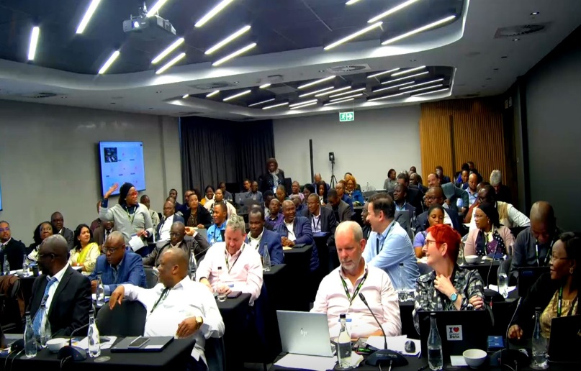  Plenary session in progress

