CRVS R-pipeline for production of Namibia vital statistics report
WORKSHOP REPORT
- Background
The African Centre for Statistics -UNECA supported Namibia Statistical Agency to hold an in-country training workshop on “Production of a vital statistics report using an R pipeline”. The workshop took place from 17th -21st November 2025 in Windhoek, Namibia. Prior to in-person mission, an introductory training workshop was held virtually in the preceding week.

This workshop aimed at strengthening the capacity of CRVS stakeholders to systematically organize existing data from civil registration for production of a vital statistics report using R programming language. The training focused on the use of R programming language, R studio and the use of the vital statistics report production toolkit. The training was attended by 6 participants of which 4 were female.

Objective of the Mission
The technical support aimed to ensure continuous and sustained learning to increase knowledge and enhance its usability. Specifically, ACS:

  - Provided basic and intermediary training on the use of R programming language for data processing.
  - Adapted the CRVS R pipeline with Namibia’s data on births, deaths and marriages for production of a vital statistics report from administrative records (i.e. a sequence of operations or transformations applied to CRVS registration data in a systematic and organized manner using R).
  - Strengthened the capacity of CRVS stakeholders to systematically undertake data cleaning, edits and analysis of the civil registration data using R to be fit for analysis and in line with UN standard guidelines and template to produce Vital Statistics report for the datasets of 2018 to 2024.
  - Generate Birth, Death, Marriage and Divorce summary tables which will be published in the upcoming Vital Statistics report of Namibia.

- Brief Summary of key findings.

The team made the following observations:
- The last vital statistics report was produced in 2024 based on data from 2018 to 2021; at the time of the training, they obtained data for 2022 to 2025. The previous report excluded causes of death that were published in a separate report. They were advised to combine and have a comprehensive report since the CRVS system captures causes of death and include divorces for the first time.
- Data sets for marriages, divorces, births and deaths were availed for analysis from the main CRVS system. We realized there is another parallel system for births and death e-notification that we need to explore how it links with the main CRVS dataset.
- Data on birth and death did not have a variable for regions and it was needed for analysis, and it took the most time for the NSO to include since it was manually being inserted causing the long delay in production of the vital statistics.
- Birth and Death data do not have information on “Place of usual residence” and the “Birth Region” was used as a proxy variable to generate tables. In addition, Urban-Rural disaggregation is missing in the datasets.
- Data on population projections to be used as denominators for select variables was missing the sex disaggregation for birth and we noted a discrepancy in the years 2023 and 2024. A discrepancy was also pointed out on birth estimates published vis-a-vie what is in the data files.
- Additionally, although the cause of deaths data was coded (using ICD codes), only 20% of the codes were valid and the team was advised to present the trend of ill-defined codes instead of presenting the causes of death which are not a true reflection of the disease pattern.
- Gaps were noted in CRVS technical working group and stakeholders in working closely. ACS recommended revitalizing the group to make progress on recurring challenges.
- The final report is expected to be released by March 2026 and will include data for 2025 if the full year’s records are available by then. However, a separate report on data quality issues (containing tables) will be prepared and discussed with the national CRVS Technical Working Group to guide improvement of the CRVS data capture system.

- work accomplished
Based on the available data, the following outputs in terms of the vital statistics report were achieved:

- Code for data exploration, cleaning and deriving of key variables for all three datasets was achieved.
- Chapter 3. Data quality, timeliness of registration, and registration completeness
  - Of the 12 minimum expected tables for this chapter, code for all including extras as requested by the team was provided and applied to the full dataset successfully.
  - More data quality issues were identified and added to the tabulation plan.
- Chapter 4. Births
  - Of the 11 minimum expected tables for this chapter, code for all including extras as requested by the team was provided and applied to the full dataset successfully.
- Chapter 5. Deaths
  - Of the 12 minimum expected tables for this chapter, code for eight, all including extras as requested by the team were provided and applied to the full dataset successfully. Four were left out because of missing variables in the dataset (i.e foetal death, rural/urban).
- Chapter 6. Causes of Deaths
  - Code for all the 10 tables expected for this chapter was provided and they will decide to include in the report after comparison with what was obtained from the HMIS analysis by WHO.
- Chapter 7. Marriages and divorces
  - Of the 9 minimum expected tables for this chapter, code for six, all including extras as requested by the team were provided and applied to the full dataset successfully. Three were left out because of missing variables in the dataset (i.e duration of previous marriage, number of dependents).

Given the above observations and existing data gaps, the team agreed to:
- To move away from a multi-year retrospective vital statistics report to produce an annual vital statistics report that includes causes of death.
- Document and develop a standard CRVS data editing guideline to ensure consistency.
- Continue collaboration with ACS-ECA until the report is produced.

The team’s evaluation of using R for CRVS data processing was rated highly especially that it helps identify and visualize problem variables easily during data cleaning, the time taken to clean and generate tables for one chapter (dataset) is so short (one day) compared to when they were using MS excel to identify areas for data cleaning. Thus, tables for the entire report are generated within five days, which was exciting. Despite the challenges of conducting R training online, the virtual training offered by ACS prior to the training was helpful and appreciated for laying a foundation for using R.

This training contributes to increased visibility through civil registration and good legal identity.

- Recommendation(s)/Action to be taken/Implication for ECA/ACS:

- ACS to follow up with the country with revised R scripts and production of its multi-year data report to ensure its quality compliance and adherence to standards.
- ACS should consider developing standard guidelines for CRVS data management to share with countries.
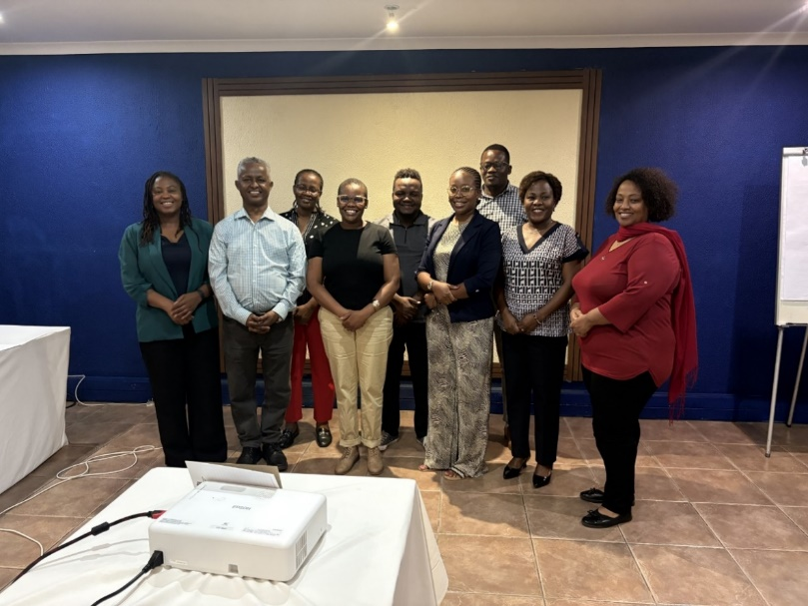
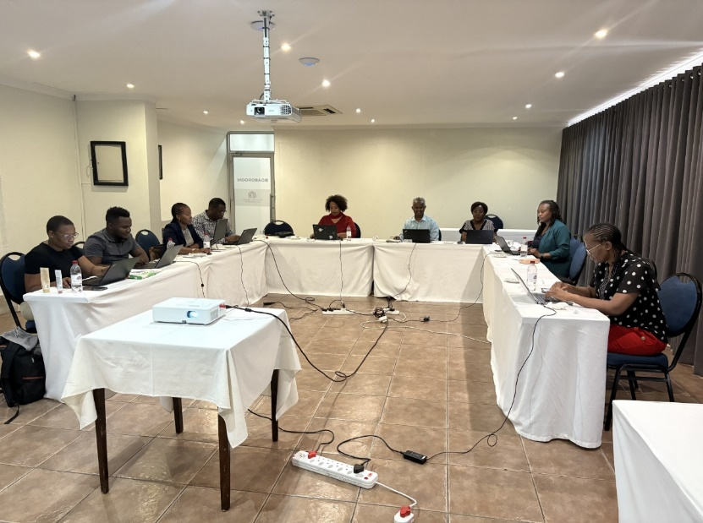
- Photo Gallery

- Agenda

Date | Activity | Facilitator
Monday – 17th Nov 2025
8:30 -9:00 | Arrival and Registration
9.00 – 9.10 | Welcome and opening remarks including administrative issues | ECA
9.10 – 9.40 | Introductions | All
9.40 –10.00 | Workshop Overview/Objectives | ECA
10.00 –10.30 | Presentation – Overview of available datasets to be used for the report including the tabulation plan, update on cause of death | Country team
10.30 –11.00 | Health break
11.00 –13.00 | Data cleaning and manipulation of births records | All
13.00 –14.00 | Lunch break
14.00 – 17.00 | Populate and review output of tabulation plan for birth records | All
Tuesday – 18th Nov 2025
8.30 –10.30 | Data cleaning and manipulation of death records | All
10.30 –11.00 | Health break
11.00 –13.00 | Data cleaning and manipulation of death records | All
13.00 –14.00 | Lunch break
14.00 – 17.00 | Populate and review output of tabulation plan for death records | All
Wednesday – 19th Nov 2025
8.30 –10.30 | Data cleaning and manipulation of marriage records | All
10.30 –11.00 | Health break
11.00 –13.00 | Data cleaning and manipulation of divorce records | All
13.00 –14.00 | Lunch break
14.00 – 17.00 | Populate and review output of tabulation plan for marriage and divorce records | All
Thursday – 20th Nov 2025
8.30 –10.30 | Populate and review output of tabulation plan on data quality | All
10.30 –11.00 | Health break
11.00 –13.00 | Populate and review output of tabulation plan on data quality | All
13.00 –14.00 | Lunch break
14.00 – 17.00 | Populate and review output of tabulation plan on data quality | All
Friday – 21st Nov 2025
8.30 –10.30 | Populate and review summary tables and annex to report | All
10.30 –11.00 | Health break & Group Photo
11.00 –12.00 | Populate and review summary tables and annex to report | All
12.00 –13.00 | Wrap up and discussion:  - Audit of tables for the report that have generated  - Development of an action plan for next steps.  - Workshop evaluation | ECA
13.00 –14.00 | Lunch break

- Attendance list
