WORKSHOP REPORT
SENEGAL’S IN-COUNTRY WORKSHOP ON THE OPEN SDG PLATFORM AND CAPACITY BUILDING OF DATA FOCAL POINTS
  - Dakar, 04–07 August 2025

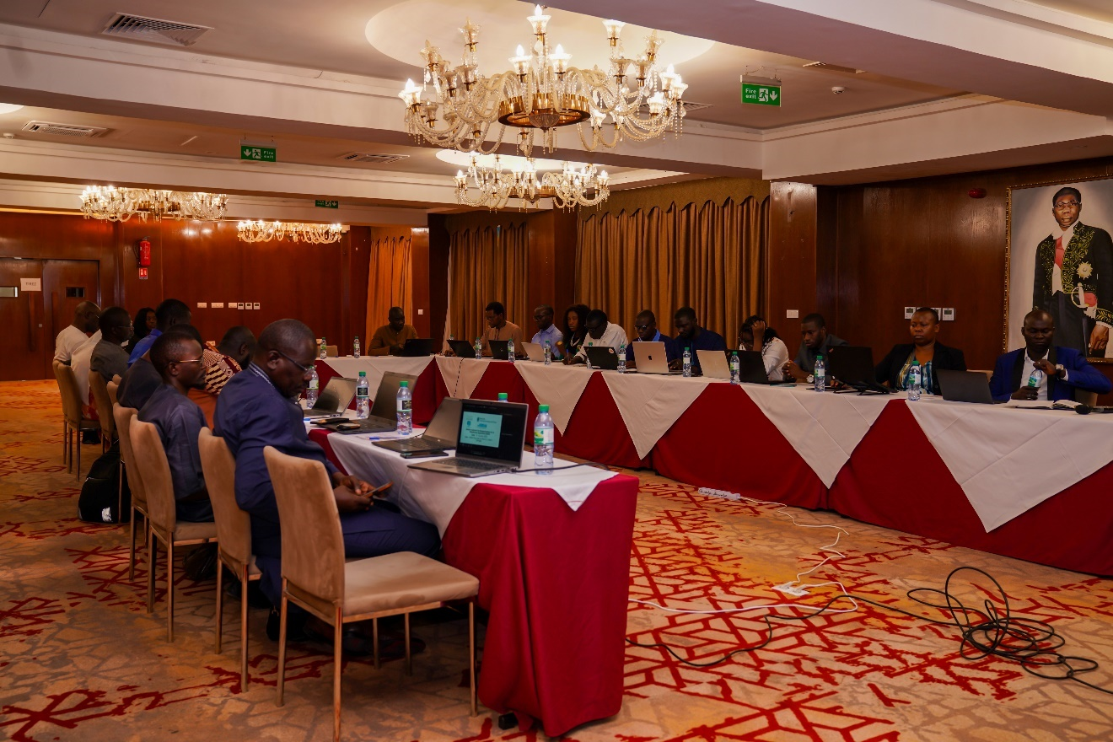

EXECUTIVE SUMMARY
Purpose
The national workshop's purpose was to familiarize participants with the Statistical Data and Metadata Exchange (SDMX) standard and the Open SDG dissemination platform, emphasizing their role in SDG indicator exchange and dissemination. The overarching goal is to strengthen member states' capacities in collecting, managing, and disseminating SDG data, ensuring better interoperability with international databases. This initiative aims to centralize SDG data, enhance transparency in indicator dissemination, and improve overall data management.
Key Outcomes:
Participants gained a clear understanding of the SDG-SDMX platform and its functionalities for data exchange and dissemination. National actors are now equipped to effectively use the platform for managing, coding, and publishing SDG data in the SDMX format. Key challenges related to integrating national data were identified, and potential solutions were shared, capitalizing on lessons from other countries. The workshop fostered strengthened inter-institutional collaboration for improved coordination of data flows and facilitated collaborative efforts to update SDG indicators for integration into the Open SDG platform.
Strategic Achievements
This workshop represents a strong and continuous collaboration between the Government of Senegal and the United Nations system, demonstrating Senegal's unwavering commitment to data-driven development and evidence-based decision-making. It aligns fully with Senegal's national development strategies, including the Stratégie Nationale de Développement (SND 2025-2029), Senegal 2050 vision, the Sustainable Development Goal, and the Agenda 2063. The initiative directly reflects the United Nations Strategy on Data, aiming to transform data into a lever for sustainable development, and embodies the spirit of UN 2.0, championing data, digital transformation, and partnerships. As a pilot country selected by the Economic Commission for Africa (CEA), Senegal has actively engaged in this dynamic, including launching initial technical implementation of Open SDG
Progress & Accessibility
The upcoming launch of Senegal's Open SDG dissemination platform marks a significant advancement in transparency, accessibility, and interoperability of SDG data. Open data is recognized for its capacity to create value for government, enhancing policy evaluation, increasing governmental efficiency, and stimulating citizen participation. It also promotes the modernization of statistical systems and improved IT infrastructure. Senegal's adoption of the SDMX standard provides a harmonized framework for data exchange, helping to bridge data gaps, particularly concerning gender, governance, and environment, and enabling more regular progress reporting. This initiative will empower decision-makers, researchers, civil society, and citizens to access and utilize data meaningfully, ultimately strengthening the country's capacity for evidence-based decision-making
Future Directions:
For the Open SDG platform to achieve its full impact, it must be continuously fed with updated, high-quality data that accurately reflects realities on the ground. There is a call for all stakeholders to commit to producing quality, disaggregated, and timely data and to actively promote its use. The United Nations in Senegal, through its 34 agencies, funds, and programs, is ready to collaborate with the government and all partners to make data a driving force for transformation and equity. Specific recommendations for the sustainability of the Open SDG-SDMX platform include consolidating existing systems, incorporating technicians' input, learning from past experiences, developing a clear governance charter, strengthening technical and material capacities for indicator quality, making the platform dynamic through communication and ownership, and expanding SDMX training.
The Direction Générale de la Planification et des Politiques Économiques (DGPPE), and coordinator UCSPE is committed through systematic collection and analysis of disaggregated data, and to supporting multi-stakeholder dialogue on data governance. A national roadmap for implementation is elaborated.
Conclusion:
The workshop was both timely and strategic, reinforcing the collective commitment to building a robust SDG monitoring system in Senegal. The success of the SDG fundamentally relies on collective effort and a spirit of partnership. By strengthening data systems and collaboration, Senegal aims to achieve its development targets and significantly improve the lives of its citizens.

Table of Contents
1 EXECUTIVE SUMMARY 2
2 Activities of the mission: 3
2.1 Sessions with the Senegal ANSD and Partners, 4 August 2025 4
2.2 This report presents the workshop's highlights: 5
2.2.1 Opening Ceremony 5
2.2.2 Presentations 5
2.2.3 Recommendations and Perspectives 5
2.2.4 Sharing of Participant Experience 5
2.2.5 Session with ANSD and IDEP 2025 6
3 Annexes 7
3.1.1 Termes of reference and Agenda of the Workshop 7
3.1.2 Allocution de Madame Karima Bounemra Ben Soltane, au nom du Coordonnateur Résident du Système des Nations Unies au SENEGAL 8
3.1.3 Welcome remarks delivered by Coordinator of SDG, 9
3.1.4 Welcome remarks delivered by DG of ANSD Senegal at Open SDG Platform 9
3.1.5 Evaluation of the Training Workshop on SDMX, Open Data Platform 2.0, and Open SDGs Tools 10
3.1.6 List of Participants 10
3.1.7 Pictorial of the Mission 11
3.1.8 Presentations delivered during the workshop. 13
3.1.9 Workshop Evaluation: results of evaluation forms (online) 17

Activities of the mission:

The United Nations Economic Commission for Africa (ECA) in partnership with the United Nations Statistics Division (UNSD), Office for National Statistics of the United Kingdom (ONS-UK) and the African Development Bank (AfDB) undertook a five-day mission in Nairobi – Kenya to train participants from Pilot countries on the use of Statistical Data and Metadata Exchange (SDMX) for SDGs, the Open data Platform (ODP 2.0) and the Open SDG dissemination platform. ECA is promoting the applied use of SDMX standardization and harmonization of data management and dissemination for improved data integration and interoperability for better monitoring and reporting on SDGs, continental and national priorities.
The mission was undertaken in the context of ECA’s programme to improve the centralization of data produced by National Statistics Offices (NSO) and other producers of official Statistics in the national statistical systems (NSS) and support countries to reduce the data gap to enhance the monitoring of progress of SDGs implementation. This programme corresponds to the second work package – SDGs Dashboards; under the European Union Contribution agreement to finance the implementation of the action “Cooperation with UNECA- Support to monitoring of SDGs and statistics in Africa”, referred to as the EU grant. ECA funded the mission under this contribution agreement.
The SDGs Dashboards work package aims, amongst others, to support target countries in centralizing the data produced within the National Statistical Office as well as the National Statistical System for more efficient reporting of official statistics including the SDGs and Agenda 2063.
The mission team comprised:
- Angela Kiconco,
- Baakal Tesfaye, ECA-ACS

This report summarizes the mission activities and articulates recommendations.

Sessions with the Senegal ANSD and Partners, 4 August 2025
The mission commenced with a courtesy visit to the UN Resident Coordinator and the United Nations System in Senegal to gain an understanding of the national data landscape. In discussions with Mr. Cheikh Ba, Data Officer, the team explored opportunities for partnerships to advance statistical work in Senegal and identified the country’s progress as a potential showcase for its statistical system. The mission and workshop objectives were presented to Mr. Ba.
Subsequently, the team visited IDEP, UNECA to brief the Director and coordinate with the division for workshop facilitation. The meeting highlighted the importance of the SDMX - Open SDGinitiative, noting Senegal’s role as a pilot country and the need for close follow-up.
The day concluded with a visit to ANSD to finalize workshop preparations. During this meeting with Ms. Sophia Diop, consensus was reached on the workshop agenda.

This report presents the workshop's highlights:
The report is structures as follows: Opening Ceremony, Presentations, Sharing of Participant Experiences and Recommendations

Opening Ceremony
The protocol phase, moderated by the Director of ECA’s Regional Office, was marked by speeches from the UN Resident Coordinator and the Director General of INS.
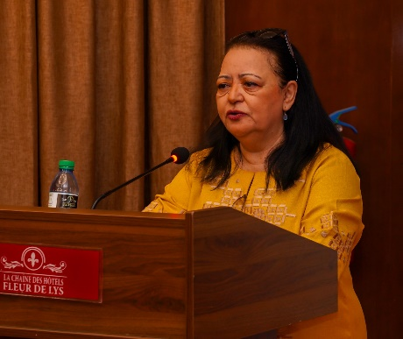
Madame Karima Bounemra Ben Soltane, representing the UN Resident Coordinator, opened a national workshop in Dakar on Statistical Data and Metadata Exchange (SDMX) and the Open SDG dissemination platform. She commended the National Agency of Statistics and Demography (ANSD) for its strong leadership and acknowledged the crucial financial and technical support from the African Centre for Statistics of UNECA and UN Women. The workshop underscored Senegal's commitment to data-driven development and emphasized the immense value of open and disaggregated data for improved decision-making, transparency, and addressing persistent data gaps in achieving the 2030 Agenda for Sustainable Development. She concluded by quoting Clive Humby, stating, "Data is the new oil". Welcome Speech.
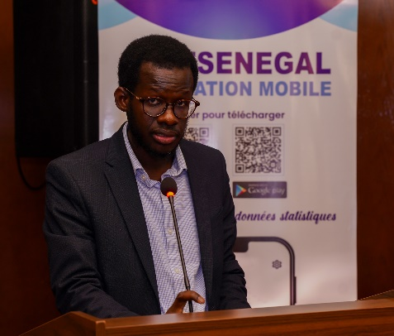
The UCSPE Coordinator's speech at the national at the workshop underscored Senegal's commitment to integrating Sustainable Development Goals (SDGs) into its national strategy. The platform aims to harmonize data exchange, bridge data gaps (especially on gender), and enable regular reporting. The Directorate General of Planning and Economic Policies (DGPPE) is dedicated to strengthening SDG monitoring through skill development, open data, gender equality integration, and collaborative partnerships to achieve Agenda 2030
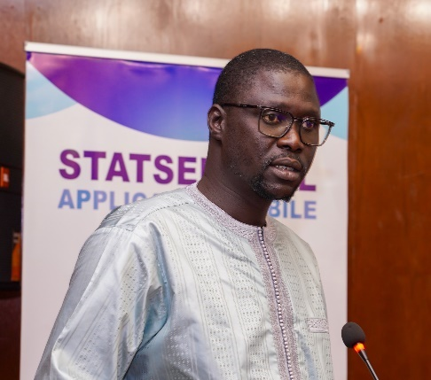
In his opening speech, the Director General of the ANSD welcomed participants to the national workshop on the OpenSDG-SDMX platform, co-organized with CEA and UN Women. He emphasized the platform's role as a structuring solution for improving data management and dissemination, crucial for monitoring public policies. The platform's clear objective is to centralize SDG data, enhance its interoperability with international databases, and increase transparency in indicator dissemination, while also strengthening coordination among data producers.
The workshop provided an opportunity to update the data on this platform. All participants were therefore invited to provide the necessary data. They were also urged to familiarize themselves with the concepts to be presented to ensure the success of the activity.
The protocol phase concluded with a group photo.
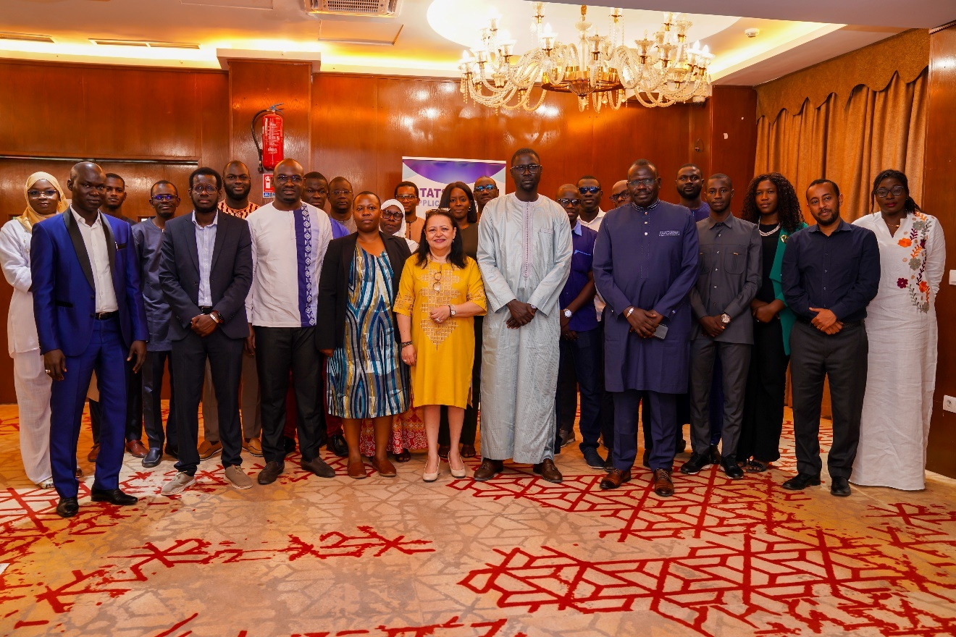

Presentations

Objectives and Expected Outcomes of the Workshop
The technical phase began with a presentation of the workshop objectives and expected results. The overall objective was to present the Open SDG platform to increase awareness of the platform. Specifically, the workshop was aimed at:
- Sensitizing data focal points from ministries on Senegal’s Open SDG Platform with a view of enhancing data collection to filling missing data for SDG indicators.
- Present an overview of the Statistical Data and Metadata Exchange and its role in improving data management and dissemination of SDG data.
Expected results:
- Full buy-in and motivation to update Senegal’s SDG dataset for subsequent upload to the centralized Open SDG platform.
- Strengthened the capacities of Senegal’s data focal points in SDMX for data management and dissemination.

The national mechanism for monitoring the Sustainable Development Goals (SDGs)
The first presentation of the workshop began with a presentation by the UCSPE, delivered by Ms. Sène, who recalled the general context, the national mechanism for monitoring the Sustainable Development Goals (SDGs), and the outlook for preparing the Voluntary National Review (VNR) in 2026. She emphasized the importance of having reliable and regular data for effective monitoring.
During the Q&A, Ms. Bounemra showed how Senegal positions itself in SDG monitoring, describing it as an essential tool for guiding development actors’ decisions. She expressed strong interest in the territorialization of the SDGs, reminded participants that Senegal will present its VNR at the UN in 2026, and stressed the need to strengthen capacities in planning and foresight. The Deputy Director General (DDG) highlighted the close collaboration between the UCSPE and the ANSD, the importance of quality data, and the need to define a set of indicators by cluster for territorialization. He mentioned the launch of the Data Innovation Lab (DIL) and the expected support from ECA. Ms. Sène concluded by noting that all comments and suggestions would be considered.

Assessing Progress Towards Achieving the SDGs
The second presentation, by Ms. Kiconco, UNECA, provided a concerning overview of SDG implementation in Africa: regression in five areas, an insufficient pace to achieve the goals by 2030, and incomplete target coverage (54% assessed at the continental level, 61% for Senegal). She detailed the SDGs showing progress and those regressing, as well as statistical gaps, particularly for SDG 13. She presented ECA’s support program, focused on data centralization, reducing gaps, and using SDMX.
The follow-up discussions focused on the reasons behind the observed regressions and their data sources, data availability by region, and concrete ways to strengthen statistical collection for insufficiently documented indicators. Questions included whether work had been done on the regression of indicators 5, 8, and 15, and the overall SDG coverage level.

Introduction to Open SDG-SDMX, and ODP 2.0
The third presentation, led by Baye Demba, was on the Open SDG Platform. He outlined its objectives, operation, and interconnections with other tools such as ODP 2.0, the Global SDG Data Structure Defintion, and APIs. He also encountered challenges, involved partners, and conducted a navigation demonstration to visualize the data.
Participants were interested in how to regularly update the portal, train users, and ensure interoperability with other national or regional systems. They also asked whether the platform had incorporated SDG disaggregation at the regional level, and about outreach efforts toward researchers. According to the presenter, the portal is flexible and interoperable. Disaggregation has already been integrated into the platform. As for web scraping, it is unnecessary since there are API endpoints that can automatically retrieve data without human intervention, which can be connected to the site.

Open Data Platform
A presentation was given by Mr. Elhadji Malick for the second day on the SDMX platform for unified and integrated data management. He began by presenting the most widely used data portals in Africa, mentioning ODP 1.0, a dissemination tool for monitoring data in the context of the NSDD.
He then presented ODP 2.0, currently being implemented at ANSD and within the NSS. Progress made includes internal deployment on ANSD servers, SDMX modeling with the training of several experts, regular data updates in parallel with ODP 1.0, and use by STATSENEGAL. Senegal is one of three pilot countries chosen by the WAEMU Commission for the implementation of ODP 2.0, which is also interconnected with Open SDG.
For the next steps, the plan is to establish an internal team (based on the NSDD contributors and ODP 1.0 focal points model), organize training sessions on SDMX modeling and MDM administration, prepare for the full transition to ODP 2.0 by 2027, deploy regional ODPs, and select pilot NSS structures to adopt ODP 2.0.
The presenter emphasized the importance of SDMX, recognized as an ISO standard since 2005. This standard facilitates the collection and centralization of data, their management and storage, dissemination, as well as exchange and transmission. Multidimensional SDMX modeling is based on three key concepts: dimensions, attributes, and measures.
In SDMX, a data model describes every relevant characteristic of the data to be exchanged, each concept can be coded, uncoded with a format, or uncoded free text. Internationally agreed code lists, where available, enable data to be understood irrespective of the producer’s language. In SDMX exchanges, code lists must be harmonized among all data providers.
Multiplier, and Observation Value. Concepts can be coded or free text. Internationally harmonized code lists ensure that data are understood regardless of the producer’s language.

Workshop Recommendations and Perspectives

Data Collection
- List all missing SDG indicators;
- Integrate historical data into the platform;
- Document indicator metadata;
- Improve data reliability (quality, qualified personnel);
- Identify producing and collecting agencies (data collection mapping);
- Strengthen sectoral capacities;
- Regularly update data;
- Ensure better coordination between UCSPE and ANSD (planning a meeting with UCSPE to share missing indicators);
- Redefine roles and consider entrusting data collection to ANSD.

Sustainability of the Open SDG–SDMX platform
- Consolidate existing systems rather than starting over;
- Consider technicians’ input;
- Learn lessons from previous systems;
- Develop a governance charter for SDG systems and data;
- Strengthen technical and material capacities for indicator quality;
- Go beyond the technical aspect by making the platform dynamic (communication, ownership);
- Expand SDMX training.

Sharing of Participant Experience
Before closing the workshop, UNECA conducted an evaluation of the national dissemination workshop for the SDMX powered Open SDG platform. The evaluation consisted of rating the workshop based on a series of questions.
The evaluation of the Training Workshop on SDMX, Open Data Platform (ODP) 2.0, and Open SDGs tools shows generally positive feedback from participants, with an overall satisfaction score of 4.14/5. Participants rated the clarity of objectives at 4.00/5 and expressed high satisfaction with most sessions, especially those covering the ODP 2.0 platform and SDMX-Open SDG integration. Key strengths highlighted include the quality of presentations, the usefulness of feedback, and the relevance of workshop content. Suggestions for improvement focused on providing more technical materials, addressing complex concepts in simpler terms, and offering additional support for data standardization and management. The feedback indicates that while the workshop successfully met its core objectives, further capacity building and follow-up support would strengthen the impact of these tools in practice.
The Head of the Division of Statistical Cooperation and Coordination thanked all participants, as well as technical and financial partners. She also noted that the concerns raised by Angela, particularly regarding data coordination and disaggregation, are now better understood and that the necessary measures will be taken once remaining uncertainties are resolved.

Session with ANSD
Concluding the intensive activities, a session to debrief took place immediately following the workshop days of August 5-6, 2025. This debrief served to review the workshop's outcomes, with Mr. Fode Dieme, (Directeur de la Méthodologie, de la Coordination statistique et de l'Innovation) acknowledging and addressing concerns, particularly regarding data coordination and disaggregation, ensuring necessary measures would be taken. These collaborative discussions and the final debrief were vital for reinforcing inter-institutional collaboration and charting the future course for the SDMX powered Open SDG platform of Senegal.

Annexes

Termes of reference and Agenda of the Workshop
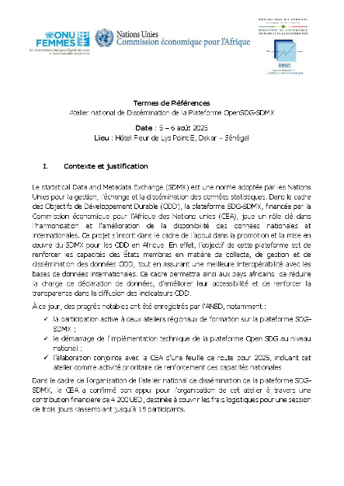 | 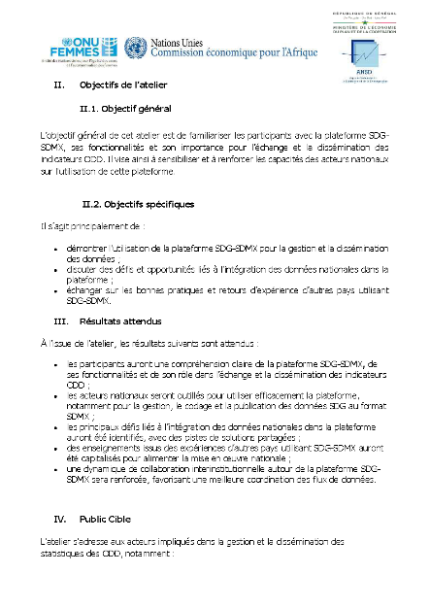 | 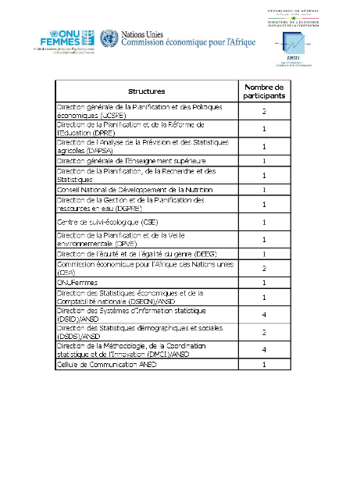
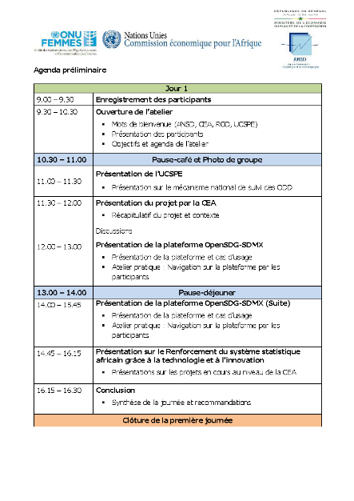 | 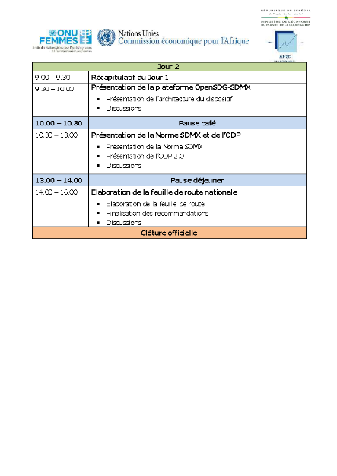

Allocution de Madame Karima Bounemra Ben Soltane, au nom du Coordonnateur Résident du Système des Nations Unies au SENEGAL
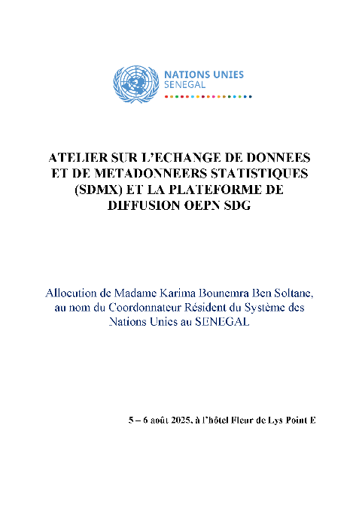 | 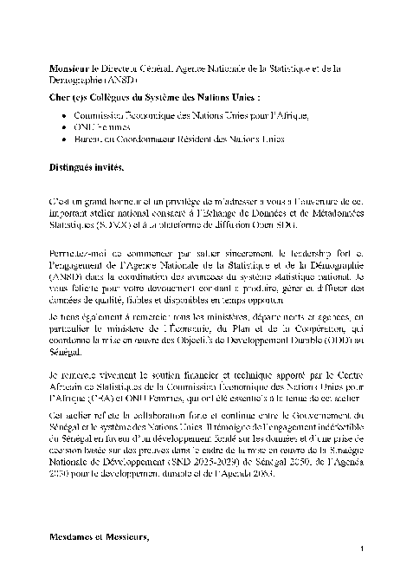 | 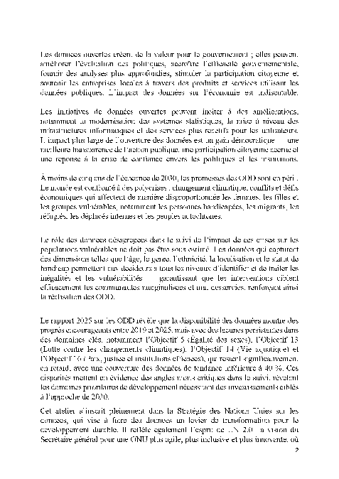
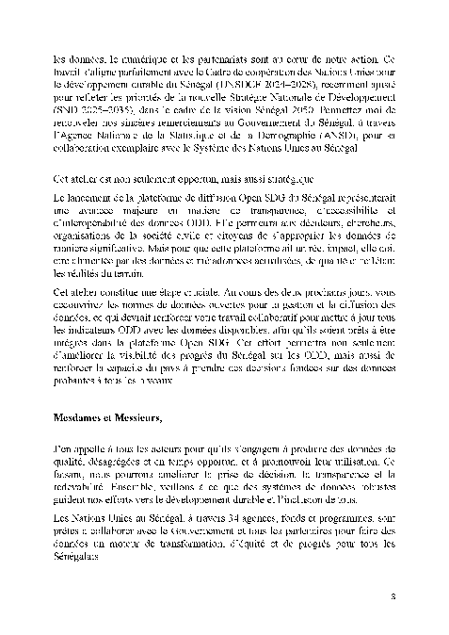 | 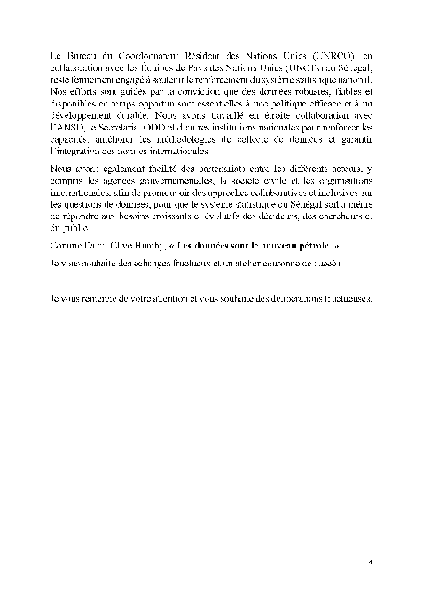

Welcome remarks delivered by Coordinator of SDG,
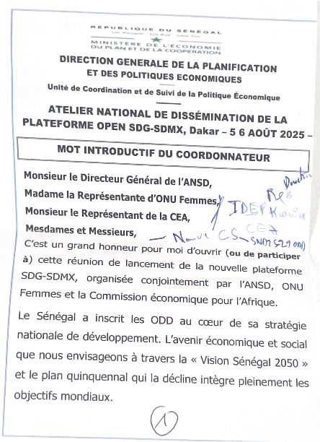 | 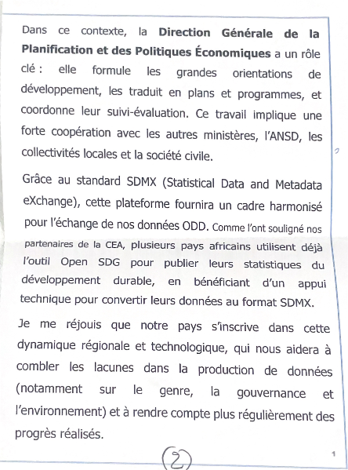 | 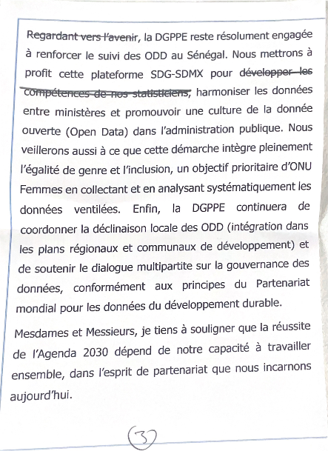
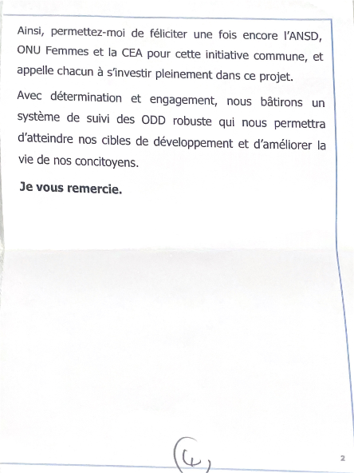

Welcome remarks delivered by DG of ANSD Senegal at Open SDG Platform

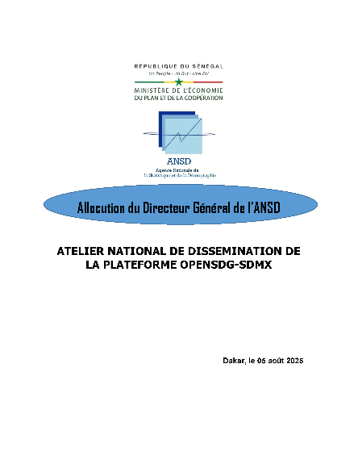 | 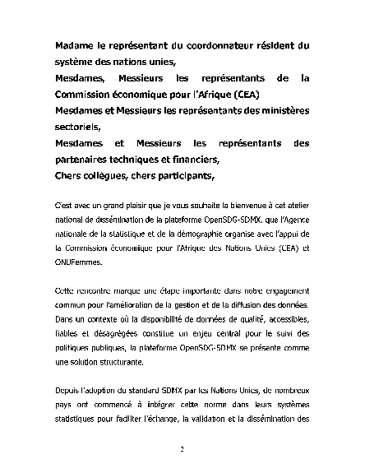 | 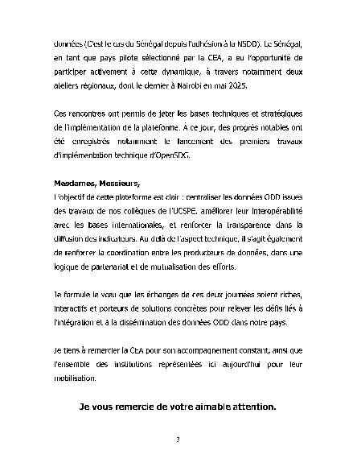

Evaluation of the Training Workshop
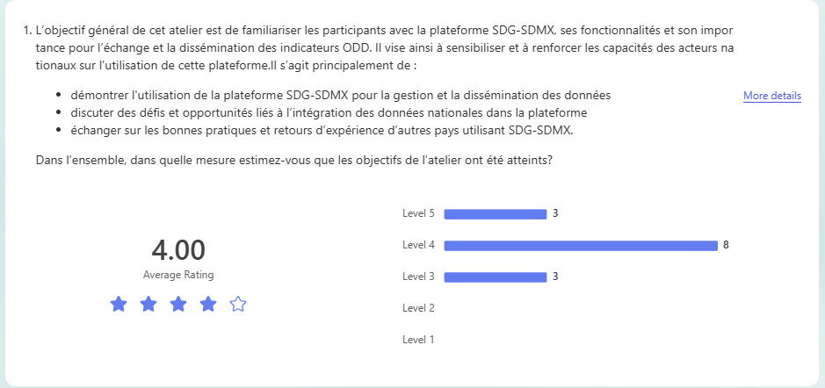

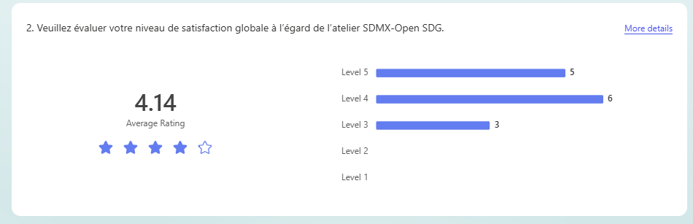
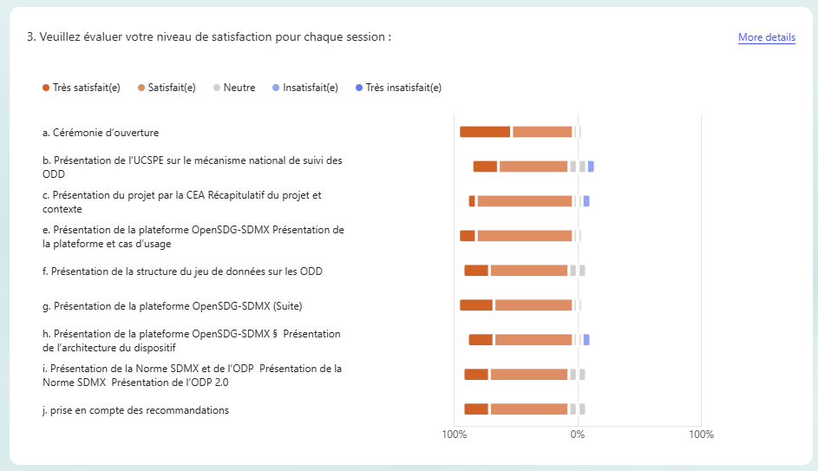
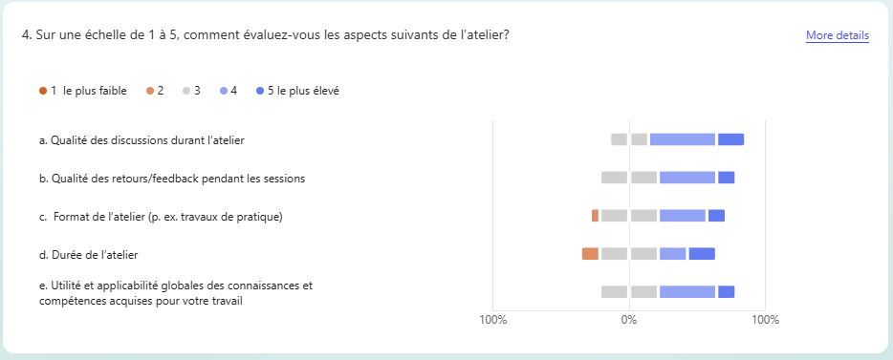
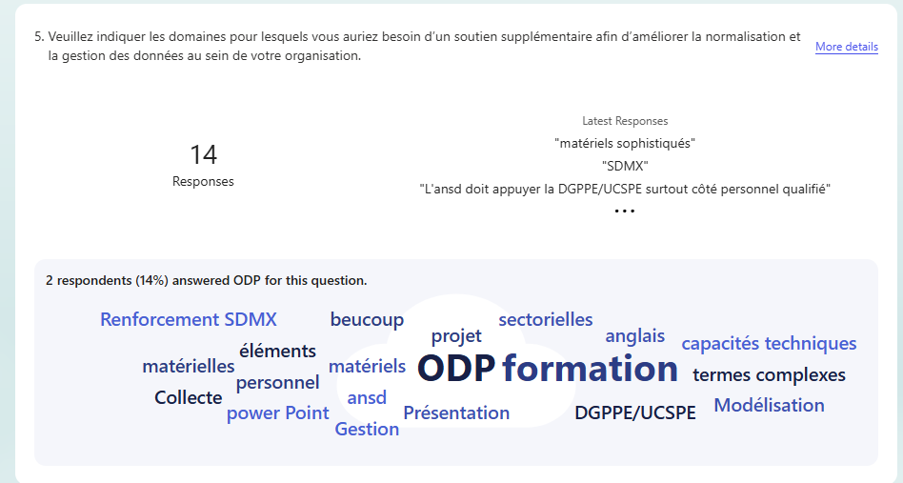

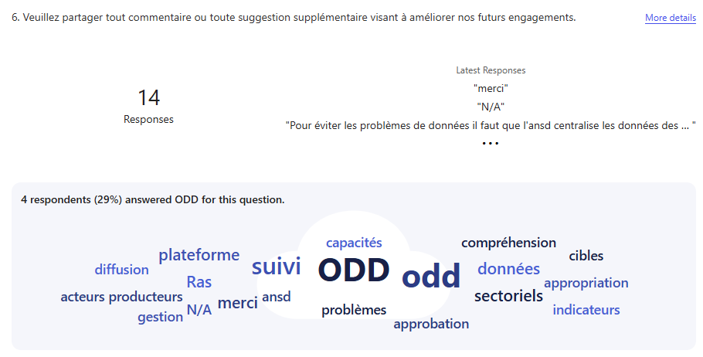

‌

‌

List of Participants
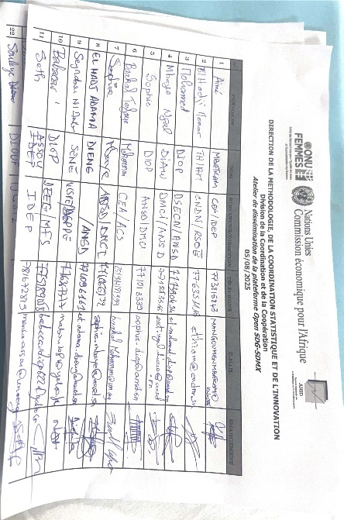 | 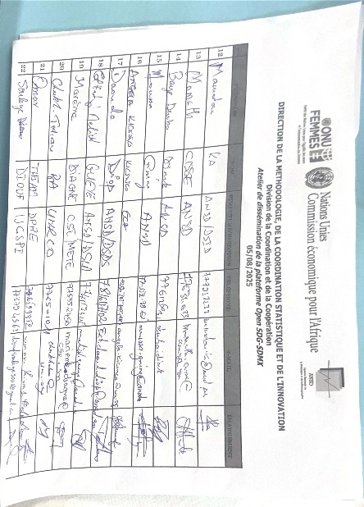 | 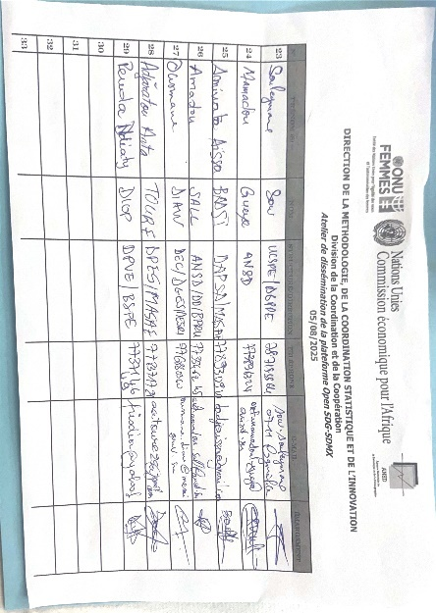

Pictorial of the Mission
Workshop 5-6 August 2025
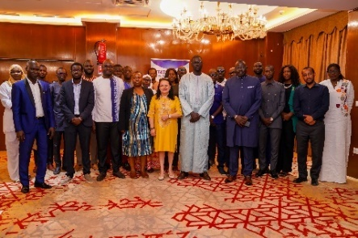
 | 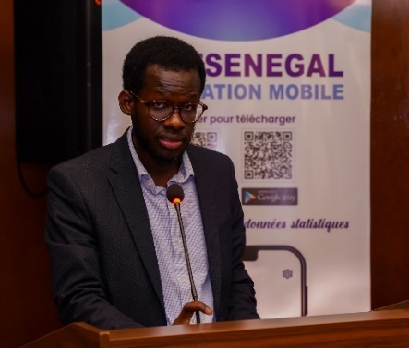 | 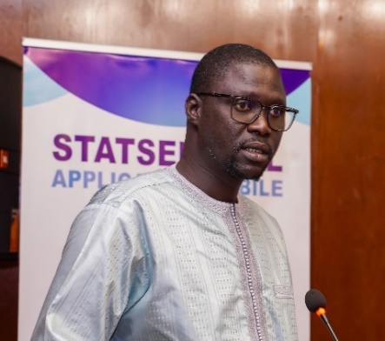
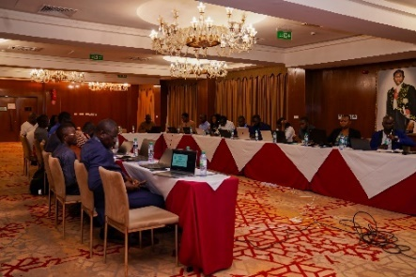 | 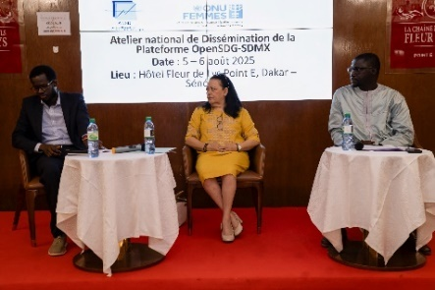 | 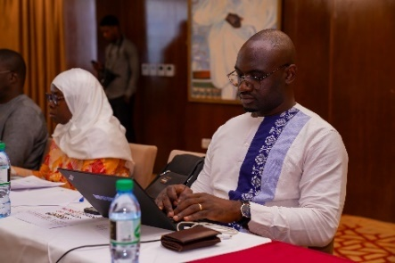
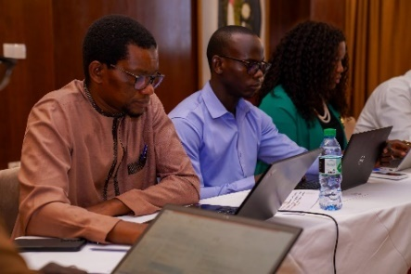 | 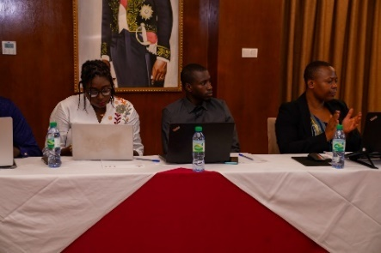 | 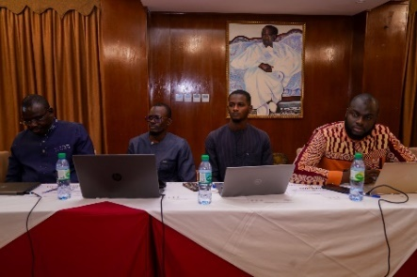
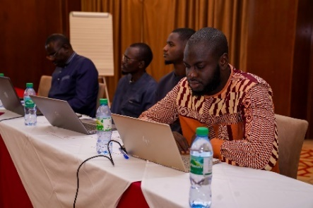 | 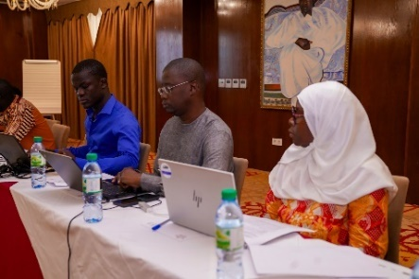 | 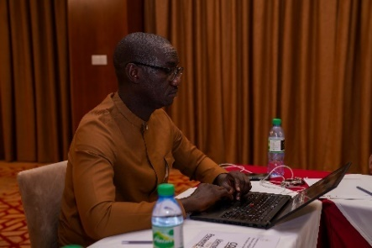
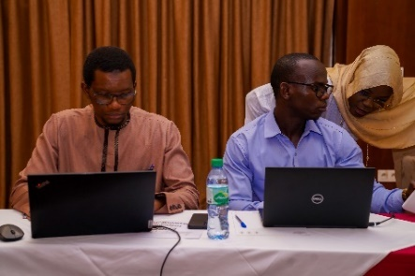 | 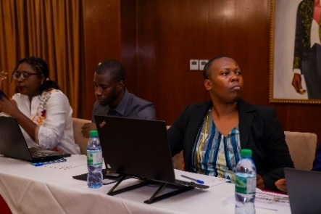 | 
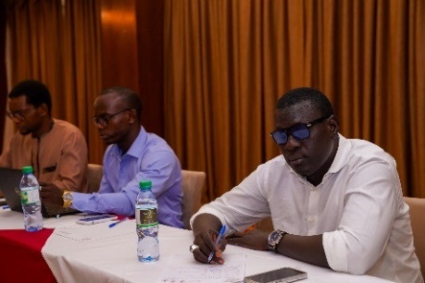 |  | 
Debrief witn Director of ANSD | 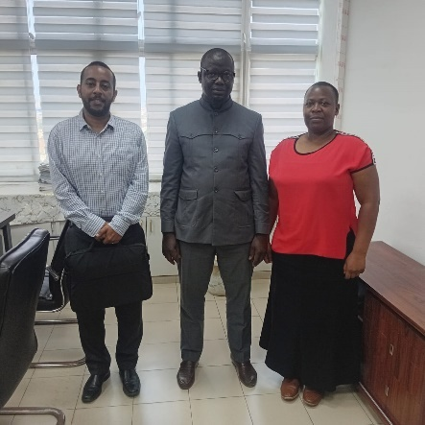
Visit To UN System Senegal | 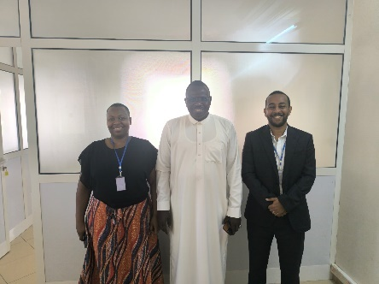

Presentations delivered during the workshop.
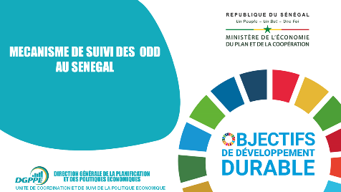 | 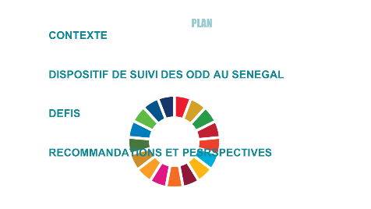 | 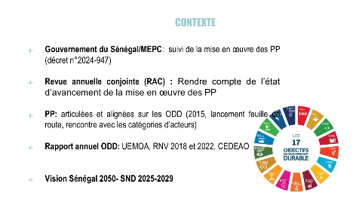
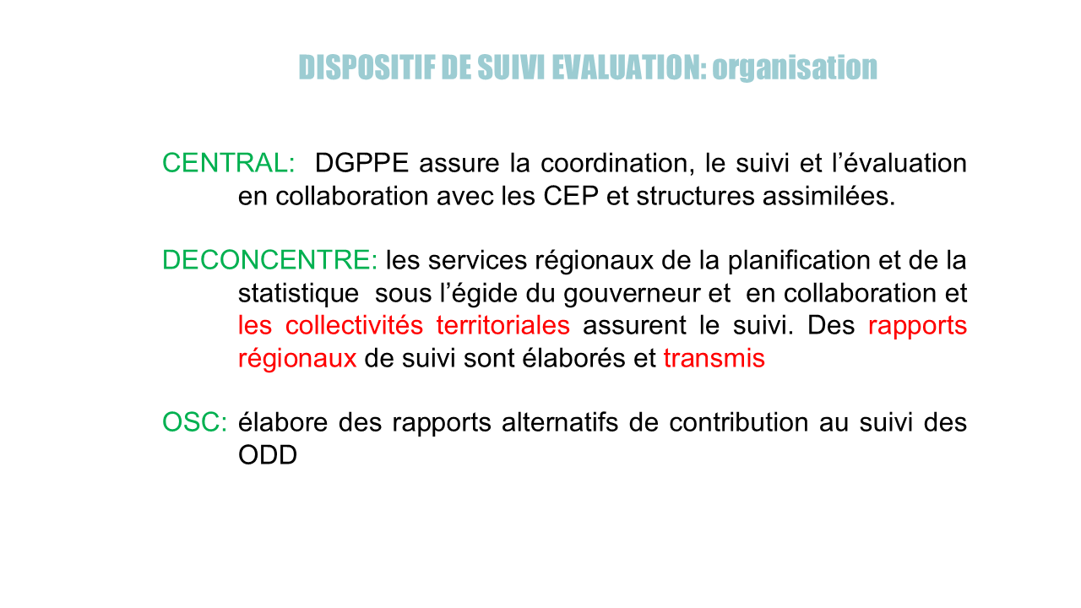 | 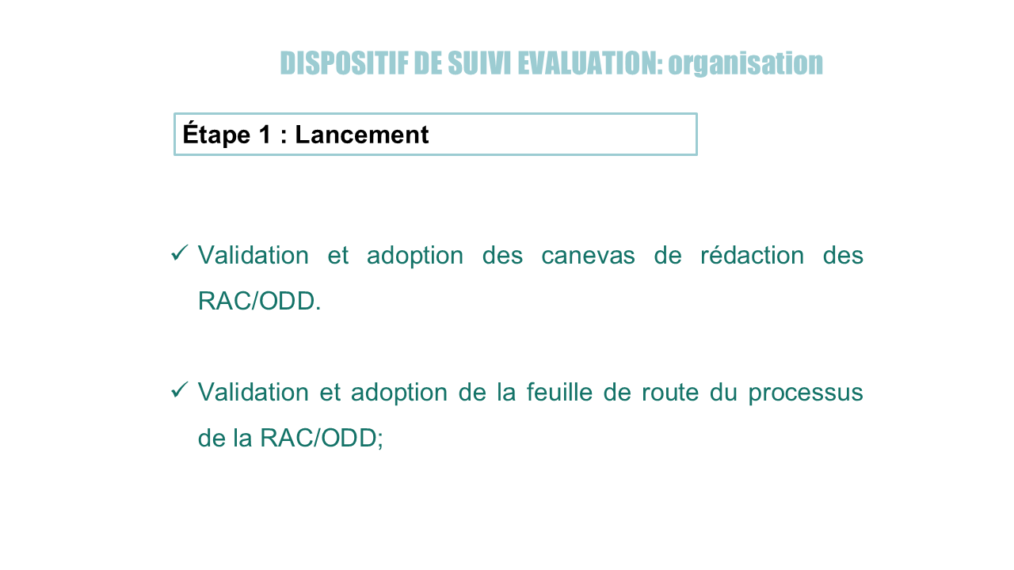 | 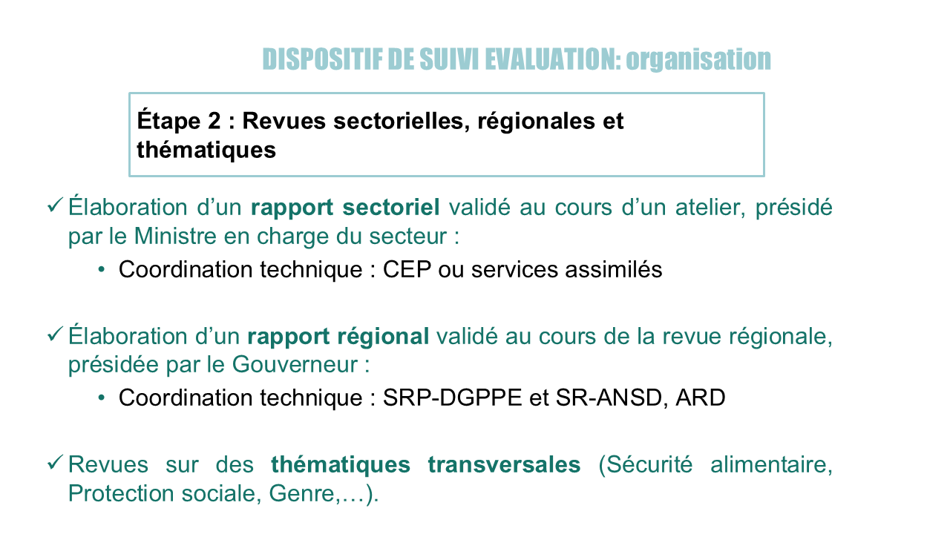
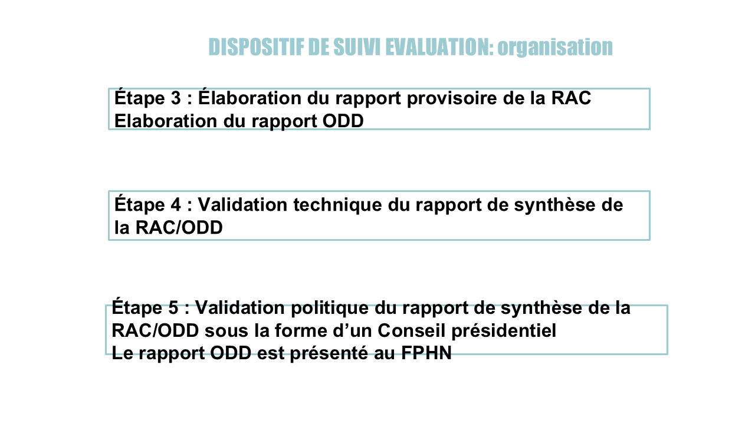 | 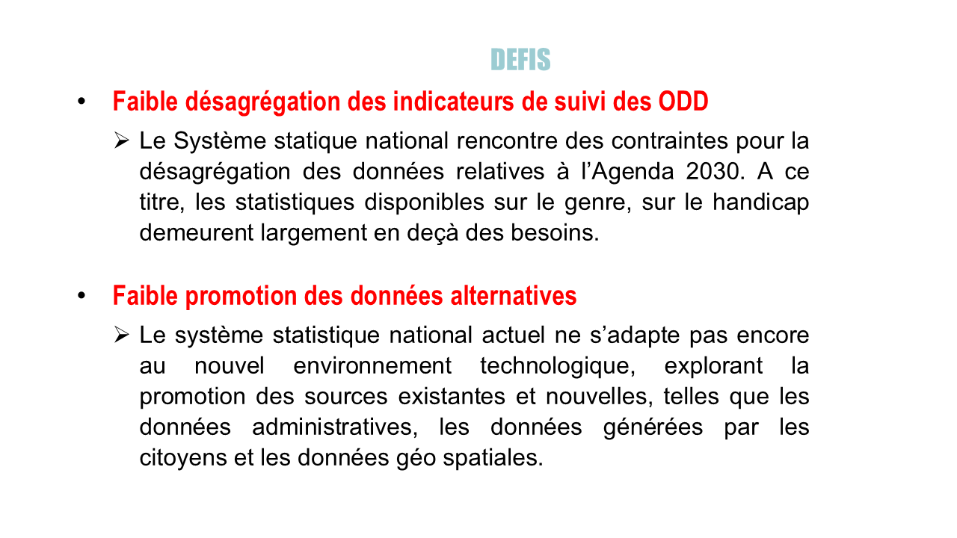 | 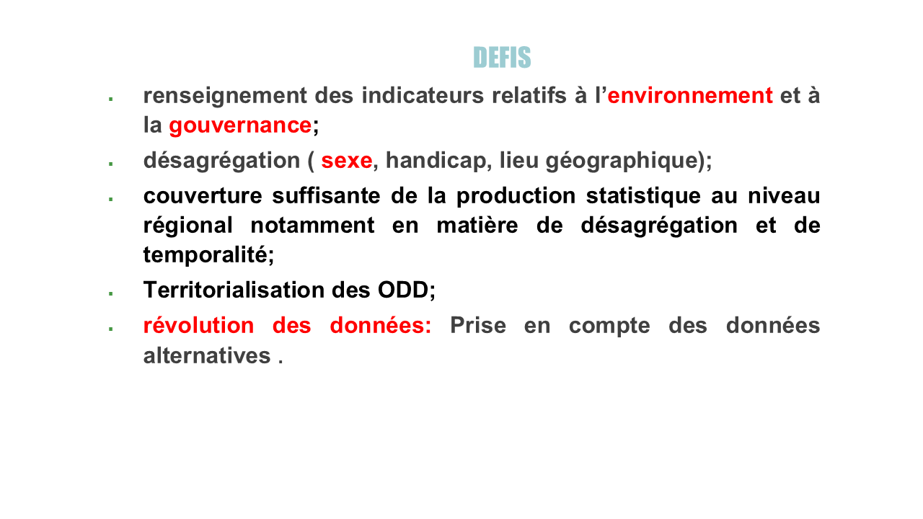
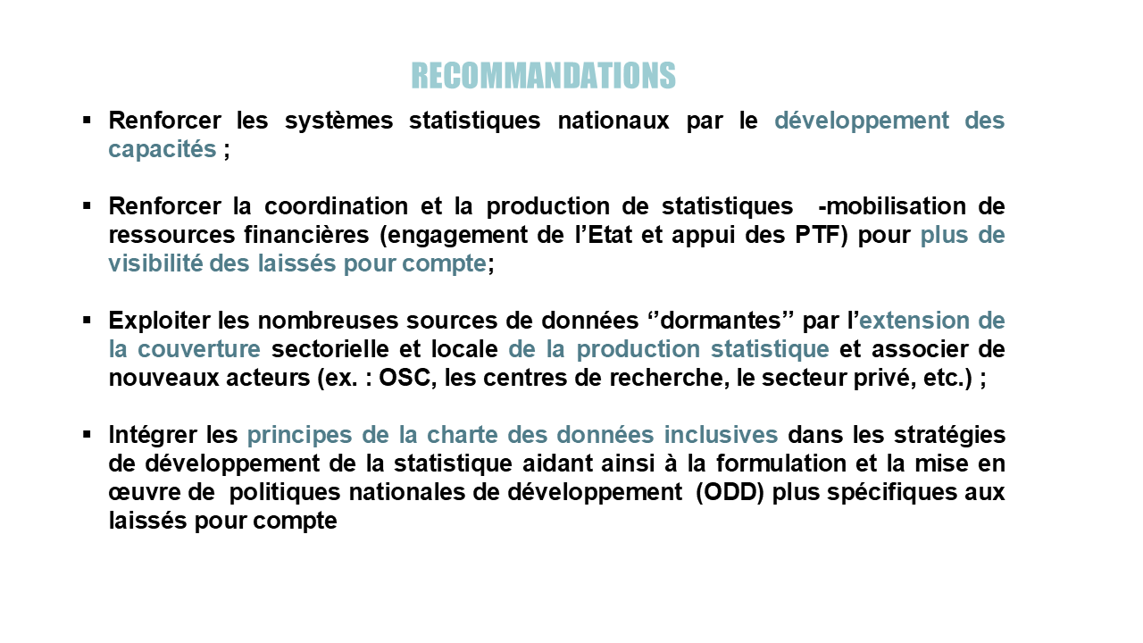 | 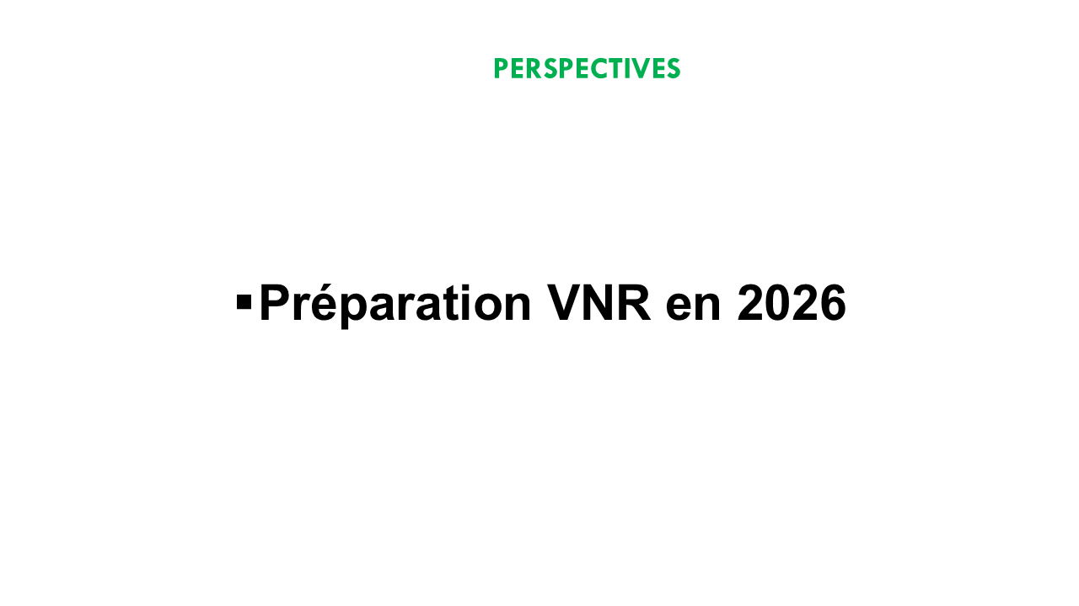 | 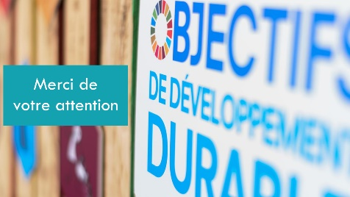

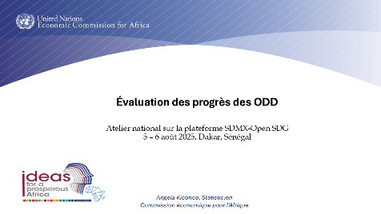 | 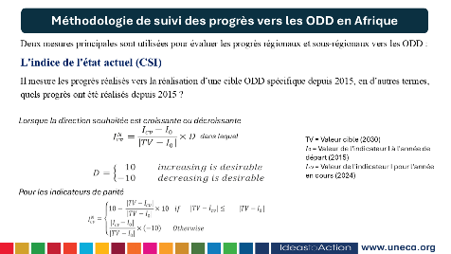 | 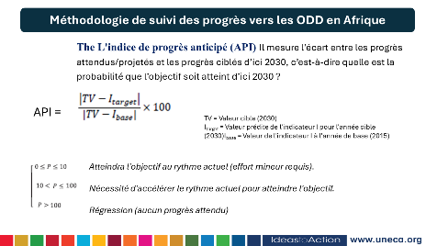
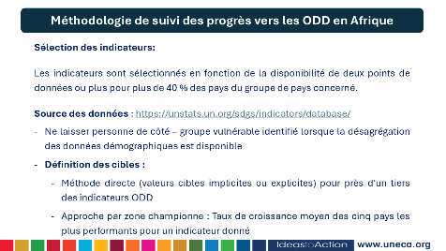 | 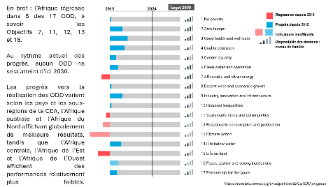 | 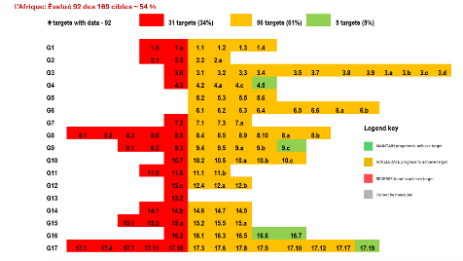
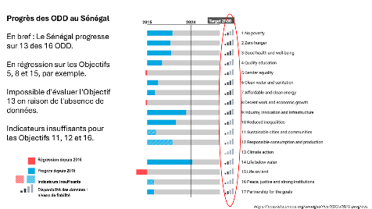 | 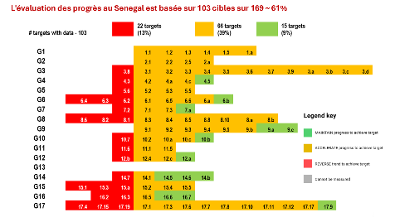 | 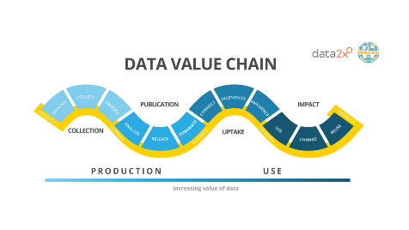
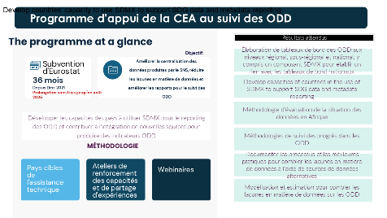 | 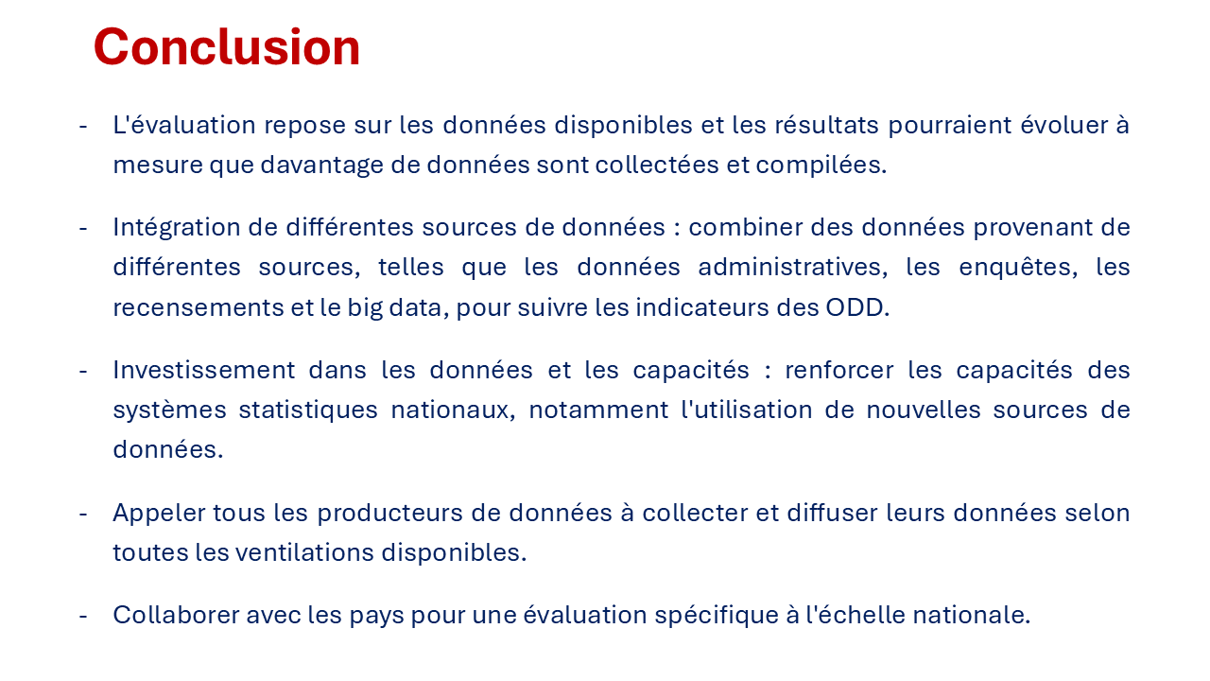

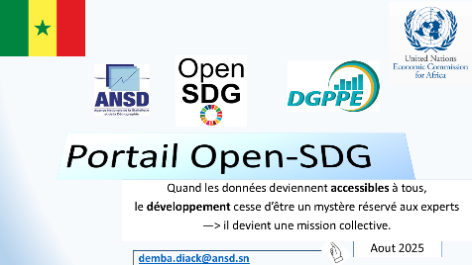 | 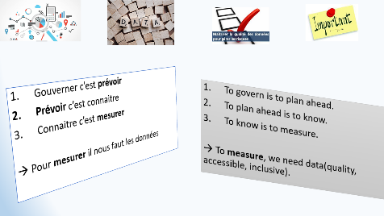 | 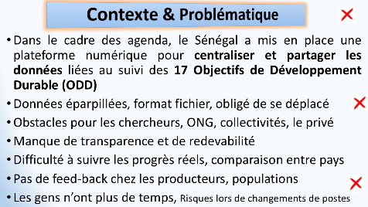
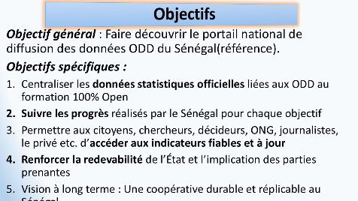 | 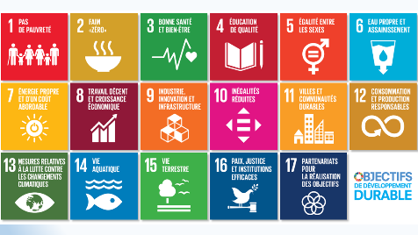 | 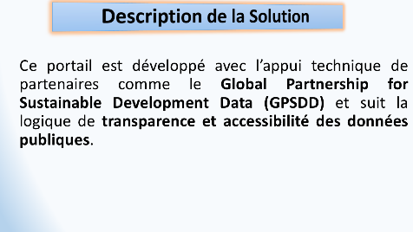
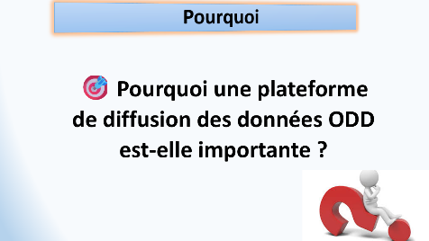 | 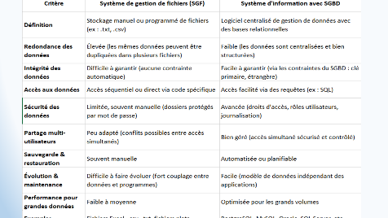 | 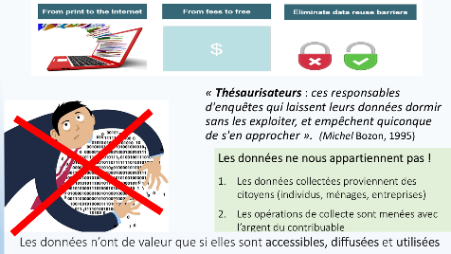
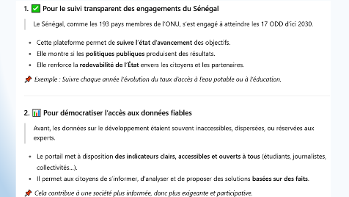 | 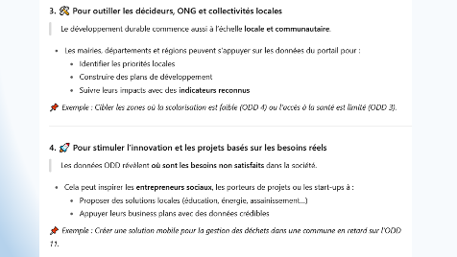 | 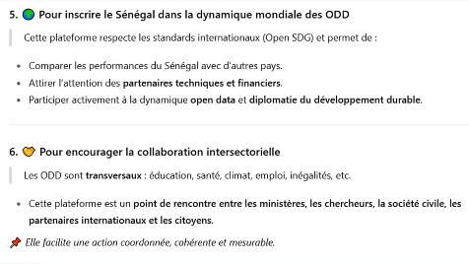
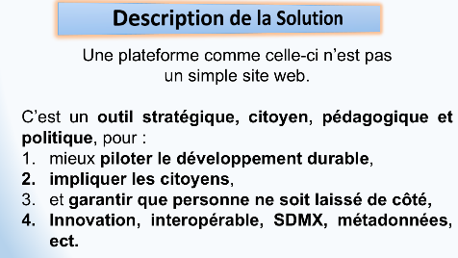 | 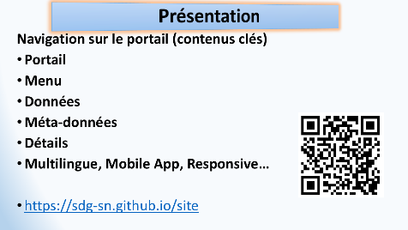 | 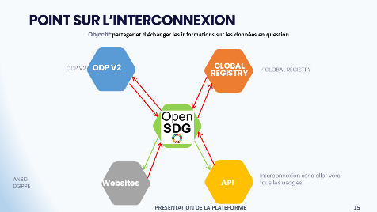
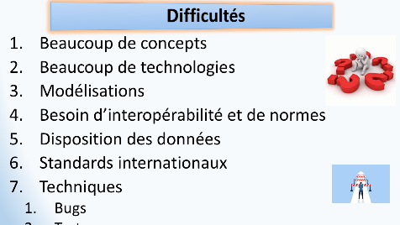 | 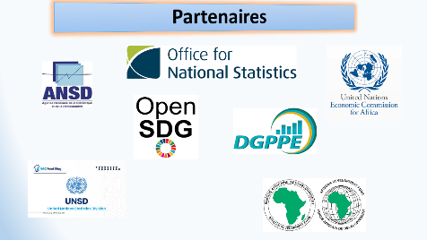

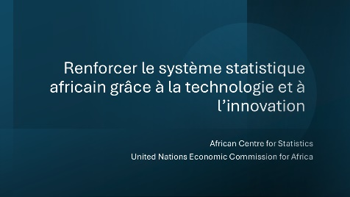 | 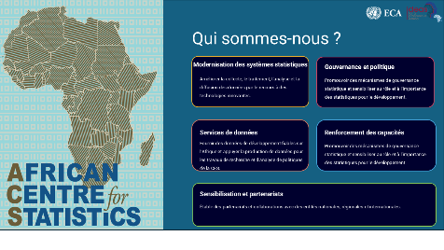 | 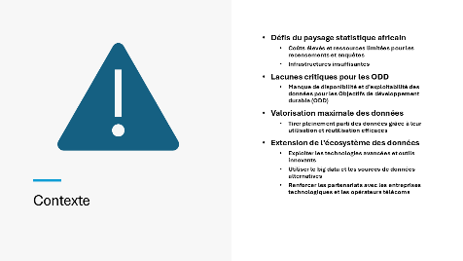
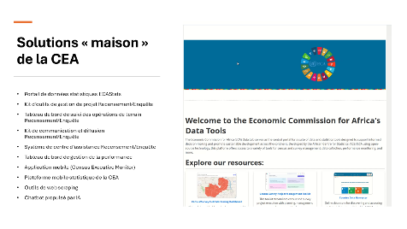 | 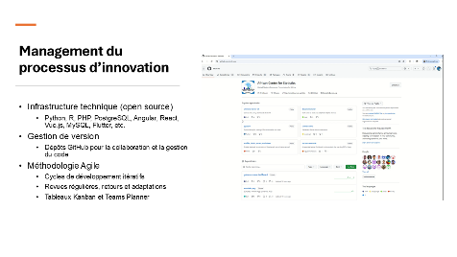 | 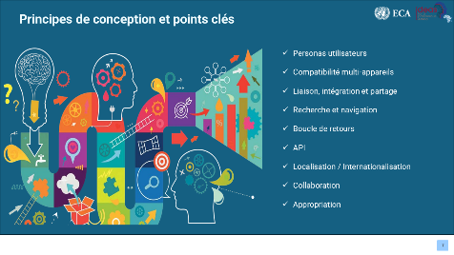
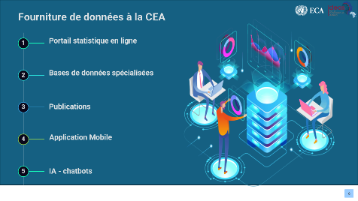 | 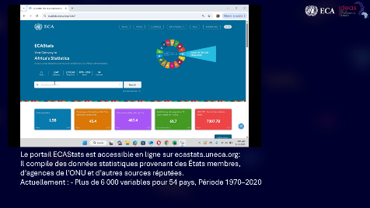 | 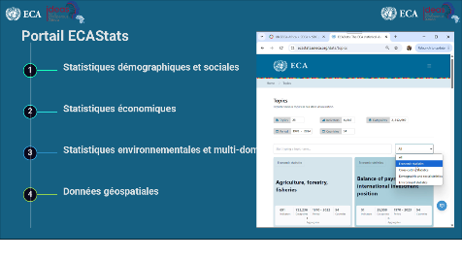
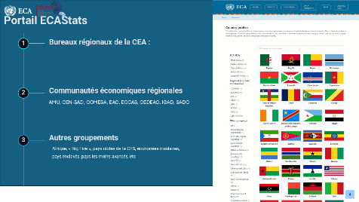 | 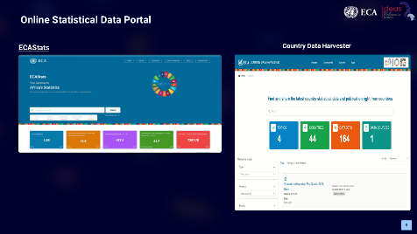 | 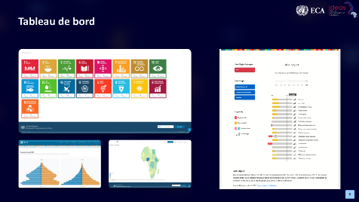
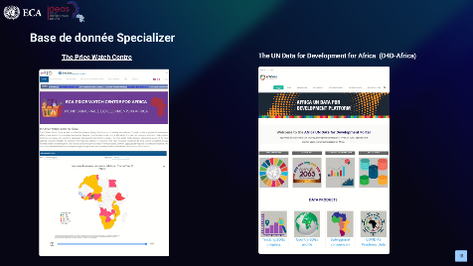 | 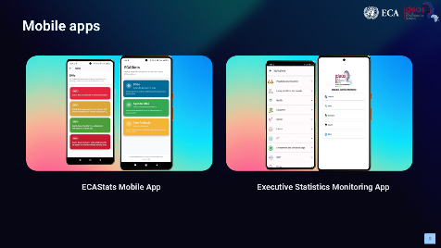 | 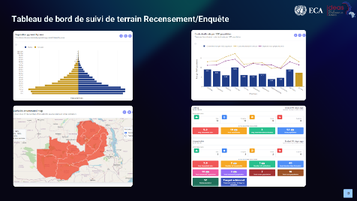
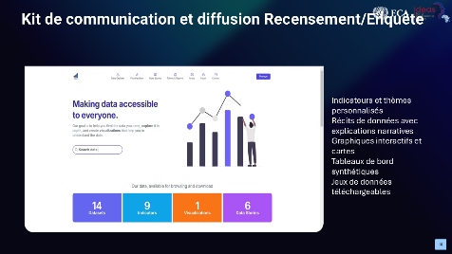 | 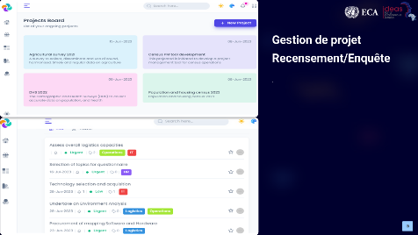 | 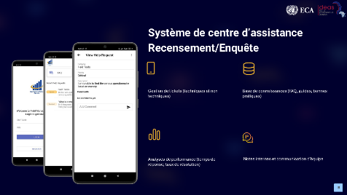
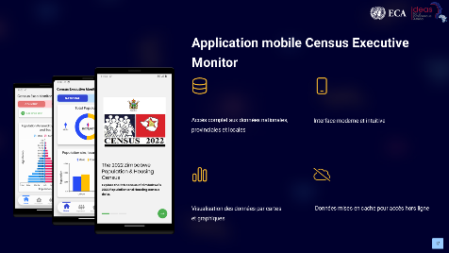 | 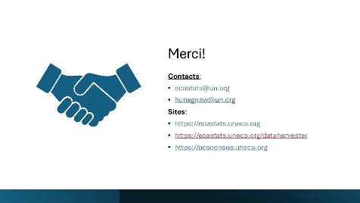

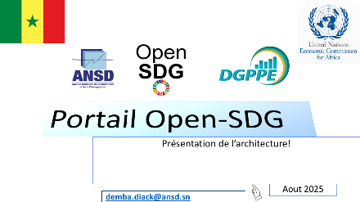 | 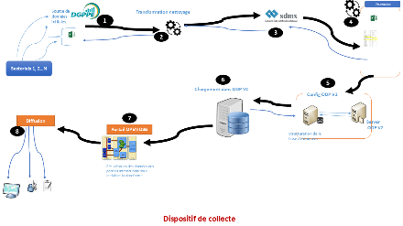 | 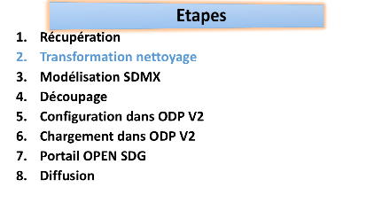

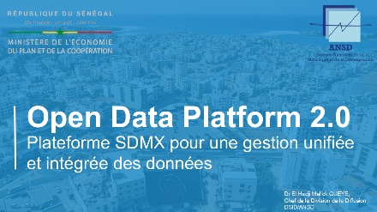 | 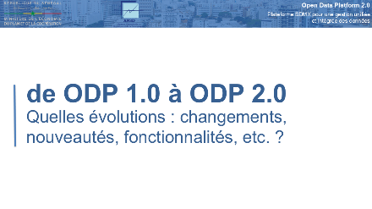 | 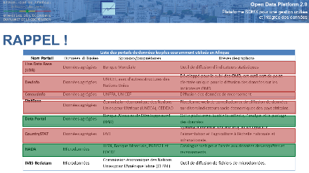
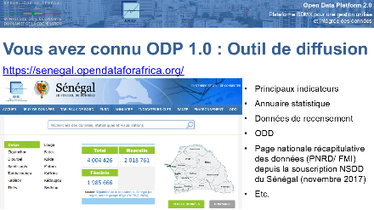 | 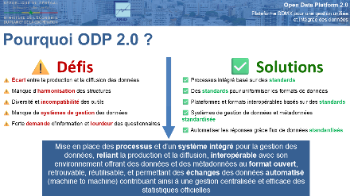 | 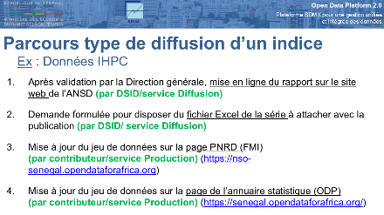
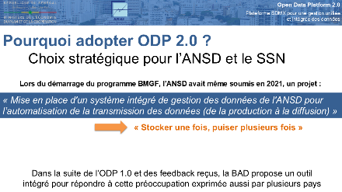 | 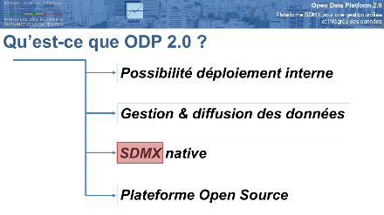 | 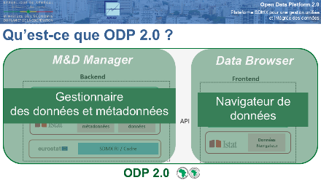
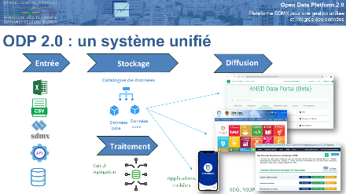 | 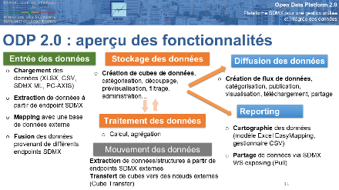 | 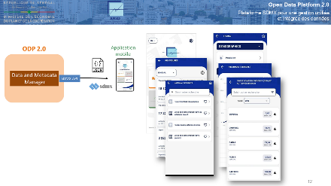
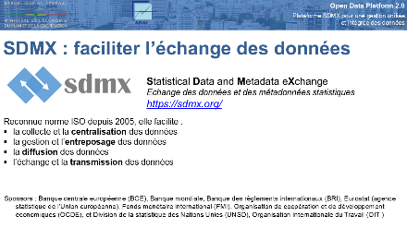 | 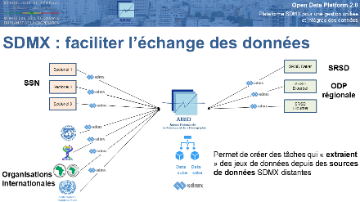 | 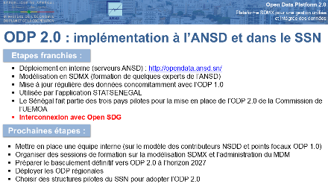
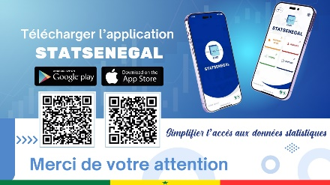 | 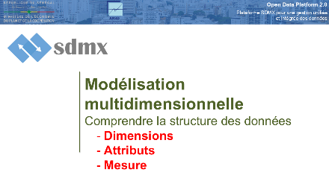 | 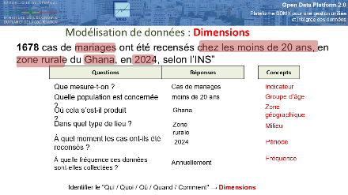
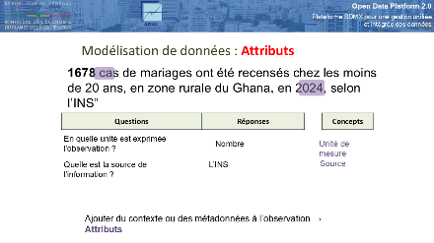 | 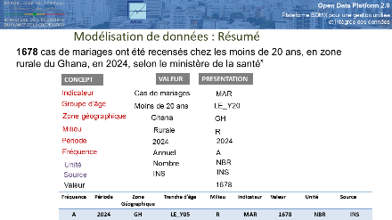 | 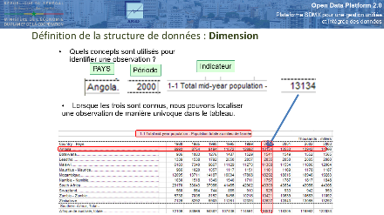
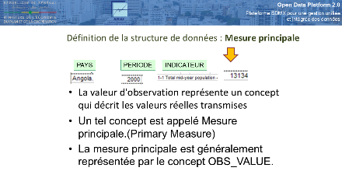 | 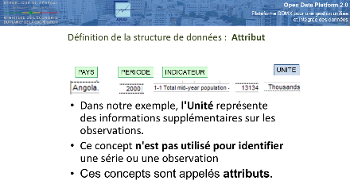 | 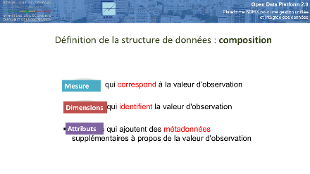
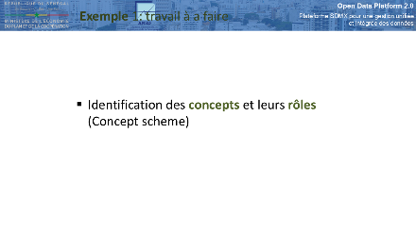 | 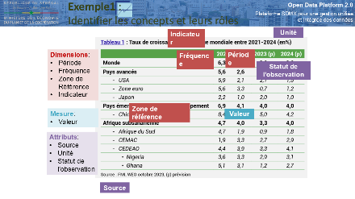 | 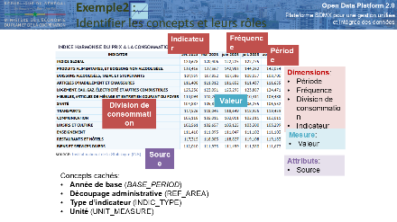
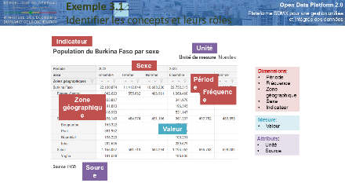 | 